Guidelines for Conducting Historical Archaeological Surveys
Heritage Victoria
February 2024
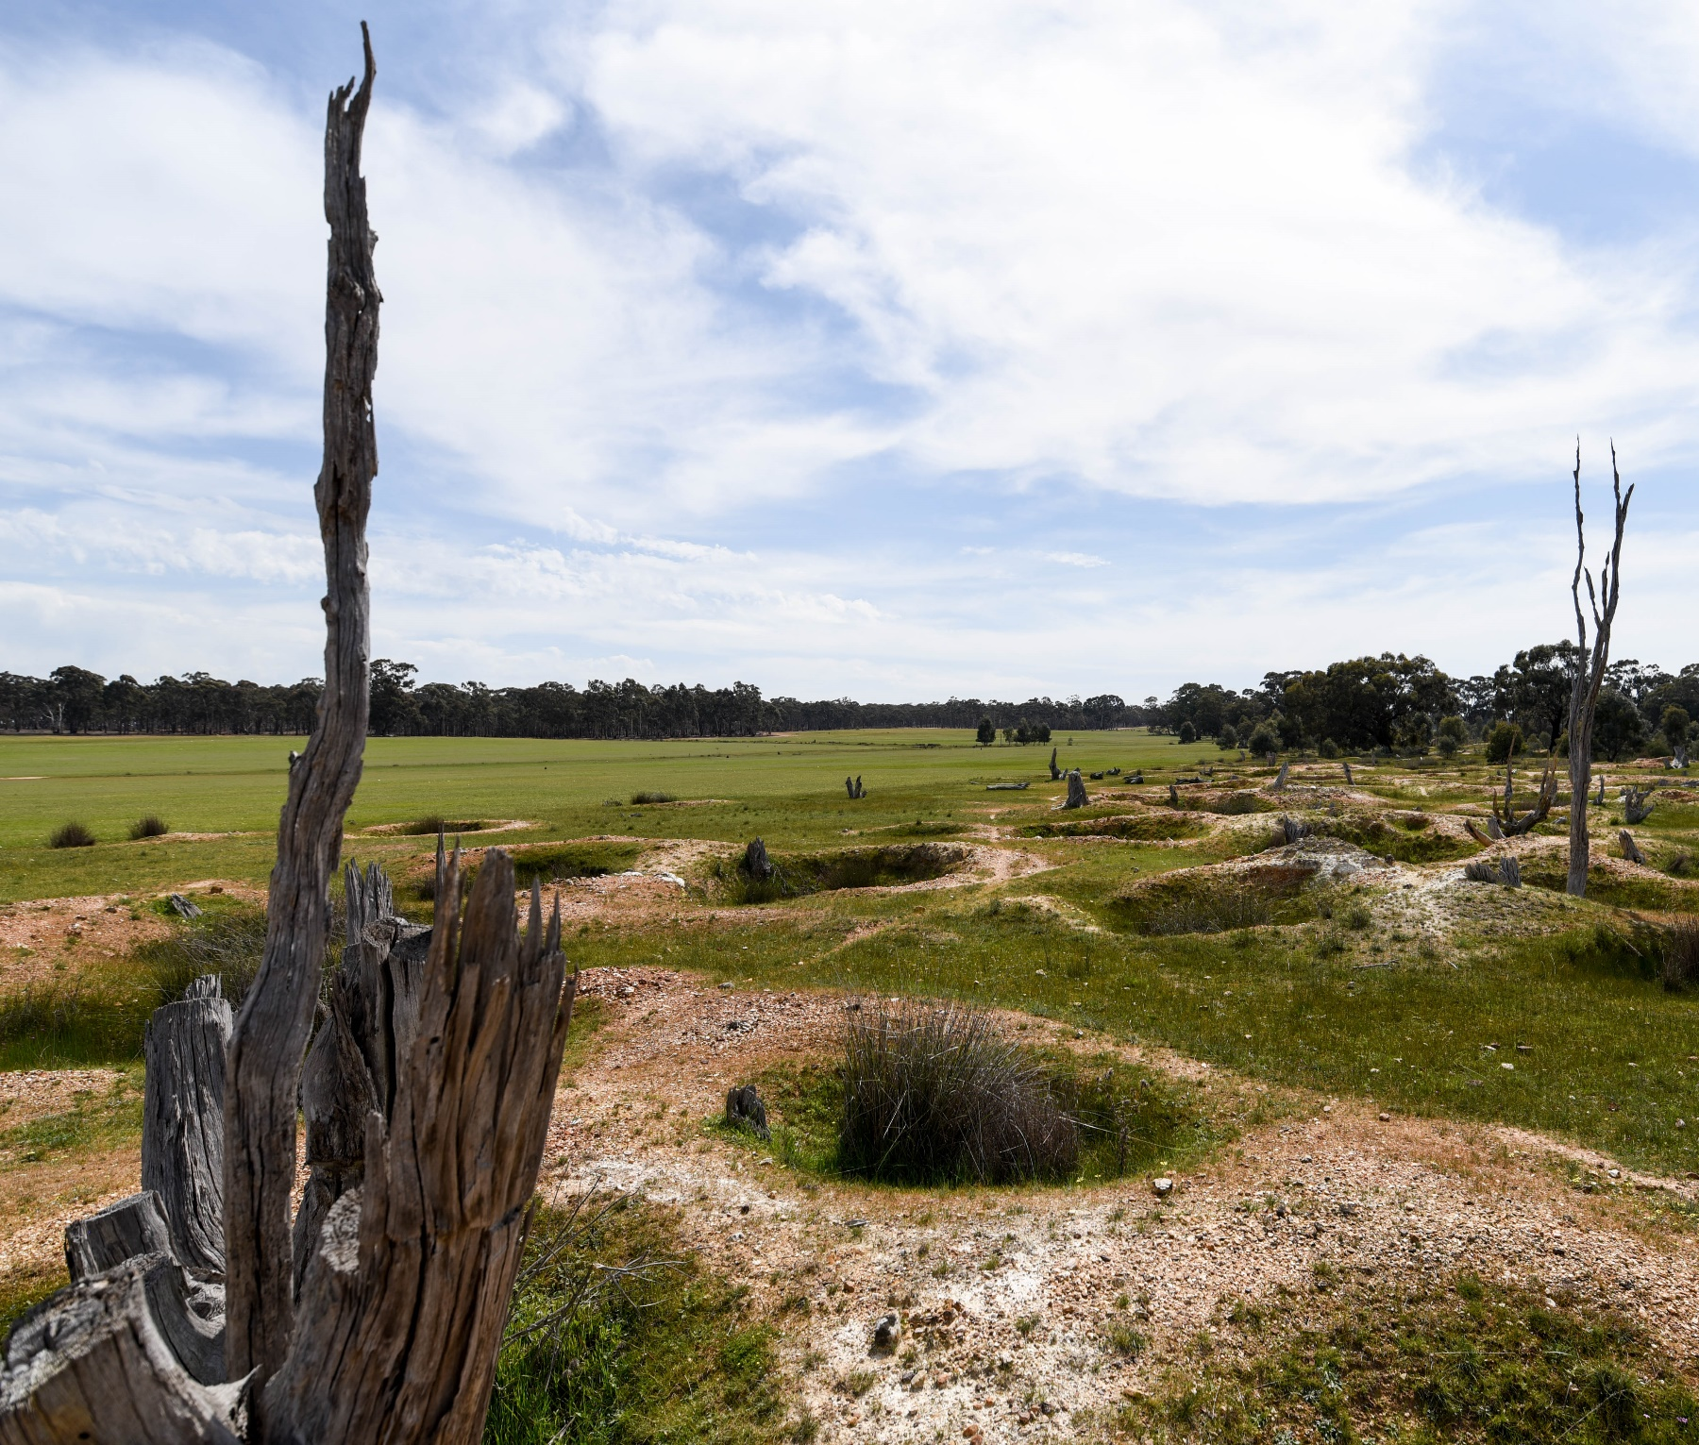

Contents
1. Introduction 2
When is a Notification of Intent to Survey Form (NOI) required? 2
When is a NOI not required? 2
Intersection with the Aboriginal Heritage Act 2006 3
Conducting a survey 4
Prior to the commencement of a survey: 4
During a survey: 4
At the completion of a survey: 4
2. Historical Archaeological Sites 5
How is inclusion of a site in the Heritage Inventory determined? 5
What places do not warrant inclusion on the Heritage Inventory? 6
3. Completing a site card 7
4. Completing a survey report 9
What to include in a survey report? 9

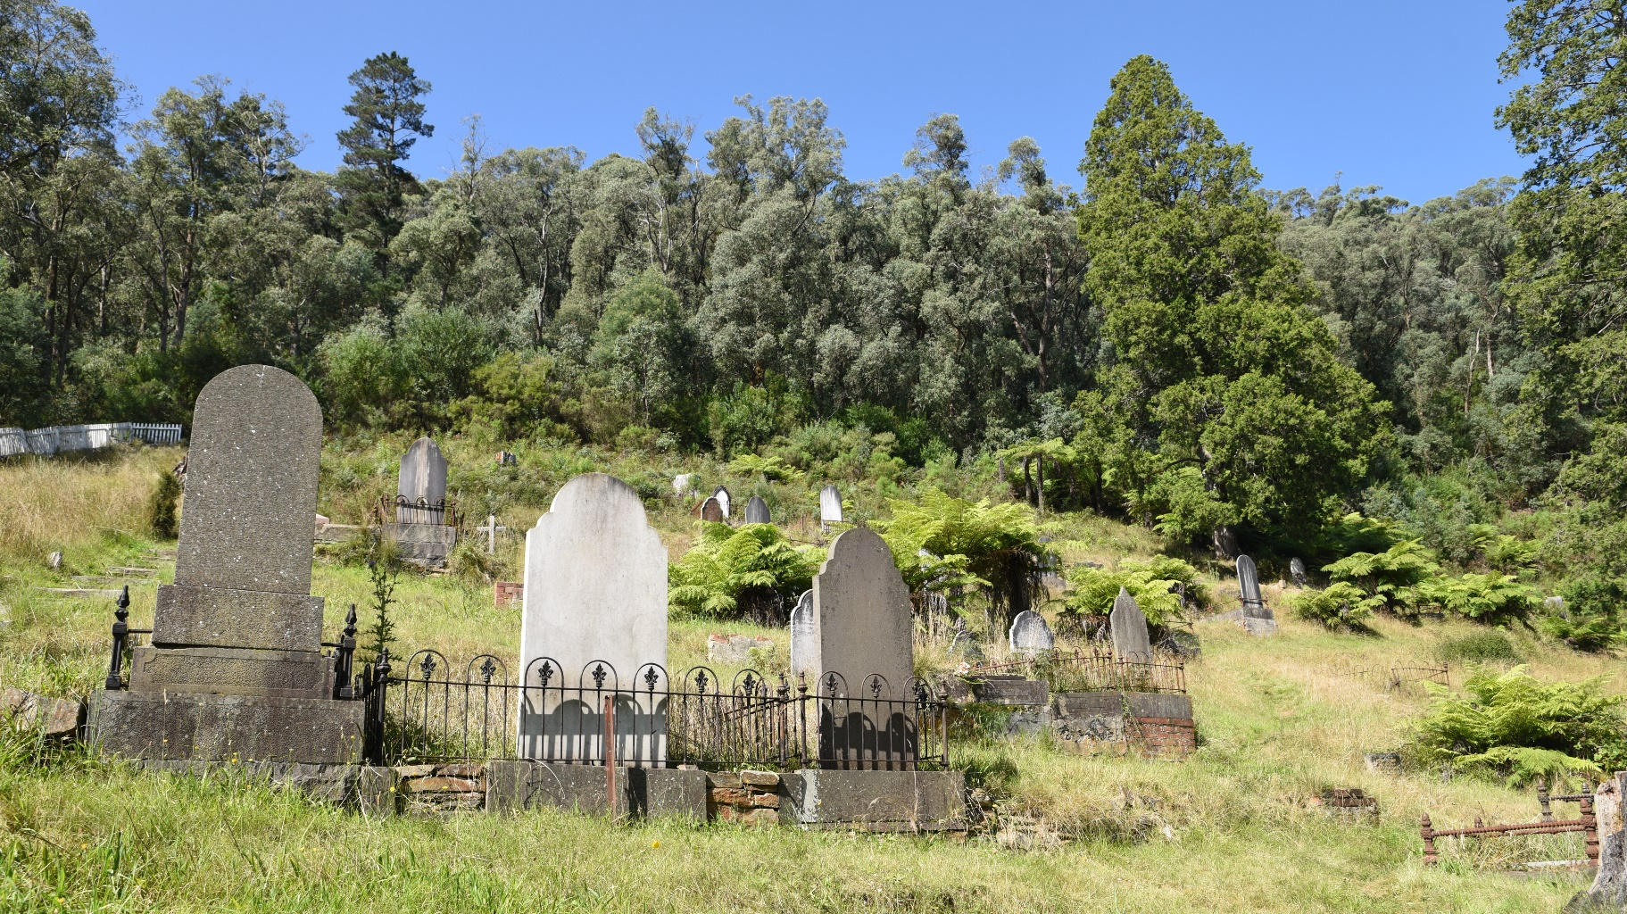
Walhalla Cemetery

Introduction
These guidelines provide an overview of the Heritage Act 2017 requirements for conducting archaeological surveys and reporting historical archaeological sites in Victoria.
The Heritage Act 2017 (‘the Act’) and Heritage Regulations 2017 (‘the Regulations’) (amended on 1 February 2024), provide for the protection and management of all historical archaeological sites in Victoria. The Act establishes the Heritage Inventory, which is maintained by Heritage Victoria. The Heritage Inventory is a listing of all known historical archaeological sites in the State (see Section 2 for the definition of a historical archaeological site) that have been assessed as having more than a low level of archaeological significance.
The Inventory is not an exhaustive list as many historical archaeological sites have never been recorded and reported. Importantly Section 123 of the Act provides ‘blanket protection’ for all sites in the state even those that have not been identified and assessed for inclusion in the Heritage Inventory.

What is an archaeological survey?
An archaeological survey is a non-invasive assessment undertaken for the purpose of identifying historical archaeological sites. A survey does not include any disturbance to a site, below-ground investigation, or excavation. Any form of disturbance to an archaeological site is likely to require an Act approval (‘Consent’).
The Act and the Regulations specify the requirements for the following:
- Notification of Intent to Survey (Section 126a)
- Reporting the results of archaeological surveys (Section 127(4))
- Reporting the discovery of a site through the submission of a Heritage Inventory site card (Section 127(1))
Why is an archaeological survey important?
The aim of a survey is to identify unrecorded archaeological sites within a subject area, or to update the details of sites currently listed in the Inventory. The results of a survey are critical in identifying whether the subject area may contain archaeological sites that are protected under the terms of the Act. Conducting surveys early in the planning or development phase of a project allows all parties to identify and understand Act requirements and helps to avoid situations where archaeological sites are discovered during works that can cause last minute delays.
Who can conduct an archaeological survey?
A survey should be undertaken by a heritage professional with relevant qualifications and expertise. A multi-disciplinary team should be engaged if the survey requires the assessment of a range of different heritage values and heritage places (built heritage, historical archaeology (including maritime), landscape, etc).
A list of archaeologists can be found at the Victorian Heritage Services Directory https://www.heritageservicesdirectory.com.au/, which is managed by the National Trust.

When is a Notification of Intent to Survey Form (NOI) required?
Section 126a of the Act specifies that a person who intends to undertake a survey of land for the purpose of discovering a historical archaeological site must notify the Executive Director of Heritage Victoria before beginning. The NOI process is required to ensure that Heritage Victoria can maintain its detailed reports database.
The ‘Notice of Intent’ form must be submitted through Heritage Victoria’s Heritage DESK portal.

When is a NOI not required?
A NOI is not required if you are completing desk-based assessment/research or undertaking a survey solely for the purpose of preparing a Cultural Heritage Management Plan (CHMP) or Cultural Heritage Permit (CHP) under the Aboriginal Heritage Act 2006 (Aboriginal Heritage Act). However, if a historical archaeological site is discovered during any survey, a site card and survey report must be provided to Heritage Victoria within the specified timeframes.
When is an archaeological survey report required?
Section 127(7) of the Act requires that a person who undertakes a survey of land for the purpose of discovering a historical archaeological site must submit a survey report to the Executive Director within 6 months of completing the survey.
If a historical archaeology survey is conducted and no sites are found, a survey report is still required because it is useful for archaeologists to be aware of areas where previous work has been conducted. In this case, the required report can be in a ‘short report’ format.
Section 127(5) stipulates that a person who discovers a historical archaeological site while conducting a survey for the purpose of preparing a CHMP must prepare and submit a survey report to Heritage Victoria. Section 127(6) lists the same reporting requirements in relation to the discovery of a site during works undertaken in accordance with a CHP.
Information about the contents of survey reports is detailed in Section 4, below. Penalties apply for not complying with survey reporting requirements.

What is a site card and when is it required?
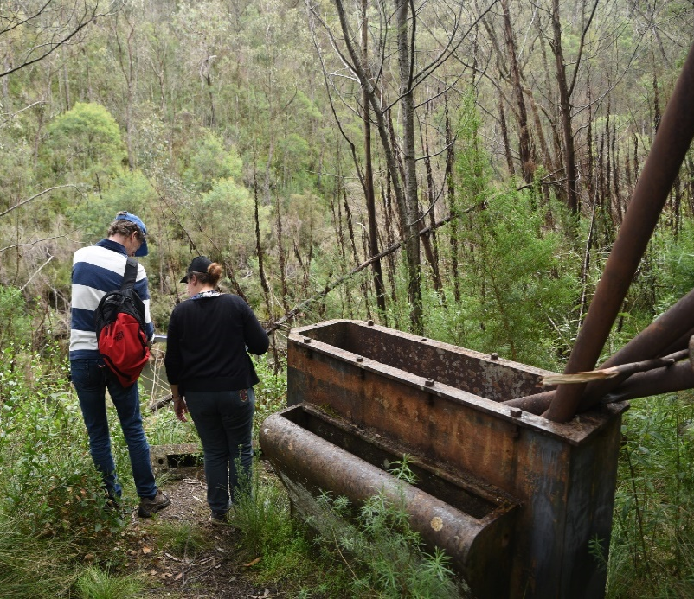
The site card, as prescribed in the Regulations, is a form that is used to record details about an archaeological site including its geographical location; spatial extent; current description of physical characteristics; condition; assessment of former use/s; background research; historical and archaeological significance. In most cases, the site card will become the main Inventory record for an archaeological site.
In cases where historical evidence indicates that a site may exist a field visit should also be undertaken to assess site condition and archaeological potential. If a site inspection is not practicable a site card can still be submitted for assessment on the basis of the known desktop evidence.
A site card must be submitted to Heritage Victoria (for assessment for inclusion in the Heritage Inventory) within 30 days of the site’s discovery (see section 127(1) of the Act). Penalties apply for the failure to submit a site card within the required timeframe.
In cases where consultants are reassessing existing Heritage Inventory site records, a new site card should be forwarded to Heritage Victoria for updating.

When is an archaeological survey report not required?
An archaeological survey report is not required when no historical archaeological sites are identified during the preparation of a CHMP or works under a CHP.
A survey report is also not required when only a desktop study is completed (without a field survey). However, if a desktop study is completed that may be of interest to other parties or researchers, it can be submitted to Heritage Victoria for addition to the state’s historical archaeology reports collection (email to: archaeology.admin@delwp.vic.gov.au).

Intersection with the Aboriginal Heritage Act 2006
Aboriginal cultural heritage in Victoria is protected and managed under the terms of the Aboriginal Heritage Act. However, if a historical archaeological site is discovered during any works or activities approved under the Aboriginal Heritage Act, a Heritage Inventory site card must be lodged with Heritage Victoria within 30 days of discovery. A survey report is also required (within 6 months of the discovery) to provide context to the discovery of the historical archaeological site or sites. If you are a consultant, this should be discussed with proponents.
It is necessary to obtain approval from Heritage Victoria to undertake any works that will affect any historical archaeological remains, regardless of whether the subject site is listed on the Inventory. This applies during works associated with CHMP testing, and activities authorised under a CHMP or CHP.
Visit the First People’s – State Relations website for further information on the Aboriginal Heritage Act and its requirements: www.firstpeoplesrelations.vic.gov.au.

Conducting a survey
This section identifies the key considerations and responsibilities involved in the conducting of a survey.

Prior to the commencement of a survey:
An appropriate survey methodology should be established to optimise the results of the survey. The methodology should:
- identify the survey area,
- explain the reason for the survey,
- note any constraints and limitations,
- detail the way the survey will be conducted, and how much survey coverage will be achieved,
- detail how sites will be recorded,
- identify the survey personnel,
- identify the relevant place history and character of the survey area.
The survey should not aim to duplicate previous studies but should enhance, expand, and contribute to the existing body of information that is available.
The following sources must be consulted prior to conducting a survey:
- statutory and non-statutory cultural heritage lists (including the Heritage Inventory, Victorian Heritage Register, and relevant Heritage Overlays); and
- online interactive mapping tools, including VicPlan; and
- previous reports and studies (including historical archaeological reports); and
- other relevant sources (heritage studies, historic plans and images, local or thematic histories), which may identify currently unrecorded sites that warrant assessment during the survey.

During a survey:
The methodology, as detailed above, should be addressed during the survey. Information about discovered sites, updates for existing Heritage Inventory sites, observations on condition, visibility across the surveyed area, and other details should be recorded. Assessments of current or future threats to sites located in the study area should also be documented.

At the completion of a survey:
A site card must be completed for each new identified archaeological site that may meet the Act’s definition and Heritage Inventory threshold policy, as detailed in Section 2. The site card must be submitted to Heritage Victoria for assessment within 30 days of the identification for determination.
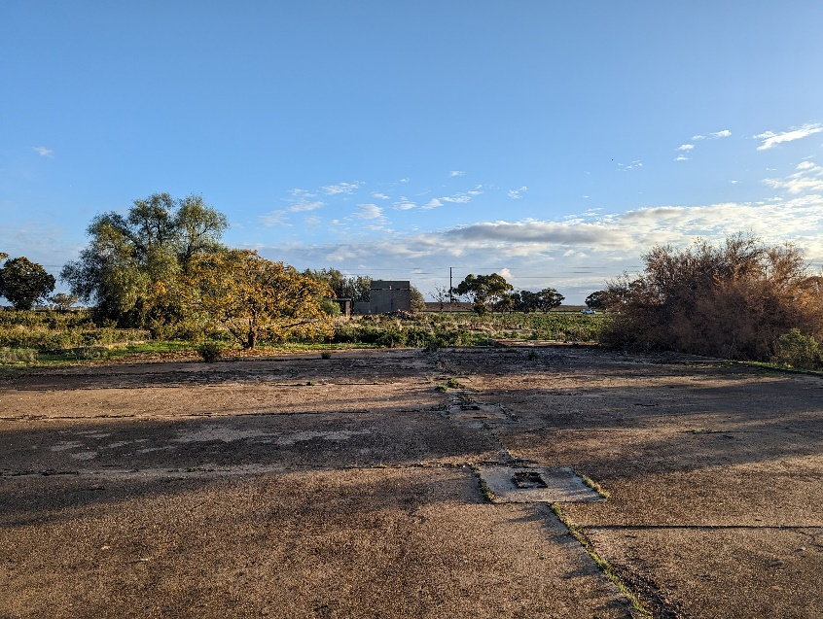
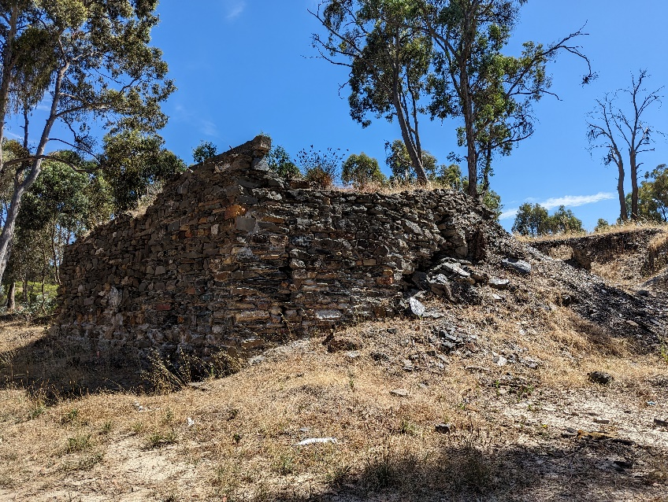
If the Executive Director, Heritage Victoria, determines that a site is to be included in the Heritage Inventory, a site number will be allocated. The Inventory number must be included in the survey report.
Lake Boga Hangars
New Moon Quartz Mine

2. Historical Archaeological Sites
A key part of any survey is the identification and recording of sites. This section will help with the assessment and recording of sites located during a survey. This section will assist archaeologists to determine whether an identified place is likely to address the Act’s definition of an archaeological site, or whether it may be a different type of heritage place that is not eligible for inclusion in the Inventory.
The Act defines an archaeological site as:
a place (other than a shipwreck) which —
- contains an artefact, deposit or feature which is 75 or more years old; and
- provides information of past activity in the State; and
- requires archaeological methods to reveal information about the settlement, development or use of the place; and
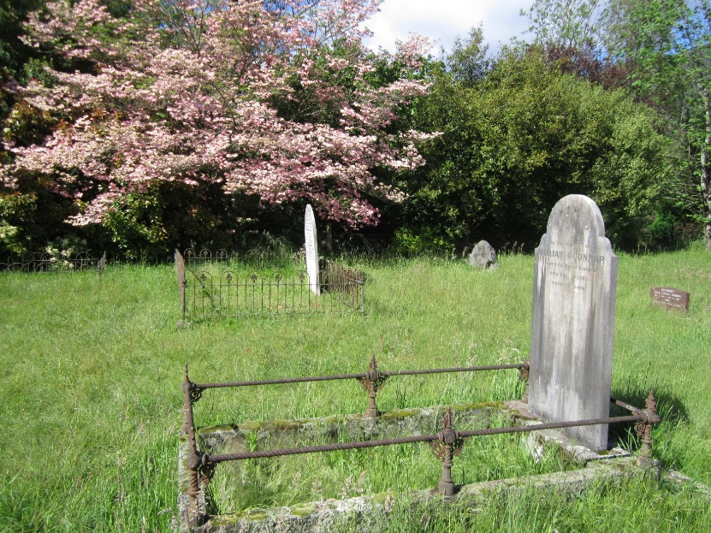
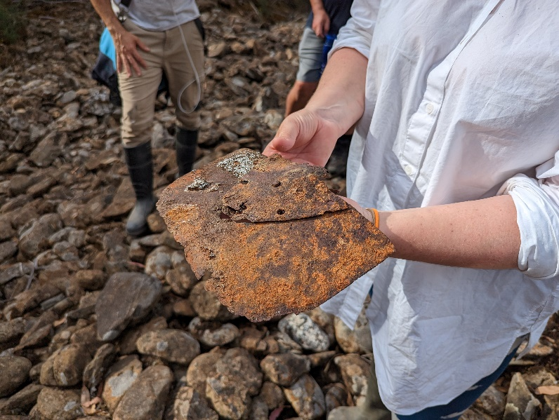
- is not associated only with Aboriginal occupation of the place.
Buckland Cemetery

How is inclusion of a site in the Heritage Inventory determined?
Section 118 of the Act specifies that the Inventory must not include sites that have been determined by the Executive Director to have low archaeological value. A guidance document, the Policy for Determining Low Archaeological Value was developed to assist with the assessment of a site’s significance and archaeological value. For a site to be included in the Inventory, it must address the following threshold:
Threshold A (archaeology):
- the place meets the definition of archaeological site under the Act; and
- it can be demonstrated that the site contains archaeological features, associated artefacts and/or deposits; and/or
- documentary evidence and/or oral history, landscape features, visible site fabric or other information indicates a likelihood that the site contains archaeological remains; and
- the archaeological remains are, or are likely to be, in a condition that will allow information to be obtained that will contribute to an understanding of the site;
and
Threshold B (place history):
- the site evidences (or is likely to evidence) an association with a historical event, phase, period, process, function, tradition, movement, custom or way of life; and
- the site history is of significance within a state, regional, local, thematic or other relevant framework.
A copy of the policy can be found on the Heritage Victoria website. It should be noted that the Inventory can also include archaeological sites that are less than 75 years old, subject to the approval of the Executive Director, Heritage Victoria, and the Heritage Council (section 130 of the Act).

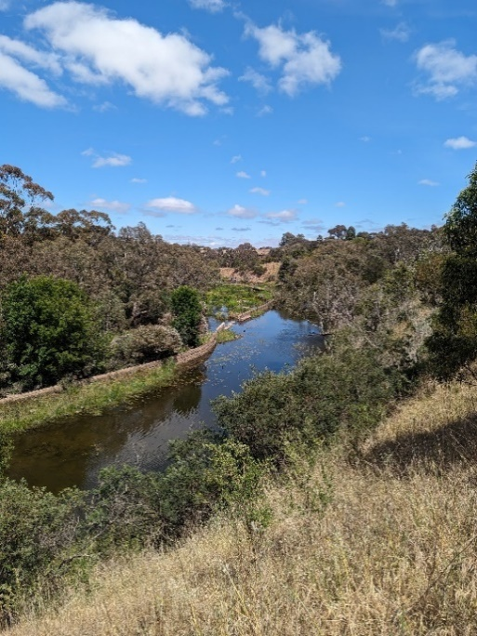
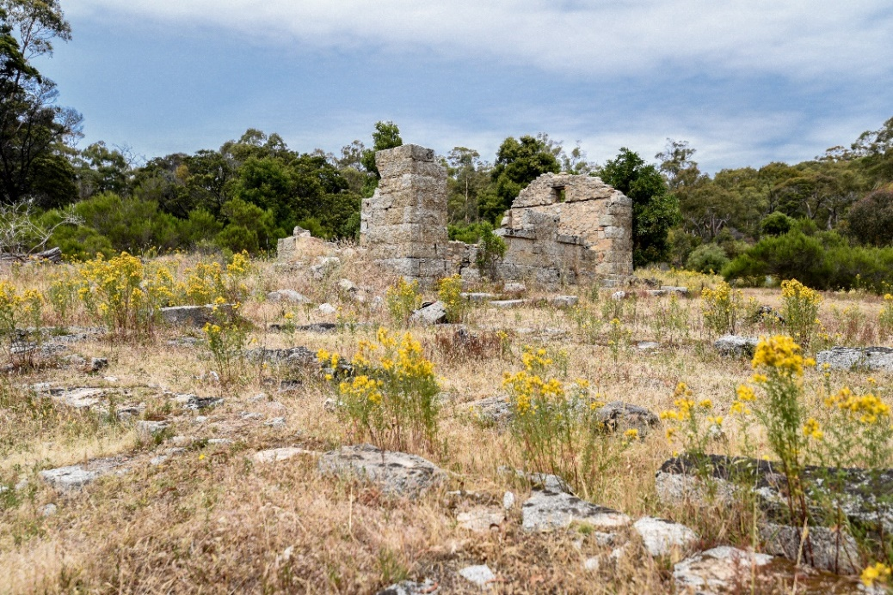
What places do not warrant inclusion on the Heritage Inventory?
Barwon Paper Mill
Mt Alexander Silk Farm
Part 1 of the Act provides a clear definition of a historical archaeological site. The threshold policy (above) also provides guidance about the factors that must be addressed to qualify a site for inclusion in the Heritage Inventory.
As a general guideline, the following features or places are unlikely to address the Act’s definition of an archaeological site and meet the threshold policy, and so are unlikely to warrant inclusion on the Heritage Inventory:
- Drystone walls
- Intact and/or functional infrastructure, even when totally or partly buried (e.g., pipelines, culverts, channels)
- Standing structures (such as houses and other buildings) unless they are likely to contain notable occupation or sub-floor deposits
- Machinery, plant and farm equipment
- Vegetation, gardens and plantings (although these can sometimes be indicators of habitation or occupation sites)
- Railway or road cuttings
- Look-outs and forestry towers
- Intact bridges, weirs, and fords
- Survey markers, historic signs and milestones
- Posts, fence lines and gates
- Dams
- Historically modified trees
In some cases, the above features may be associated with other archaeological features and sites, in which case reference to these elements may be included as part of the broader site record and Heritage Inventory site card. However, it may be possible that such places can be protected in other ways, such as Local Government Heritage Overlays.
Site types, like quarries, can be problematic. If the site is likely to consist only of a former outcrop of stone that has been worked and extracted, it would not be considered likely to contain any archaeological deposits and would not be eligible for listing. However, if it contained other features, like the remains of the quarry master’s house or relic machinery and artefacts buried beneath stone scatters across the site, a strong case for listing could be made.
Another site type that presents challenges are long, linear places like mining water races, other water supply systems and historic tramways. In many cases these sites do have the potential to contain archaeological features and deposits that provide information about their construction, use and abandonment, and they may be eligible for inclusion in the Inventory. Consideration should be given to a ‘sampling’ or ‘representative’ approach to the listing of these site types (which in some cases may be very extensive) which would see the best preserved, most representative and/or most significant elements of the system recommended for addition to the Heritage Inventory.
Heritage Inventory site cards for places that are very unlikely to address the Act’s definition and Thresholds A and B should not be submitted. However, if consultants are unsure whether a site may be suitable for inclusion in the Heritage Inventory, the card should be submitted to Heritage Victoria for assessment.
Barwon Paper Mill
- Completing a site card
This section provides guidance on how to complete key sections of a Heritage Inventory site card. Incomplete site cards will not be assessed by the Executive Director until all required information is received.

Owner details
Heritage Victoria requires the owners’ details (including email address) to inform them of the addition of their place on the Heritage Inventory.

Current description of site
This provides a clear description of current site conditions and any visible archaeological fabric. The date of the survey should be noted in this section, as well as any factors that may limit the ability to accurately describe the site.

Place history
This section should contain a brief history of the site, including its phases of historic occupation, construction, abandonment, demolition, and land use. Any significant events, people and historic associations with the site should be detailed.

Analysis of site (interpretation)
This should synthesise all relevant site information including place history, current site condition, archaeological potential, the results of comparative analysis and significance assessments, and other relevant information to provide an interpretation or summary of the place.
Questions to consider as part of the interpretation of the site include:
- What sort of place was it?
- What activities have taken place here?
- How do the archaeological features observed, or potentially present, reflect the phases of site use and abandonment?
- How does the site relate to other places and landscape features in the vicinity?
- Do field observations conform with understandings and expectations of land use and history?
This section should also provide an evaluation of the site’s potential to contain archaeological features and/or deposits.

Statement of significance

The statement of significance must clearly address the thresholds identified in the Policy for Determining Low Archaeological Value. The site significance must be evaluated and described within a state, regional, local, thematic or other relevant framework.

The Victoria’s Framework of Historical Themes (Heritage Council of Victoria, 2010) document and the Victorian Heritage Register Criteria and Threshold Guidelines (Heritage Council of Victoria, April 2019) are likely to be useful. Other research such as typological, regional or thematic studies and local council heritage studies can also be consulted. Site assessments should also be informed by archaeological investigations that have been conducted on comparable sites, by archaeology consultants or other specialists.

Be aware that a place may be of significance beyond the criteria that are normally applied for archaeological sites, Victorian Heritage Register Criterion A (importance to Victoria’s history) and Criterion C (potential to yield information). There may be other reasons for a place to be of significance and it should be assessed against all eight of the criteria that have been established by the Heritage Council. The Heritage Council has recently published the report Assessing and managing social value (Heritage Council of Victoria, 2018) which assists with the assessment of a place’s social value (Criterion G).

Some consultants and researchers find that the preparation of a Statement of Significance can be assisted by breaking it down into component parts and addressing three key questions about the place. The questions are:

What is significant?
This is a description of the place.
For example:
The Magpie Lead Diggings site consists of a large number of shallow workings that resulted from the search for nuggety gold in the mid-late 19th century. It also includes historical archaeological artefact scatters and the remains of at least two hotel or house sites.

How is it significant?
This should address the level of the place’s significance (for example, state or local significance), and refer to applicable heritage criteria.
For example:
The Magpie Lead Diggings site is of historical significance (Criterion A); it has the potential to provide new information (Criterion C); and it is a good example of a type of deep lead mining site (Criterion D), all at the local level.

Why is it significant?
This should provide more detail on how the place addresses the criteria identified above. In some cases, this section may explain why other criteria have not been addressed.
For example:
The Magpie Creek Diggings site is significant at the local level, for the following reasons:
It is one of the largest and most intact examples of a mid-late 19th century goldfield in the Creswick area. It retains large numbers of mining shafts that were excavated by the diggers as the investigated the buried leads that run through the area. The goldfield was one of the most popular and productive fields that attracted miners to the region from the gold rush years onwards (Criterion A).
The Magpie Creek Diggings site contains a relic landscape of excavated miners’ holes which are, of themselves, significant landscape features. The site has the potential to contain archaeological remains relating to back-filled holes, and other features and artefacts associated with the activities of the miners. The site also includes the ruins of at least two structures which may be the remains of a hotel, store or cottage. Artefact scatters, including fragments of glass, ceramic and iron are visible across the site (Criterion C).
The Magpie Creek Diggings are significant as a characteristic and well-preserved example of a place associated with deep sinking in the Creswick area. The site displays the density and proximity of mining shafts that quickly filled these areas when gold was discovered. The site is typical and demonstrative of a small claim’s gold field, where limited size claims allowed large numbers of miners to search for gold in crowded conditions (Criterion D).

Supporting Documentation
Supporting documentation must include:
- Maps showing the location of sites clearly identifying the extent proposed for listing on the Heritage Inventory
- The final site extent is also to be submitted in spatial data form. All spatial data collected must be recorded in Heritage Victoria’s preferred coordinate system format (GDA20, GDA94 or WGS84). When submitted spatial data is to be provided in the preferred format (sph, .gpx, .kml)
- Plan showing all archaeological features and key built and landscape elements with labels and scale
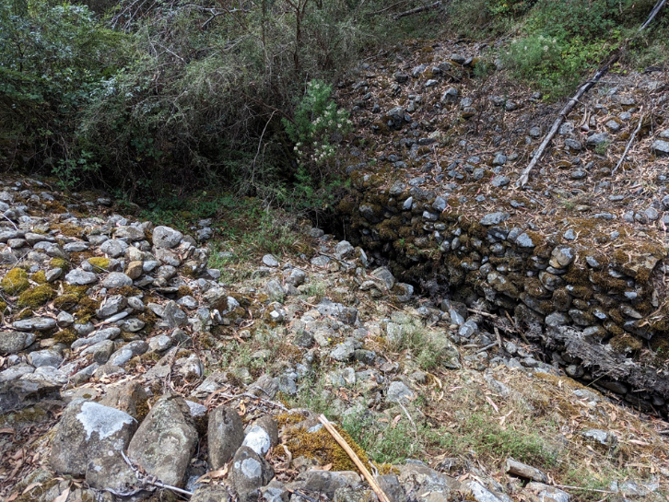
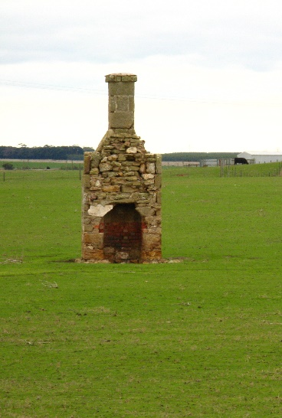
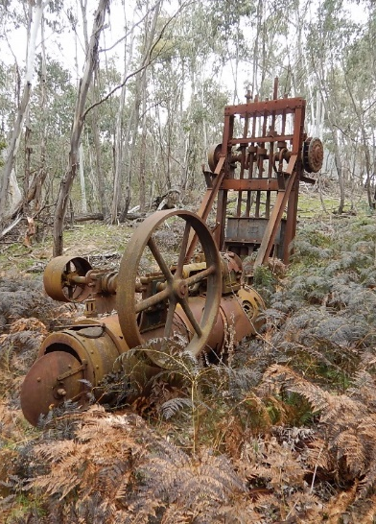
- Images of the site including photographs, historical images, plans and maps.
Ma Looks Flats

Completing a survey report

What to include in a survey report?
This section identifies the key details that must be included in a survey report in accordance with Schedule 9a and s127(7). Site cards must be submitted to Heritage Victoria prior to the completion of the survey report to allow site numbers to be included.

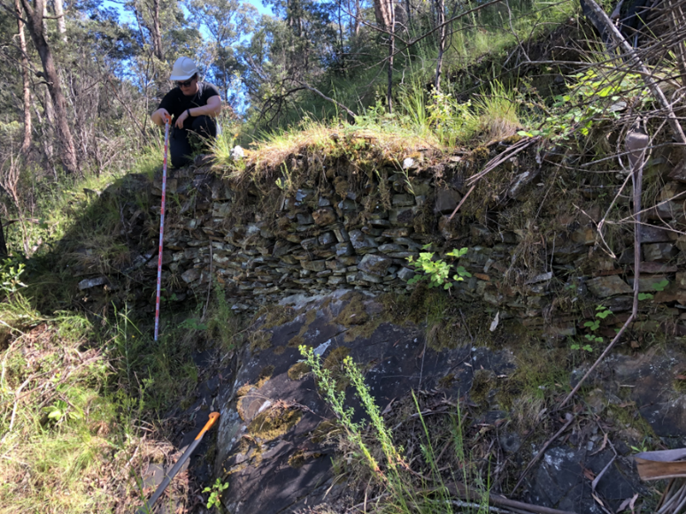
Project information
General information which outlines:
- date of survey;
- reason for survey;
- location of survey; and
- key stakeholders.

Desktop assessment
Background project information including:
- historical research;
- environmental history;
- reference to prior studies; and
- summary of places with current heritage listings within the study area.
Alta and Nelson Reef

Maps
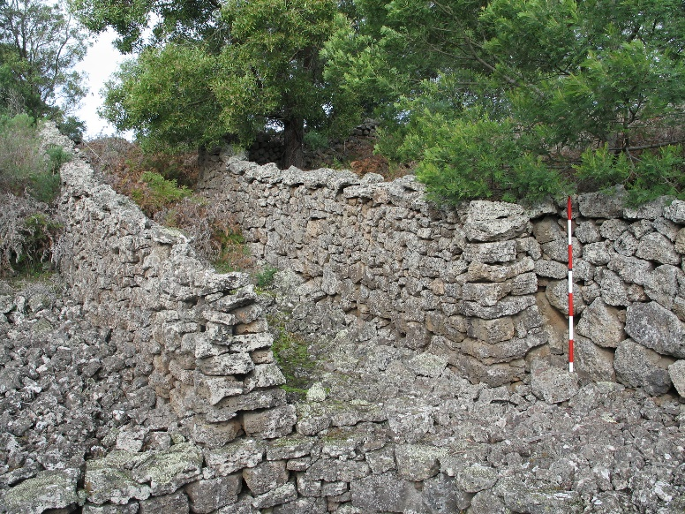
- location of the survey area;
Bessiebelle
- location and extent of known or discovered sites; and
- existing heritage listings within or in direct proximity to the survey area.

Survey methodology
The methodology including the:
- survey rationale;
- survey method; and
- limitations of the methodology.

Survey results
Findings of the survey including:
- details of current site description
- details of sites identified during the survey
- copies of site cards
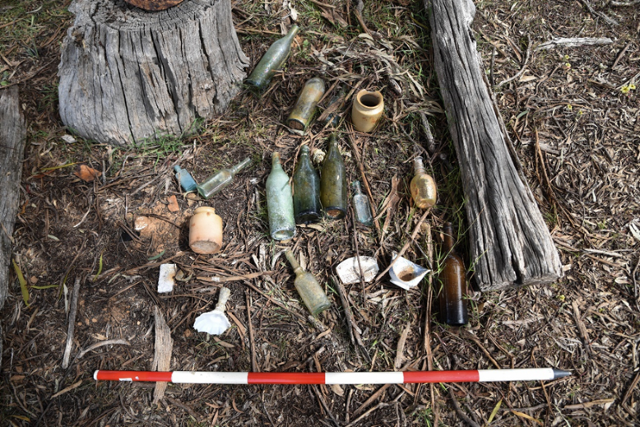
- allocated Heritage Inventory numbers
- photographs – with a photographic scale
- current and/or future threats to the physical fabric of site(s); and
- other relevant details and information.
Limitations:
- which may include access restrictions, poor visibility, etc.

Recommendations:
- additional investigations;
- project outcomes and options;
- urgent site management or protection requirements.

Bibliography
- list key sources used in the survey. This could include books, publications, websites, the names of experts or any other resources
- do not include personal details of informants

Submission of the survey report
A survey report in accordance with these guidelines must be lodged with Heritage Victoria using the Heritage DESK portal within 6 months of the completion of the survey assessment. Failure to do so may result in penalties.
Heritage Victoria will not accept CHMPs or any reports that solely relate to Aboriginal cultural heritage as these are managed under the Aboriginal Heritage Act 2006.
Questions
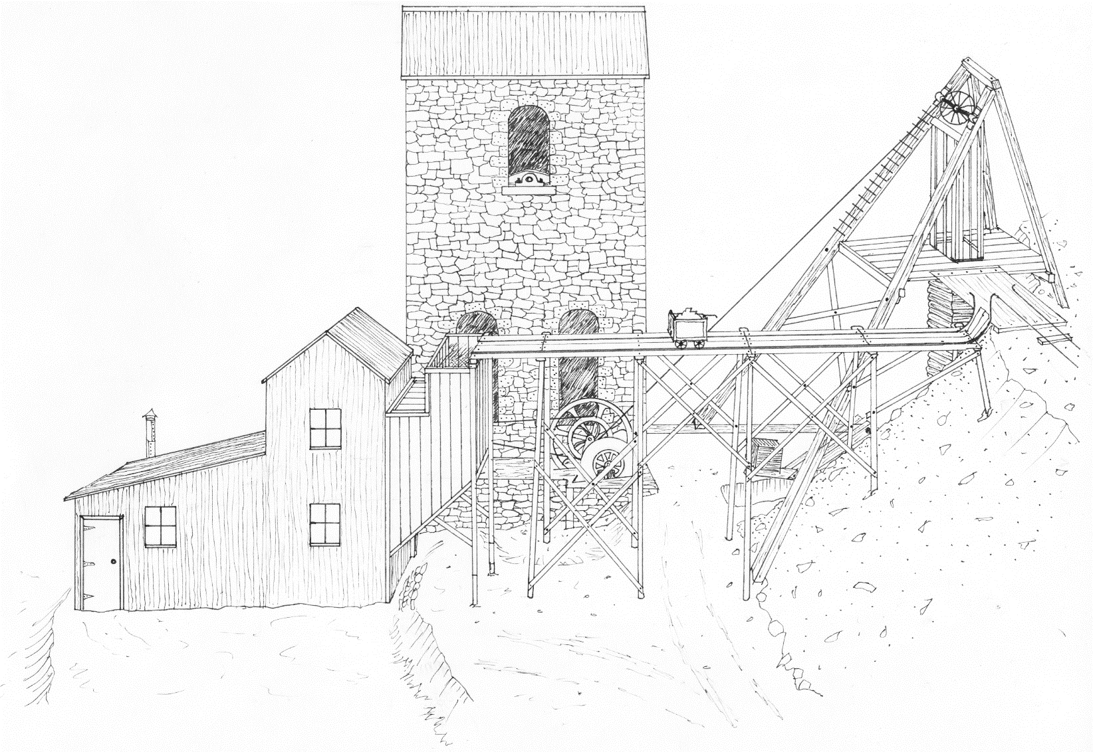
Any questions about this document can be addressed directly to the archaeology team at archaeology.admin@delwp.vic.gov.au.
Reconstruction sketch of a gold mining site, by Rob Kaufman

