Finding the right conservator,
tradespeople and materials

If you are seeking to undertake conservation work on a heritage object or place, it is important that you get help and advice from qualified and reputable conservators and tradespeople. War memorials, honour rolls and objects can be easily damaged or weakened by incorrect conservation ‘treatments’. Objects and places contain important information that can be easily lost by the incorrect treatment.

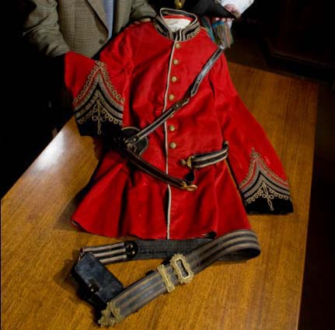What is a conservator?
Conservators are highly skilled professionals who have been trained to preserve cultural heritage for future generations. Most conservators specialise in certain types of collection items, such as paper, paintings, objects or textiles as well as outdoor objects such as sculpture and murals. Conservators may work in museums and art galleries as well as in private practice. If you wish to preserve a heritage object such as an honour roll, photo or uniform, consult a conservator. The Australian institute for the Conservation of Cultural Material has an online directory of conservators for use by the public. See www.aiccm.org.au
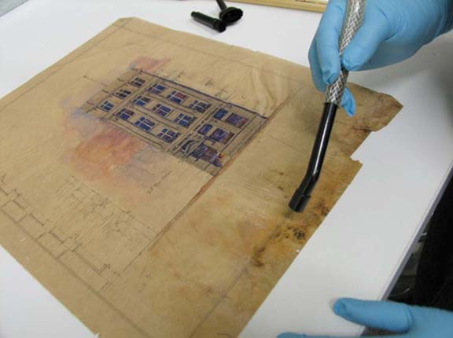
A professional conservator removes mould from a water-damaged drawing.
Photo courtesy State Library of Victoria

Where can I find a conservator?
The Australian Institute for the Conservation of Cultural Materials has a directory of practicing conservators in Australia. See: www.aiccm.org.au

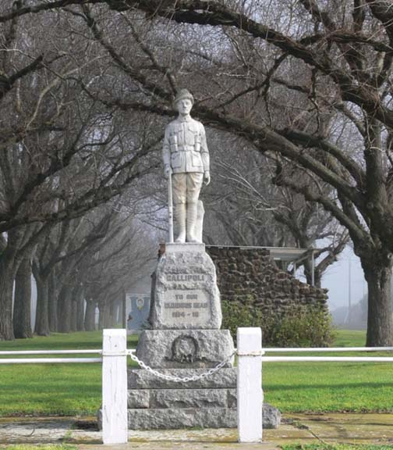What is a conservation architect (for war memorials and buildings)?
Conservation architects are qualified architects who specialise in the physical conservation of heritage buildings including preparation of conservation management plans, diagnosis of building failure, specification and supervision of repair. Typically such a consultant would be knowledgeable about historic and contemporary building construction techniques and materials and possess a good grasp of both architectural and social history. If you are considering how to preserve or repair a war memorial, consult a conservation architect. Heritage Victoria’s ‘Consultants and Contractors Directory’ can assist you to find a suitable conservation architect. See www.heritage.vic.gov.au

What is a heritage consultant?
These include engineers, landscape architects, historians and archaeologists who specialise in heritage places, gardens, monuments and collections. Heritage Victoria’s ‘Consultants and Contractors Directory’ can assist you to find a suitable heritage consultant.
See www.heritage.vic.gov.au

What is a tradesperson?
Tradespeople are skilled manual workers who specialise in particular trades such as stonemasonry, carpentry and building. Some tradespeople are skilled in traditional trades while others are only familiar with modern techniques. The expertise of tradespeople can vary widely. Some are highly skilled while others have a lower level of skill, particularly in relation to dealing with heritage objects, places and materials. It can be difficult to determine the level of skill that tradespeople have. Heritage Victoria’s ‘Consultants and Contractors Directory’ can assist you to find a suitable tradesperson. See www.heritage.vic.gov.au

Poor quality conservation work is uneconomical and can be damaging.
Never entrust repairs to unskilled or inexperienced tradespeople.
Experienced, specialist conservation architects or builders should work on war memorials.
Conservators should work on honour rolls and moveable objects.
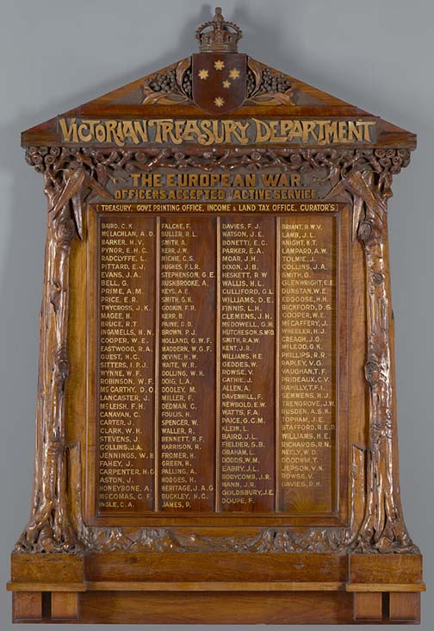

Who should restore honour rolls?
Any repair or restoration to honour rolls should be restored by a trained conservator. It is not appropriate for signwriters to repair or restore honour rolls as they are not trained in the preservation of the original varnish and lettering and prefer to strip and re-colour rolls.
Inappropriate ‘restoration’ work can permanently damage honour rolls and inscriptions. Honour rolls treated by a conservator will be attractive and presentable and the history will have been saved. The Australian institute for the Conservation of Cultural Material has an online directory of conservators for use by the public. See www.aiccm.org.au

Victorian Treasury Department honour board 1916
Photo courtesy National Gallery of Victoria

Where can I find a conservation architect, builder or heritage consultant or contractor?
Heritage Victoria’s website includes a ‘Consultants and contractors directory’. It has a searchable online database where you can find a suitable tradesperson or conservator to assist you. Listings include stonemasons, materials conservators, horticulturalists and other skilled tradespeople. See: www.heritage.vic.gov.au

Where can I buy acid-free boxes and other museum quality products?
Museums Australia (Victoria) has compiled a Museum Suppliers list. This contains the contact details of speciality suppliers which sell materials for the proper storage and display of heritage items. See: www.mavic.asn.au.
The Powerhouse Museum, National Archives of Australia and the Australian War Memorial’s also list suppliers in the conservation sections of their websites.

Who can I call for advice?
Heritage Victoria has architects and conservators who can provide advice on care of buildings and objects to owners and managers of places and objects which are on the Victorian Heritage Register. They can be contacted on (03) 9208 3333.
Most Local Councils in Victoria employ full or part-time heritage advisors who can provide advice to owners and managers on care of historic buildings and monuments (but not objects). You can ring your local council and ask for the Heritage Advisor. The list of advisors can be found on Heritage Victoria’s website: www.dpcd.vic.gov.au/heritage/local-government/heritageadvisors-contact-list
The Australian War Memorial (AWM) has conservators who can provide advice to members of the public about war-related heritage. They can be contacted on (02) 6243 4418.
Conservators at the State Library of Victoria (SLV) can provide advice about preserving books, newspapers, photographs, works on paper and documents. Call (03) 8664 7359 (Melbourne) or 1800 999 735 (outside Melbourne).
The Centre for Cultural Materials Conservation (CCMC) at the University of Melbourne provides conservation services and advice, including preventive care of collections, conservation treatments and conservation management plans. They can provide advice about looking after fragile objects and documents, and can undertake work on damaged or at risk material – phone (03) 8344 7989.

Where can I get this and other fact sheets? The DPC Preserving war heritage and memorabilia fact sheets provide information about the care and conservation of a range of heritage material. They can be downloaded at www.dpc.vic.gov.au/veterans/factsheets
Disclaimer The material contained in this guide is for general reference only and should not be relied upon as the sole basis for heritage conservation or restoration. A professional conservator or conservation architect should be consulted before any conservation or restoration is undertaken. The Victorian State Government does not warrant the accuracy or completeness of the information and disclaims all liability for any loss or damage that may be caused by reliance upon it. Provision of names of suppliers or websites does not imply that a supplier is endorsed or approved by Heritage Victoria or the Department of Premier and Cabinet.

