Supporting Photos Proposed Lockable and clad container

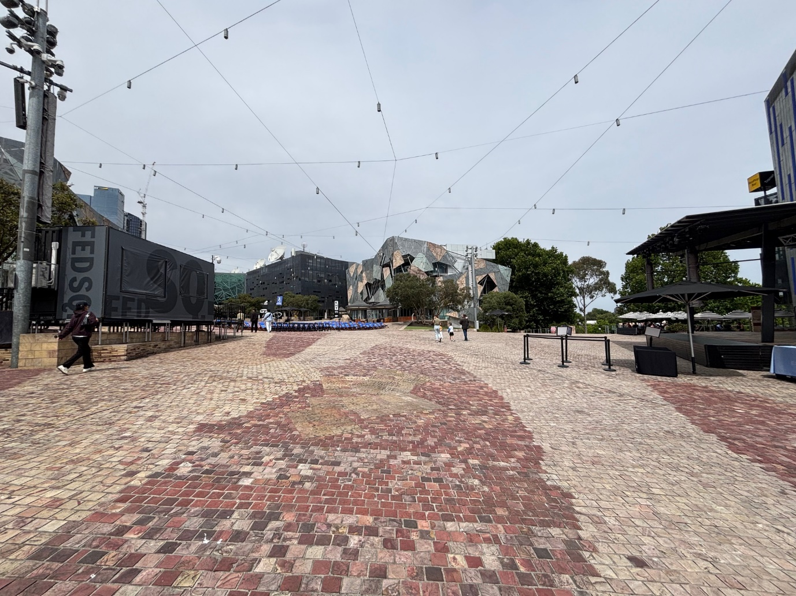

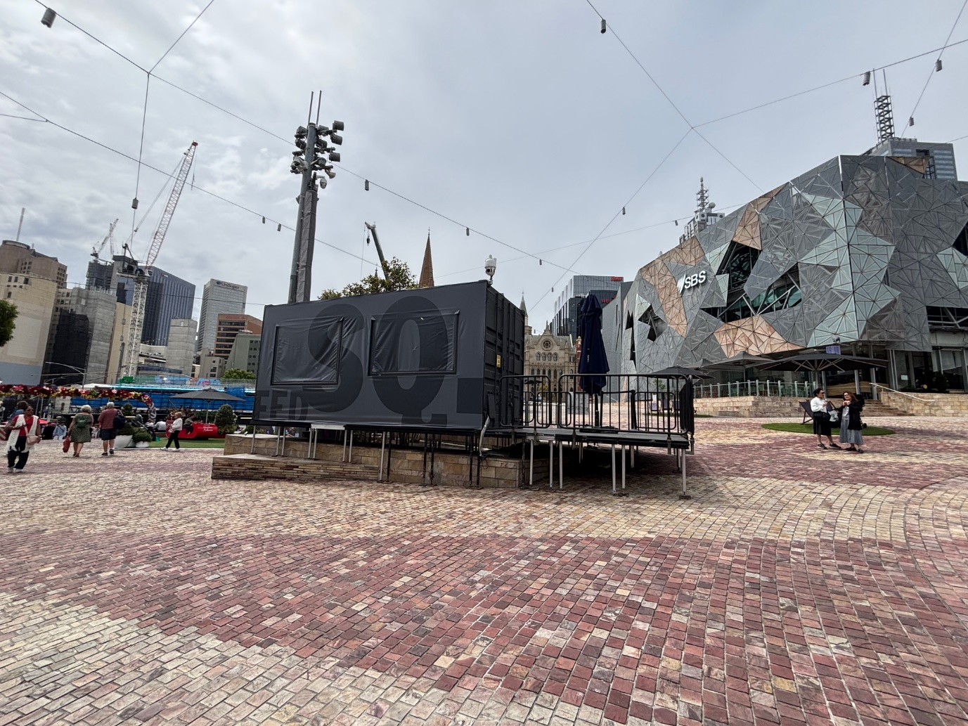

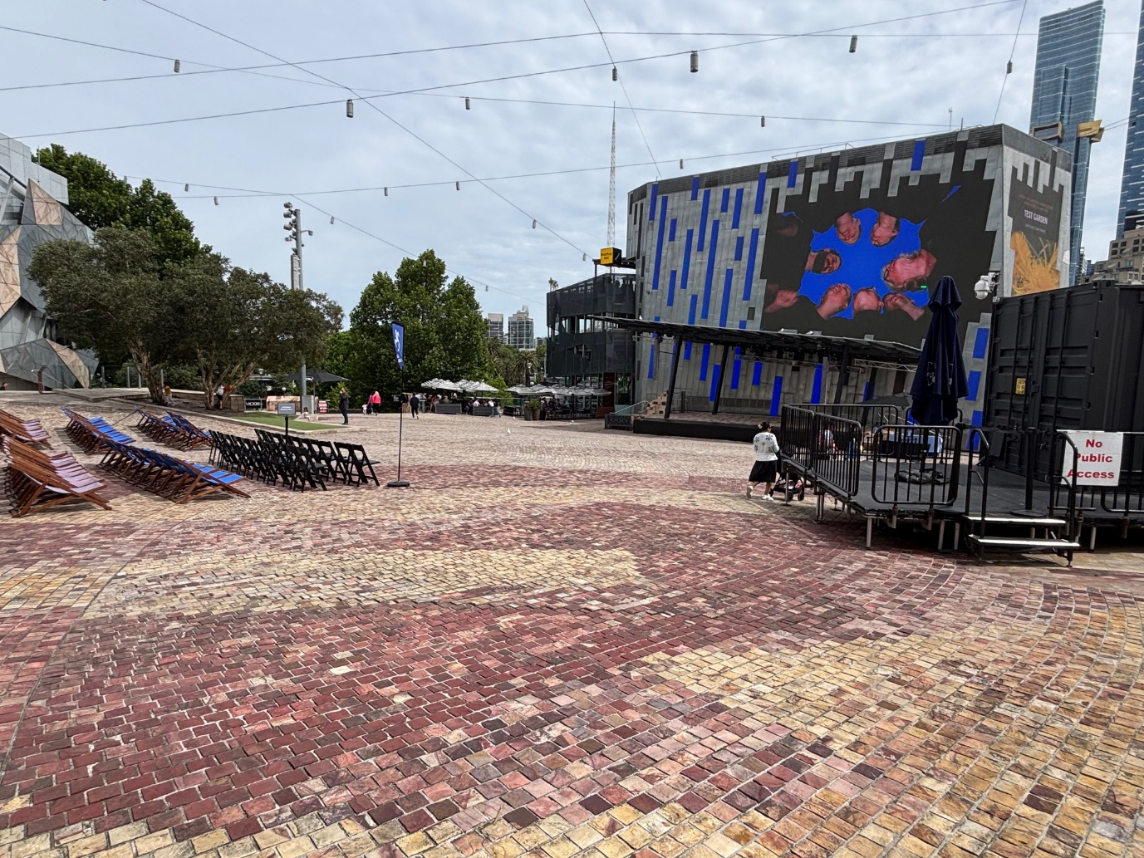

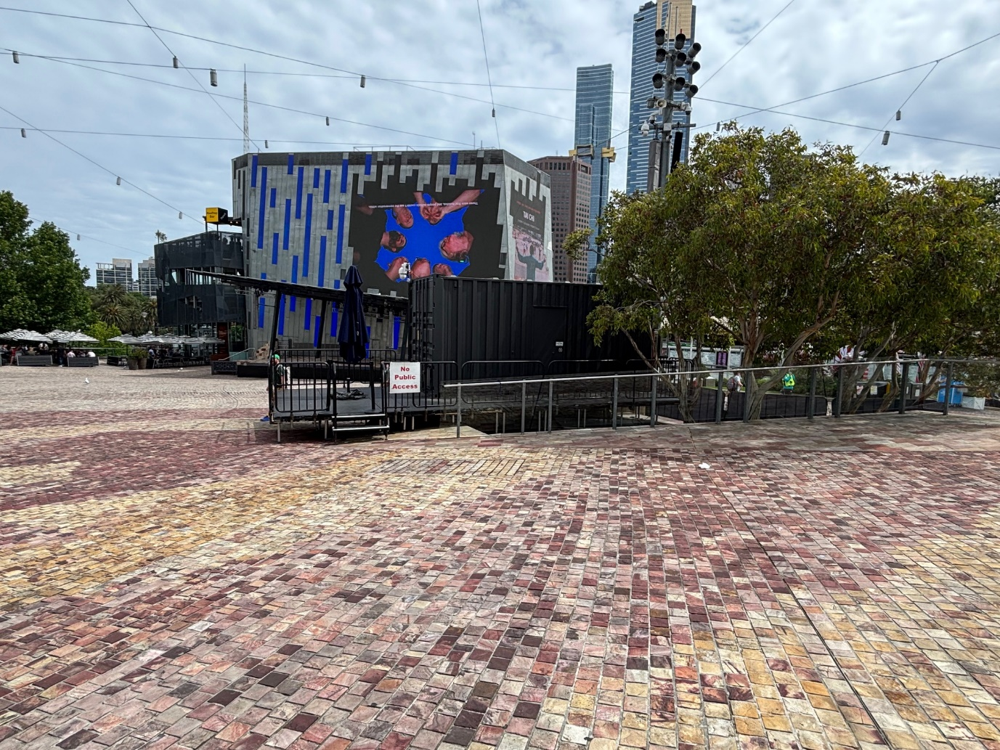

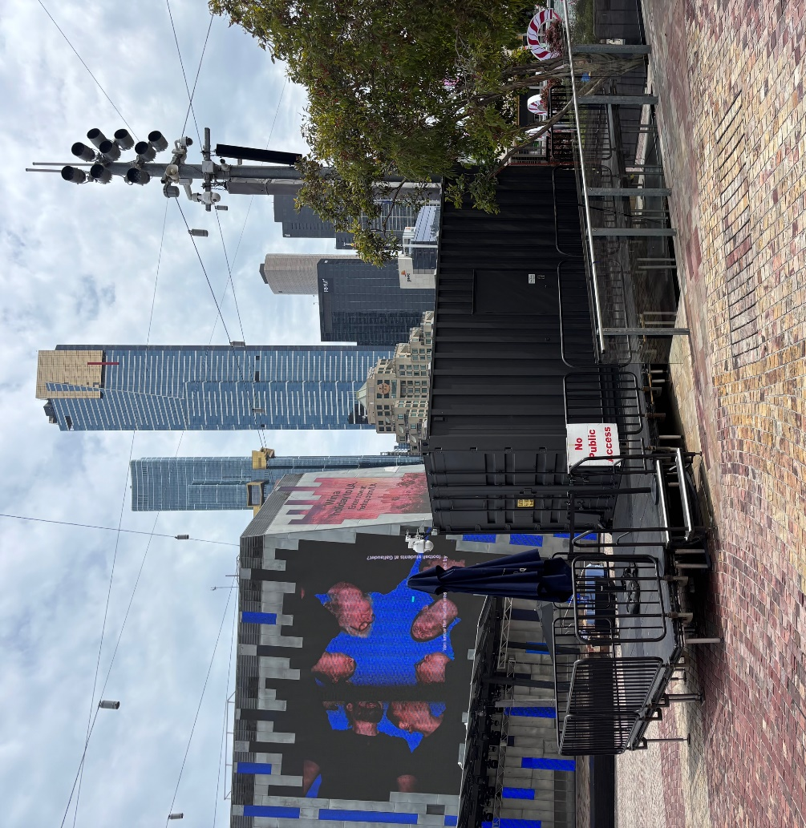

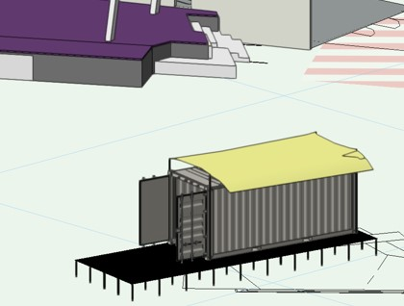

Proposed additional heat reflective light-coloured shade cloth sail mounted on top of the container to mitigate heat and improve OHS conditions for crew.

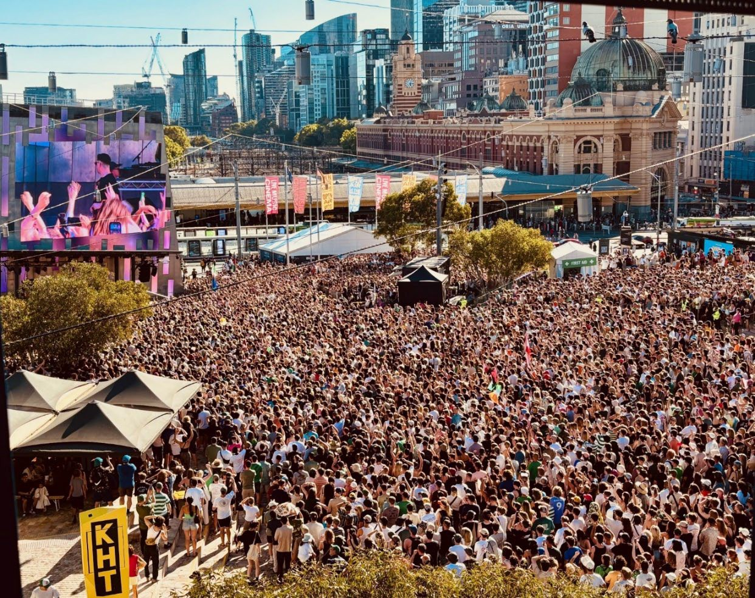
Proposed Location to the Nth edge of square, within the garden bed, improving sightlines

Replacing the White Marquee location in central position that blocks sightlines
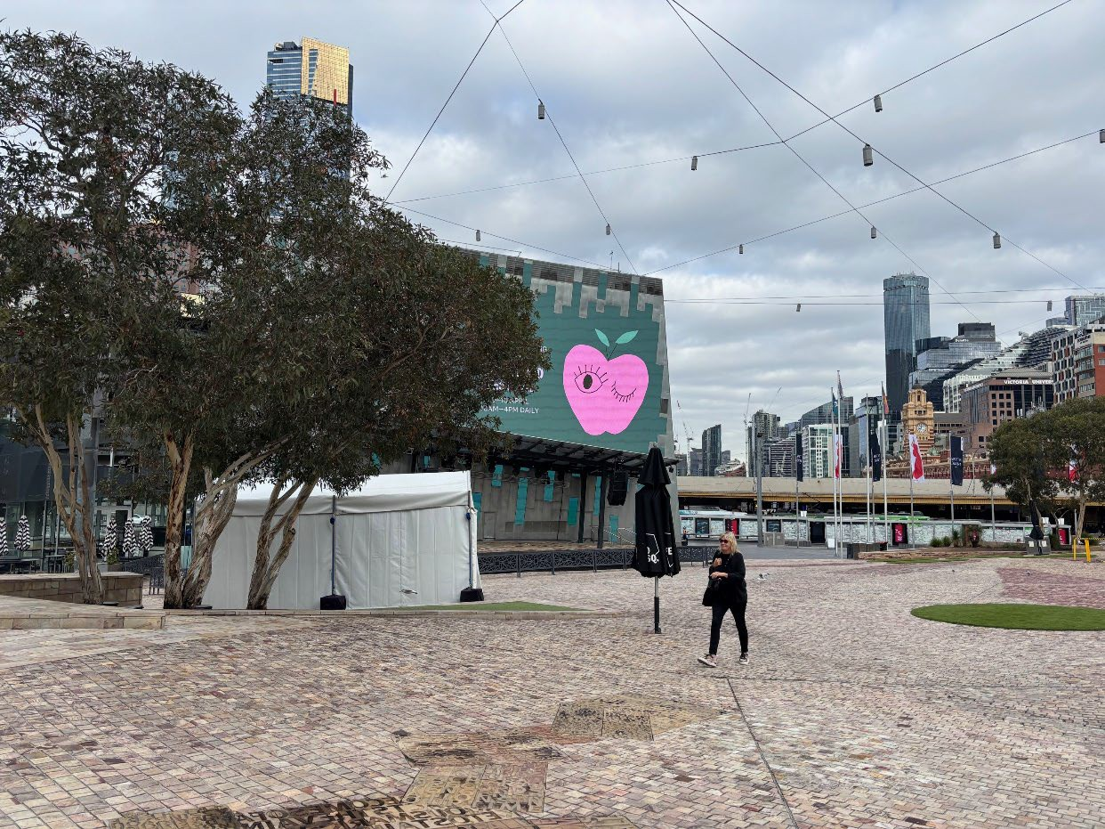

Replacing white marquee
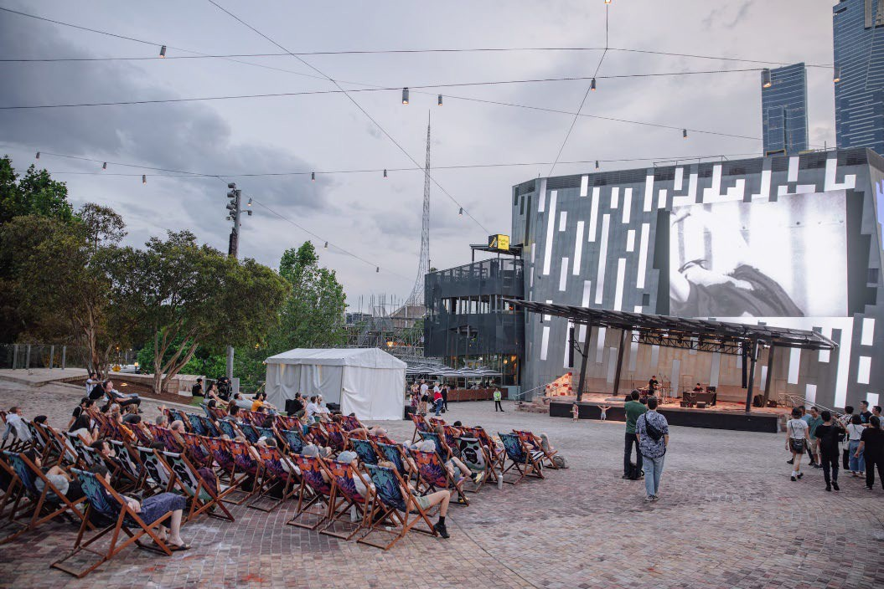
Aerial view showing proposed location of container (green) to white marquee (red)
