

# Uniforms, costume and textiles

## What are textiles?

‘Textiles’ may be defined as cloth or fabric made from natural or synthetic fibres manufactured through a process such as weaving, felting or knitting.

## What is costume?

‘Costume’ is a style of dress, including garments and accessories, which is especially characteristic of a particular country, period, or people, such as defence forces and medical corps. It should be noted that garments often have multiple elements (buttons, zips, leather trimming) that require different treatment techniques.

## Examples

Flags, uniforms and accessories, hats, handkerchiefs, upholstery, quilts (such as those made in POW camps) and parachutes.

## What are textiles made from?

* cotton (the most common textile fabric in war heritage collections)
* wool (commonly used for uniforms and flags)
* fur (often felted to make hats or badges)
* synthetics such as rayon, acetate or polyester
* silk (parachutes and embroidery)
* rubberised fabrics
* buttons and fastenings may be made from bone or metals (see separate flyer on Metals).

## What are the main threats to costume and textiles?

Costume and textiles are among the most fragile heritage objects. They can be damaged by human action as well as environmental causes. Correct cleaning, display and storage can assist in protecting them from the main threats which include:

light

humidity

insects

dirt and pollution

poor handling and accidents

unsuitable cleaning, repair and display techniques.

This patriotic crochet cloth from 1918-19 should be stored flat or rolled with acid-free tissue paper. Do not use pins or nails to display textiles as they can damage the fabric.

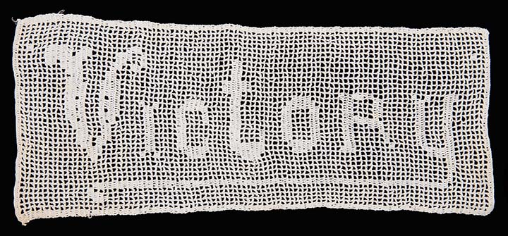

*Photo courtesy Australian War Memorial*

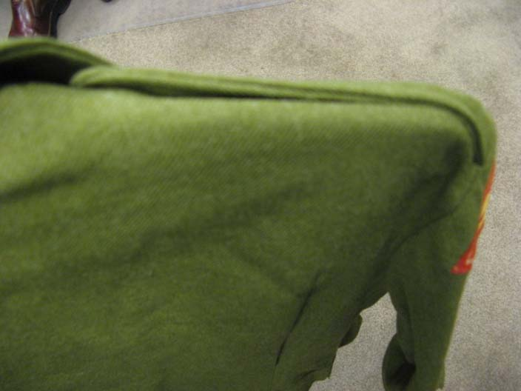

**The dangers of wire coat hangers**

Wire hangers should not be used because they concentrate the weight and stress on a very small area, causing distortion and tears. The shoulders of this uniform have been permanently stretched out of shape. It is preferable to use padded coat hangers or store uniforms flat in a box.

## How do these threats damage textiles?

* Light fades the colour of textiles and weakens the threads.
* Sudden changes in humidity contribute to the weakening of textiles.
* Dampness encourages insects and mould.
* Insects eat textiles made from natural fibres.
* Dirt on textiles can encourage insects.
* Incorrect handling can result in perspiration and dirt weakening the fabric (always wear white gloves), and/or stress being placed on weak points.

## REMEMBER

* Never give up – something that looks ‘hopeless’ can often be recovered.
* All textiles will age – it is the speed at which this happens that you can influence.
* It is not a disgrace for a textile to look its age and reflect its history.
* Be aware that some of the apparent ‘dirt’ on textiles is often harmless or an important part of its history.
* Never wear a historic costume or textile – weak fabrics can tear, and perspiration and modern cosmetics will hasten their deterioration.
* Always handle costume and textiles carefully with white gloves. Perspiration and dirt can weaken the fabric and incorrect handling can place stress on weak points.

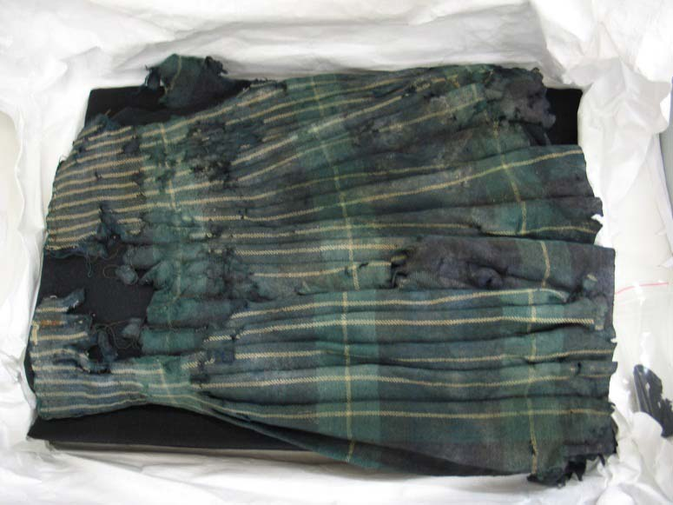

**A Kilt from the Western Front**

This kilt was recovered from a battlefield near Pozières, and clearly shows the damage it sustained. Its significance lies in preserving the appearance ‘as is’. To achieve this, and to prevent any further deterioration, the kilt was frozen as part of a pest management strategy to remove any live insects or eggs that may have been present. The kilt was then carefully prepared for storage in a specially constructed box and mount that provides full support for this fragile item.

The kilt can now be stored, or displayed safely. Gordon Highlander Kilt, First World War

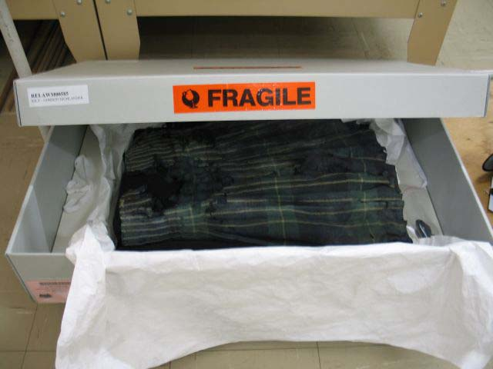

*Photos courtesy of Australian War Memorial (Conservation Unit)*

## Costume and textiles general principles

**DO**

* Store in an indoor room, away from external walls or windows and heaters.
* Store in the dark.
* Store flat where possible
* Make appropriate supports for garments or larger textiles.
* Use vacuuming techniques to clean textiles.
* Monitor textiles regularly for insect activity.
* Use freezing to kill insects in textiles not mothballs.
* Keep textiles away from cigarette smoke, perfume, perspiration and cosmetics (especially hand cream). Wash hands before handling textiles.
* Remove your jewellery and watches during handling as they may snag the threads of a textile. Wear an apron to prevent textiles catching on buttons.
* Wear gloves when handling textiles.
* Buy acid-free boxes for storage of fragile textiles.
* Use pencils not pens or felt tip pens near textiles.
* Carry textiles with both hands and don’t allow the textile to support its own weight unless you are sure it is strong. Use a piece of stiff paper or board under a fragile textile.

**DON’T**

* Wash or dry clean costumes or textiles.
* Wear costumes or uniforms as they may be weaker than they seem and are likely to be damaged.
* Display under light for a prolonged period.
* Put on permanent display, as they may become damaged by light exposure.
* Consume food and drink in areas where there are costume and textiles, as crumbs attract insects.
* Hang costumes on wire hangers. They can rust and mark the textile, and may not provide adequate support for the weight of the garment, causing dragging on the shoulders.
* Put uniforms on dummies that are too large for them, as the stretching will eventually cause splits.
* Hang any textiles without proper support.
* EVER staple, tape or nail textiles directly to a wall or showcase.

**Never wear a historic costume or textile.**

**Weak fabrics can tear and perspiration and modern cosmetics will hasten their deterioration.**

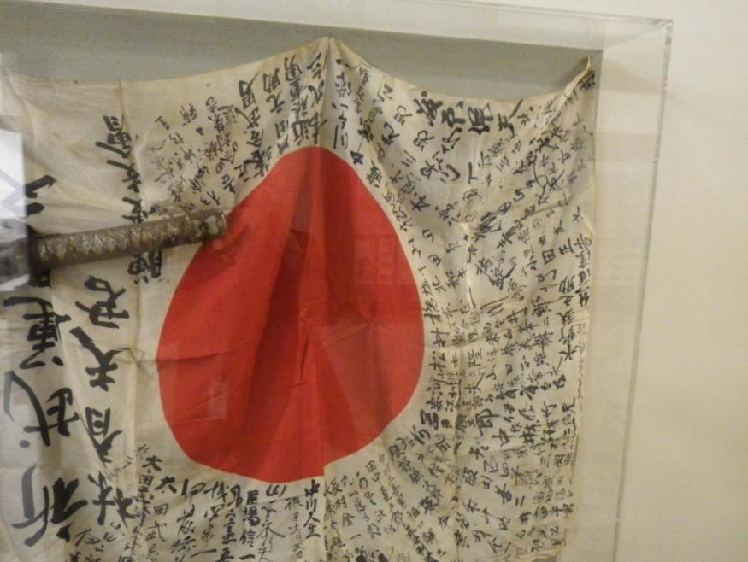

**Does your storage area look like this?**

There are too many uniforms jammed into this storage area. They will crease. Many have wire coat hangers which will not support the weight of the uniform and will lead to permanent creasing and possibly tearing.

**Poorly hanging flags**

This flag is hanging from a few pins without even support. This will cause stress on the fabric. The pins create holes which will enlarge over time, and can also rust which will cause further damage.

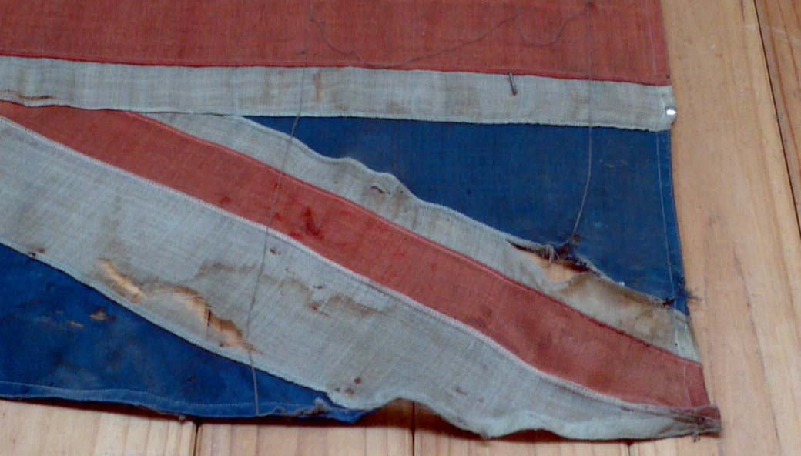

The flag on the right has been stretched and nailed to a wall. The tension on the fibres has caused them to weaken and tear. There is some rust staining around the lower nail. The red is faded and the white is yellowed, stained and discoloured.

## Types of storage

There are three main types of storage:

***Flat storage***

This is recommended for flat textiles such as flags, lace and handkerchiefs, and for fragile garments. Folding textiles creates sharp creases which eventually lead to splits. Where something is too large for a drawer or box, it will need to be folded but the folds should be carefully padded with one of the following:

* soft twists of acid-free tissue
* washed, unbleached 100% cotton calico
* sausages of unbleached 100% cotton knit filled with 100% polyester Dacron. (tubes of cotton knit are available from meat processors or medical suppliers).

***Rolled storage***

This is recommended for larger flat textiles where is there is no space for flat storage. Textiles are rolled in the direction of the warp (the threads parallel to the selvage) onto a covered acid-free tube while applying moderate pressure so as to prevent bagging. The use of acid-free tissue interleaved between layers will reduce the transfer of dirt, stains and dye.

***Boxed or drawer storage***

This is recommended for uniforms, fragile flat items and three-dimensional textiles. A large box can be created from acid-free cardboard or corrugated polypropylene. All folds and gathered areas should be gently padded with the materials listed above.

***Hanging storage***

Severe damage can result from hanging costumes that are too fragile to support their own weight. For stronger garments, hanging is a space-efficient method of storage. Padded hangers made from varnished wood covered with Dacron and washed, unbleached 100% cotton fabric should be used to support costumes to retain their original shape and condition.

**Do not use plastic or synthetic bags to cover garments as they can’t breathe and mould may grow. Make garment covers out of washed, unbleached 100% cotton fabric.**

**Where can I buy acid-free boxes, tissue paper and other museum quality products?**

Museums Australia (Victoria) has compiled a Museum Suppliers list. This contains the contact details of speciality suppliers which sell materials for the proper storage and display of heritage items. See: [www.mavic.asn.au](http://www.mavic.asn.au)

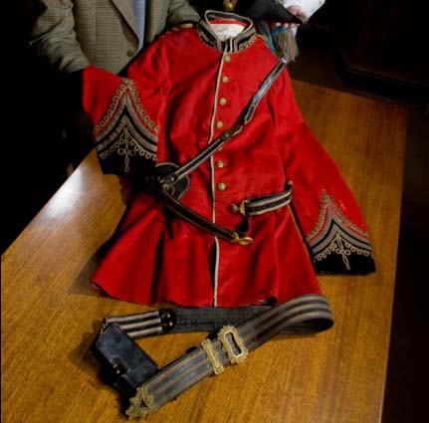

**Storing costumes**

This uniform from Coleraine Historical Society has been carefully stored in the dark and as a result has retained its vivid red colour. Ideally the leather belt and straps should be stored separately from the uniform and be well labelled. Creases will be padded to soften them and if possible the coat will be stored flat.

## Storing costumes

**Garment covers**

Make garment covers out of washed, unbleached 100% cotton fabric. Do not use plastic or synthetic bags as a garment cover because garments can’t breathe and mould may grow. Avoid the bags provided by dry cleaners. The exception to this rule is garment covers made out of perforated Tyvek, which is a specially made, breathable, polyethylene fabric.

**Cleaning and repairing textiles**

There are significant dangers associated with cleaning and repairing heritage costume and textiles. In some instances, a well-meaning clean or ‘sew up’ may damage an irreplaceable garment or erase its history. Consult a conservator or seek information from a reputable organisation online. Don’t attempt to make one new garment from several damaged items as this will erase the history of them all.

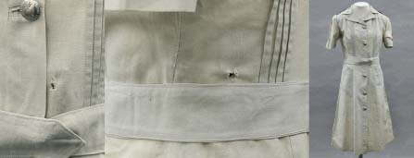

**Would you repair the holes in this dress?**

The Australian War Memorial holds the uniform of Staff Nurse Vivian Bullwinkel, 2/13 Australian General Hospital (see images above). A bullet entry hole can be seen on the back and an exit hole is on the front. This uniform was worn when Nurse Bullwinkel was shot by Japanese soldiers at Banka Island after the sinking of the *SS Vyner Brooke* in 1942.

The Australian War Memorial has ensured that this uniform is in a stable condition. But it has not repaired the bullet holes or removed traces of blood, as they help to tell this important story.

It is easy to ‘clean’ and ‘repair’ heritage an object in a way that damages or erases its history. In some instances mud, blood, dirt and bullet holes help tell the history of an object and the people associated with it.

*Photo courtesy of Australian War Memorial (Conservation Unit)*

## RESOURCES

There are many publications already available that can easily be adapted to the care of war heritage textiles.

***GENERAL***

‘Caring for Your Treasures: Textiles’, Foundation of the American Institute for Conservation of Historic and Artistic Works:  
[http://www.conservation-us.org/index.cfm? fuseaction=Page.ViewPage&PageID=634](http://www.conservation-us.org/index.cfm?%20fuseaction=Page.ViewPage&PageID=634)

‘How to Handle Antique Costume and Textiles’, Smithsonian Institute:  
<http://www.si.edu/mci/english/learn_more/taking_care/handletex.html>

‘Synthetic Fibres’, National Park Service, USA:  
<http://www.nps.gov/history/museum/publications/conserveogram/16-04.pdf>‘Australian Dress

Register: Conservation Notes’, Powerhouse Museum:   
[www.powerhousemuseum.com/pdf/research/dress_register/ADR15.1_conservation_help_notes.pdf](http://www.powerhousemuseum.com/pdf/research/dress_register/ADR15.1_conservation_help_notes.pdf)

‘Products and suppliers list’, Powerhouse Museum:  
[www.powerhousemuseum.com/pdf/preservation/products_and_suppliers.pdf](http://www.powerhousemuseum.com/pdf/preservation/products_and_suppliers.pdf)

***CLEANING***

‘Cleaning and Freezing Textiles’,   
Australian War Memorial:  
<http://www.awm.gov.au/collection/conservation/textiles/>

‘How to Brush-Vacuum an Object’, Powerhouse Museum:  
<http://www.powerhousemuseum.com/pdf/preservation/brush-vaccum.pdf>

‘How to Dry Clean Historic Textiles’,   
National Park Service, USA:  
<http://www.nps.gov/history/museum/publications/conserveogram/16-02.pdf>

***STORAGE***

‘How to Store a Fragile Garment or Textile’, Powerhouse Museum:  
<http://www.powerhousemuseum.com/pdf/preservation/store_a_garment_or_textile.pdf>

‘How to Create Rolled Storage for Flat Textiles’, Powerhouse Museum:  
[www.powerhousemuseum.com/pdf/preservation/rolled_storage_for_textiles.pdf](http://www.powerhousemuseum.com/pdf/preservation/rolled_storage_for_textiles.pdf)

‘How to Create a Padded Coathanger’, Powerhouse Museum:  
[www.powerhousemuseum.com/pdf/preservation/padded_coathanger.pdf](http://www.powerhousemuseum.com/pdf/preservation/padded_coathanger.pdf)

‘Rolling Flags’, National Park Service, USA:  
[www.nps.gov/history/museum/publications/conserveogram/16-05.pdf](http://www.nps.gov/history/museum/publications/conserveogram/16-05.pdf)

‘Padded Hangers’, National Park Service, USA:  
[www.nps.gov/history/museum/publications/conserveogram/04-05.pdf](http://www.nps.gov/history/museum/publications/conserveogram/04-05.pdf)

‘Dust Covers’, National Park Service, USA:   
[www.nps.gov/history/museum/publications/conserveogram/dustcovers4-15.pdf](http://www.nps.gov/history/museum/publications/conserveogram/dustcovers4-15.pdf)

***PEST CONTROL***

‘Cleaning and Freezing Textiles’, Australian   
War Memorial:  
[www.awm.gov.au/collection/conservation/textiles/](http://www.awm.gov.au/collection/conservation/textiles/)

‘Insects and Wool Textiles’, Smithsonian Institute:  
[www.si.edu/mci/english/learn_more/taking_care/insects.html](http://www.si.edu/mci/english/learn_more/taking_care/insects.html)

***DISPLAY***

‘Dressing a Mannequin’, Powerhouse Museum: [www.australiandressregister.org/media/pdf/resources/2.3_dressing_a_mannequin.pdf](http://www.australiandressregister.org/media/pdf/resources/2.3_dressing_a_mannequin.pdf)

***SPECIALISTS***

Australian Institute for the Conservation of Cultural Materials (AICCM) Search for conservation framers by State using the term “Storage, rehousing, mounting, framing and exhibition prep” or “Textiles” on this page:  
[www.aiccm.org.au/index.php?option=com_civicrm&Itemid=88](http://www.aiccm.org.au/index.php?option=com_civicrm&Itemid=88)

Check that the conservator is able to or undertake conservation framing of textiles or mount textiles for display.

Australian Institute for the Conservation of Cultural Materials (AICCM) Search for textile conservators by State using the term “Textiles” on this page <http://www.aiccm.org.au/index.php?option=com_civicrm&Itemid=88>

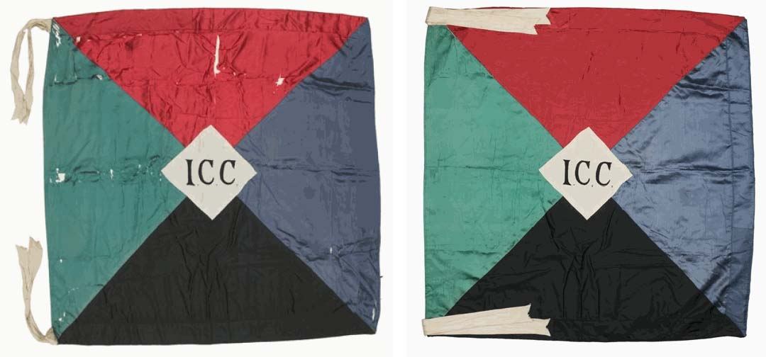

**Do not despair!**

Although damaged textiles may appear beyond help, professional conservators can usually save badly damaged costumes and other textiles. This flag was not damaged in battle, but the holes occurred due to inherent problems with weighted silk. The use of metallic salts in the manufacturing process of the silk fabric caused the silk to weaken and split over time.

Professional conservation treatment by the Australian War Memorial’s textiles conservators has remedied this problem. The flag has been cleaned and lined with a new silk backing to provide support and disguise the holes.

Photo of Championship flag – 1 Battalion, Imperial Camel Corps First World War

*Photo courtesy Australian War Memorial (Conservation Unit)*

Where can I get this and other fact sheets? The DPC Preserving war heritage and memorabilia fact sheets provide information about the care and conservation of a range of heritage material. They can be downloaded at **www.dpc.vic.gov.au/veterans/factsheets**

**Disclaimer** The material contained in this guide is for general reference only and should not be relied upon as the sole basis for heritage conservation or restoration. A professional conservator or conservation architect should be consulted before any conservation or restoration is undertaken. The Victorian State Government does not warrant the accuracy or completeness of the information and disclaims all liability for any loss or damage that may be caused by reliance upon it. Provision of names of suppliers or websites does not imply that a supplier is endorsed or approved by Heritage Victoria or the Department of Premier and Cabinet.