Bushfire Recovery Program – Heritage
Fact Sheet

Heritage Victoria’s Bushfire Recovery Program
The 2019-20 bushfires across North East and East Gippsland captured the local government areas of Alpine, Baw Baw, Cardinia, Towong, Wodonga and East Gippsland. The fire footprint contains more than 130 known historic heritage places.

Heritage Victoria expresses sympathy and support for the many communities affected by bush fires. We acknowledge the work of Forest Fire Management Victoria and other emergency services in protecting lives and communities.
In response to the bushfires, Heritage Victoria is:
- undertaking assessments of heritage places of State significance on the Victorian Heritage Register (VHR) impacted by the bushfires;
- providing advice to local government and communities on assessment of heritage places within local heritage overlays.
STRINGERS KNOB FIRE SPOTTING TOWER,
(VICTORIAN HERITAGE REGISTER H2244), MONUMENT TRACK, BETE BOLONG NORTH, EAST GIPPSLAND SHIRE
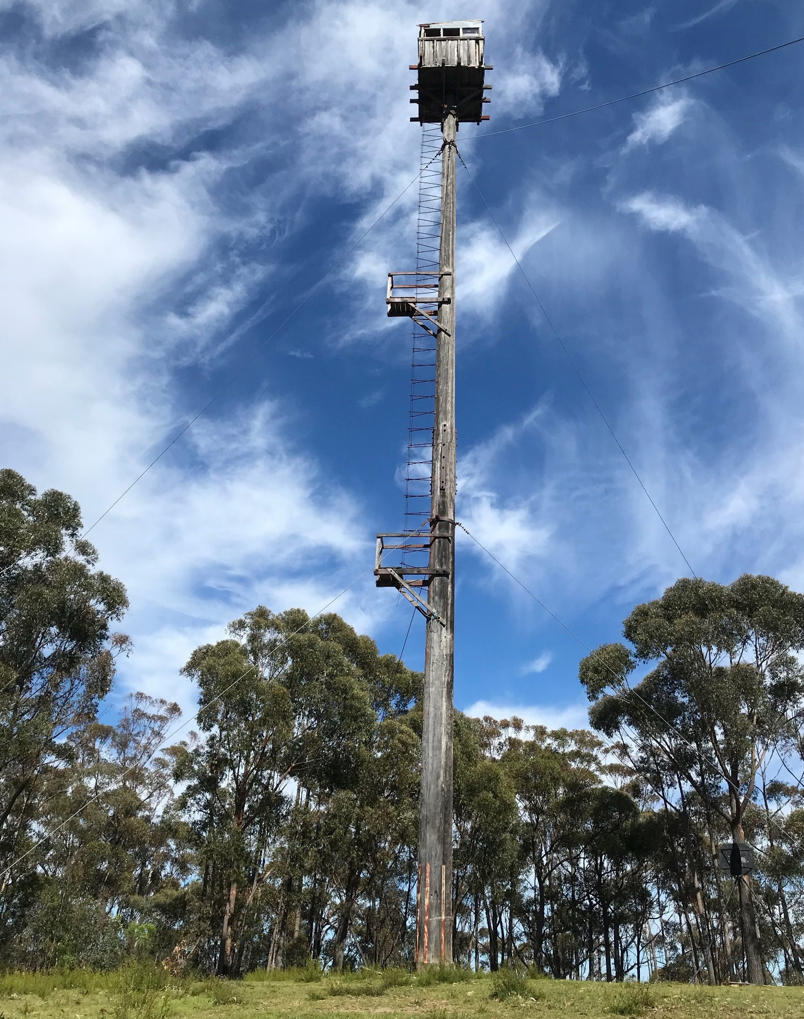 | 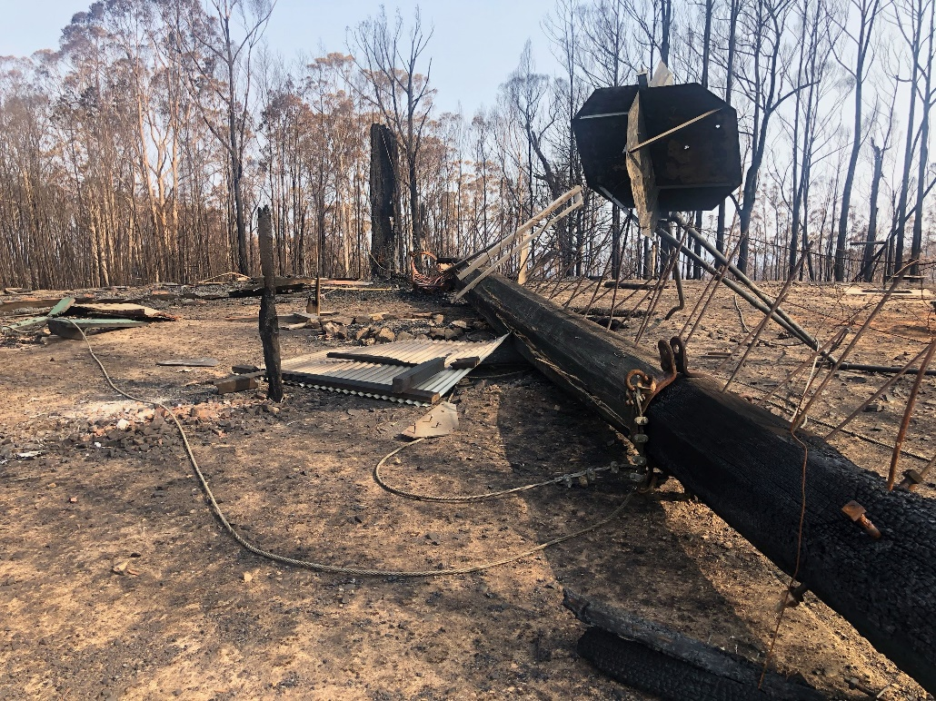
VHR H2244, Pre-fires  Image: Mark Simons, FFMV, Gippsland | VHR H2244, January 2020  Image: Christopher Anderson, FFMV, Snowy District
Stringers Knob Fire Spotting Tower is of historical significance for its association with the aftermath of the 1939 bushfires, demonstrating the efforts of the Forests Commission to improve fire safety in Victoria. It is also of technical significance for its experimental design and unusual construction technique. Stringers Knob Fire Spotting Tower was built of two poles of yellow stringybark and red iron bark bolted together, with a cabin measuring 2.5m² perched on top. It is just one of many sites impacted by the catastrophic bushfires this summer.
Heritage Victoria’s Bushfire Recovery Program will be undertaken in partnership with relevant State Government agencies, DELWP Regions, Parks Victoria, local government and relevant community groups. It should be noted that the assessment of Aboriginal cultural heritage is managed through a separate initiative.
What is the Victorian Heritage Register?
State significant heritage places and objects are included on the Victorian Heritage Register (VHR), established under the Heritage Act 2017. This legislation is administered by Heritage Victoria in the Department of Environment, Land, Water and Planning. The Heritage Act gives statutory protection to State listed heritage places and objects, historical archaeological sites and artefacts and maritime heritage. A place or object listed on the VHR is legally protected and cannot be altered without a permit or permit exemption from Heritage Victoria. There are some 2,358 places and objects included in the VHR.

How do I know if my property is on the VHR?
The Victorian Heritage Database (VHD) can be accessed at following address: https://vhd.heritagecouncil.vic.gov.au/

The database contains a number of different lists that your property may be on:
- Victorian Heritage Register
- Victorian Heritage Inventory
- National Trust
- Local Government Heritage Overlay

The places of state significance included on the Victorian Heritage Register, and archaeological places included on the Heritage Inventory are identified by the Heritage Council of Victoria logo on the VHD.

You can also find the location of VHR places, Heritage Inventory sites and Local Government Heritage Overlays, along with other planning information, through the interactive mapping tool VicPlan: https://mapshare.vic.gov.au/vicplan/.

What is a Local Government Heritage Overlay?
Heritage places of local significance are listed in the schedule to the Heritage Overlay in local council planning schemes. Over 170,000 properties are listed by local councils across Victoria.
Further information on the roles of Heritage Victoria and local government can be found at https://www.heritage.vic.gov.au/__data/assets/pdf_file/0025/443149/heritage-brochure_FINAL.pdf

Is there funding for my VHR property in fire affected areas?
Heritage Victoria’s Living Heritage Program (LHP) provides grants for “at risk” places on the VHR that are owned or managed by specific groups and have public access.
The LHP offers funding from $20,000 to $200,000. The LHP Guidelines and Frequently Asked Questions are available on the website along with past examples of successful projects: https://www.heritage.vic.gov.au/grants/living-heritage-program
The current Round 5 of the LHP is now open and has a special focus on places on the VHR within the footprint of the 2019-20 bushfires. Please note that applications for condition reports, structural engineering reports or documentation will be considered as it is understood applicants may not be ready with fully scoped and documented works.
The application closing date for the program has been extended to 12 June 2020.

Contact details for further information
Heritage Victoria
Phone: 03 7022 6390
Email: Joanna.Lyngcoln@delwp.vic.gov.au

