Guidelines for Change and Development of Heritage Places of Worship
2024

Copyright
Published by the Heritage Council of Victoria, Melbourne. November 2008, Revised June 2010.
Revised by Heritage Victoria April 2024.
© Heritage Victoria 2024.
This publication is copyrighted. No part may be reproduced by any process except in accordance with the Copyright Act 1968.
Authorised by the Heritage Council of Victoria.
Cover Image: Loreto College Chapel, Mary’s Mount, Ballarat. Source: Loreto College, Ballarat.
ISBN 978-0-7311-9315-8 (online)
For more information contact the Heritage Council on (03) 7022 6390 or at www.heritage.vic.gov.au.
Authorship
Text and photos by Dr David Rowe, Heritage Consultant and Steve Watson & Partners, Building Certifiers.
Disclaimer
This publication may be of assistance to you but the State of Victoria and its employees do not guarantee that the publication is without flaw of any kind or is wholly appropriate for your particular purposes and therefore disclaims all liability for any error, loss or other consequences which may arise from you relying on any information in this publication.

Foreword
Places of worship are some of the most significant buildings in our towns, our suburban neighbourhoods and in our countryside. They stand as symbols of faith and hope, and spiritual values in a secular world.
Their significance extends beyond the congregations that worship regularly in them. There are many who have had some association with particular places of worship through the rites of passage and various social connections.
These buildings are familiar features of our everyday environment and some have been recognised as part of our cultural and architectural as well as our religious heritage. Thus the whole community has an interest in the maintenance and preservation of these heritage buildings.
Preservation may require restoration: the ravages of time necessitate repairs that need to be carried out consistent with the character of the building. It may sometimes demand innovation to adapt these buildings to the use of their congregations. Changing patterns of worship arising out of the twentieth century movement for liturgical renewal have led to internal changes, particularly in Catholic churches following the reforms of the Second Vatican Council. This movement has also influenced other denominations, some of which have made extensive internal changes for liturgical reasons. For alterations to heritage places of worship in the Victorian Heritage Register or included as a heritage overlay in a Planning Scheme, changes should be carried out appropriately. The Heritage Council has therefore provided the following Guidelines to assist in managing such changes as well as general advice on the maintenance and preservation of heritage places of worship.
The purpose of this document is to provide guidelines for change and development of heritage places of worship. These Guidelines have been prepared to assist owners, managers, congregations, planners and decision makers with day to day thinking and planning for change. It is not intended to have a statutory effect unless it has been formally adopted as part of a planning scheme. It is also not intended to replace place-specific advice that may be provided by Heritage Victoria if the place of worship is included in the Victorian Heritage Register and proposed changes are not for the purposes of religious services or rites.
These Guidelines refer to the Burra Charter (2013). The Burra Charter is the short name of the Australia ICOMOS Charter for the Conservation of Places of Cultural Significance. It defines the basic principles and procedures to be followed in the conservation of all kinds of places of cultural heritage significance in Australia.
The Burra Charter defines certain terms, including ‘conservation’ and ‘cultural heritage significance’, and outlines a process by which the cultural heritage significance of a place should be determined and managed. The Burra Charter should be referred to in conjunction with this document.

Contents
Foreword 1
1. Introduction 5
2. Understanding Significance 7
2.1. Background 7
2.2. What does Significance mean? 7
2.3. Significant Fabric 13
2.4. Other Social Value 14
2.5. Statements of Significance 14
2.6. Levels of Significance 14
2.7. Negotiating an Updated Statement of Significance 15
2.8. Heritage Legislation and the Statement of Significance 15
2.9. Key issues in Understanding Significance 17
3. Managing Change of Ongoing Liturgical Use 19
3.1. Background 19
3.2. Needs Analysis 20
3.3. Internal Change 20
3.4. External Alterations and Additions 25
3.5. Key issues in Managing Change for Ongoing Liturgical Use 26
4. Managing the Setting 27
4.1. Background 27
4.2. Changes to the Setting 27
4.3. Key Issues in Managing the Setting for Ongoing Liturgical Use 32
5. Relocation and Demolition 33
5.1. Background 33
5.2. Relocation 33
5.3. Demolition 35
5.4. Key Issues in Relocation and Demolition 35
6. Building Services and Utilities 37
6.1. Background 37
6.2. General Principles 37
6.3. Existing Services 37
6.4. Location of New Electrical and Plumbing Services 37
6.5. Lighting 38
6.6. Heating 39
6.7. Cooling 40
6.8. Fire Safety 40
6.9. Organs 40
6.10. Bells and Associated Works 41
6.11. Solar Energy Systems 41
6.12. Telecommunications Equipment 42
6.13. Key Issues in Building Services and Utilities 42
7. Accessibility and Inclusion 43
7.1. Background 43
7.2. Legislation 43
7.3. Process of Analysis 44
7.4. Access Audit 44
7.5. Car Parking and Pathways 45
7.6. Principal Access to the Place of Worship 45
7.7. Worship Spaces 47
7.8. Auditory Barriers 48
7.9. Visual Barriers 48
7.10. Toilets 49
7.11. Key Issues in Accessibility and Inclusion 49
8. Environmental Sustainability 50
8.1. Background 50
8.2. Traditional Building Performance 50
8.3. Management of Energy Consumption 50
8.4. Existing Building and the Building Code of Australia (BCA) 51
8.5. Key Issues in Environmental Sustainability 52
References 53

- Introduction
Places of worship are important symbols of spiritual expression and community involvement in a post-European Colonisation context. They are physical and social signposts of belief, and assist in defining our sense of place, community and identity. Places of worship reflect the human condition – whether that of pilgrims, worshippers, travellers, historians or others. In addition to their primary function as places of worship, they are often an important community resource beyond that of the affiliated congregation. Traditionally, the Jewish synagogue has been a principal place of worship as a prayer hall, but also the location of the religious school, library, meeting place and community-related events such as wedding receptions and Bar Mitzvah celebrations. In more recent times, some Christian churches have become community centres, playing host to a variety of welfare and charitable activities and events, in addition to traditional church social activities.
Places of worship are a significant record of organic and accumulated growth and removal. Historically, natural processes (such as weathering and deterioration of built fabric) and social, economic and technological developments have played a part in influencing physical, liturgical and social change to places of worship. While more recent changes may be more noticeable today, changes to places of worship are not a recent phenomenon.
Different religious denominations have grown and developed since the 19th century. This has impacted on places of worship and liturgical practices. For example, the establishment of the Methodist Church of Australasia in 1902 was an amalgamation of other divisions of Methodism. Further amalgamation of the Methodist, Congregational and Presbyterian Churches in Australia occurred in 1977 with the formation of the Uniting Church in Australia. This in turn brought about different liturgical practices, re-evaluation of significant internal fittings and fixtures, and the rationalisation of church properties. Another example is the liturgical changes wrought in the Roman Catholic church after 1968, as a result of Vatican II and consequent physical changes to many Catholic church interiors.
Not all change is related to changes in liturgy. Sometimes, greater availability of funds has allowed for the original design to be realised several years after the initial construction through the building of towers, chancels, apses, vestries and porches. In other circumstances, the additions reflect expansion at a particular point in time, unrelated to the original design.

Example
St. Alipius Roman Catholic Church, Ballarat (Figure 2) opened in 1874 as a partial realisation of the original design which comprised a clerestoried nave of five bays, flanking aisles, projecting west porch, and temporary timber chancel. This church evolved both in accordance with its original design concept (but over a considerable period of time), and as a consequence of later needs. The early photograph (Figure 1) shows the church building in c.1908. The stone toothing in one corner at the front reveals the original intention of building a tower. Figure 1 shows the tower that was built in 1924, no doubt to a different design to that originally proposed. It was also in 1924 when two further bays were added to the nave and aisles and a stone chancel replaced the temporary timber structure (See Figures 3 and 4). These changes appear to have formed part of the original design intentions and were carried out when funds permitted. In 1944, the church experienced liturgical change, when the original altar (Figure 5) was replaced with a more substantial marble altar (Figure 6) and a stained glass chancel window (Figure 4) was introduced. These changes in 1944 were unrelated to the original design intentions.
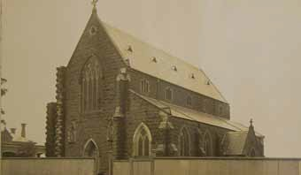
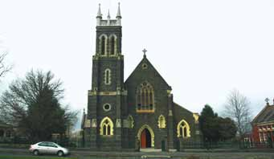

Figure 1: St. Alipius Roman Catholic Church, Ballarat, c.1908. Source: Ballarat Diocesan Historical Commission.

Figure 2: St. Alipius Roman Catholic Church, Ballarat, 2005. Source: Wendy Jacobs & David Rowe.

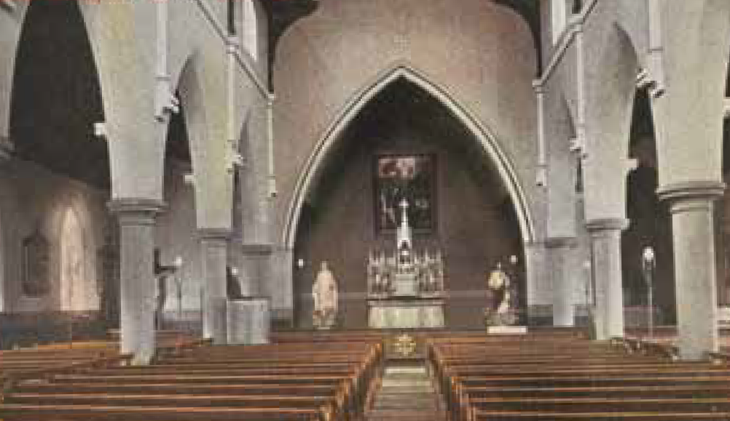
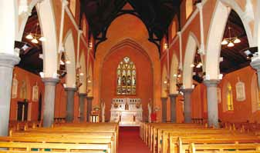
Figure 3: St. Alipius Roman Catholic Church, Ballarat, c.1908, looking east towards the original chancel. Source: La Trobe Picture Collection, State Library of Victoria.
Figure 4: St. Alipius Roman Catholic Church, Ballarat, c.2005, looking east towards the introduced chancel. Source: Heritage Victoria.

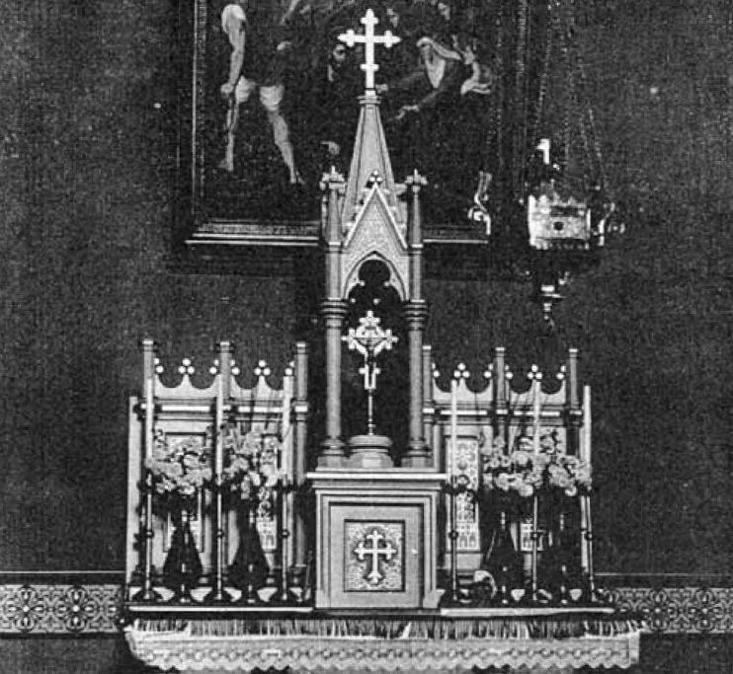
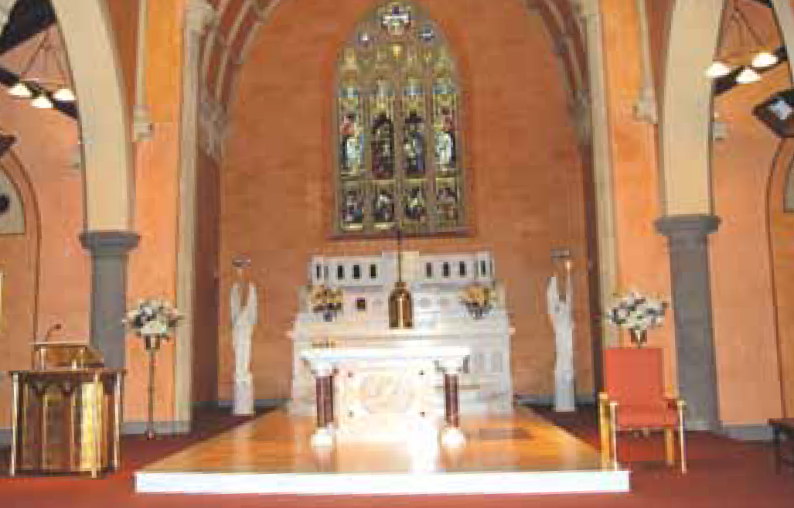

Figure 5: Original altar at St. Alipius Church, Ballarat, pre 1944. Source: Ballarat Diocesan Historical Commission.
Figure 6: St. Alipius Roman Catholic Church, Ballarat, 2008. A marble altar (shown at rear under the window) was introduced in 1944 as part of new works to the chancel, but was altered in 1979 following Vatican II. A freestanding altar introduced into the nave in 1979 was replaced by the freestanding altar and dais in 2007 (also shown). Source: Heritage Victoria.

In more recent times, liturgical and secular changes within our communities have led to a major re-evaluation of the way places of worship may be used. Today, there is a greater emphasis placed on active participation of worshippers which in turn has caused a review of the way the interiors of places of worship function. This active participation has also included mission and outreach within local communities and in some cases, has brought with it a need for greater community utilisation of significant religious buildings.
Broader community use of places of worship has also occurred as a result of declining and aging congregations and escalating maintenance costs. In an effort to prolong the sustainability and viability of these places, and to also fulfil the role of mission outreach, associated buildings such as church halls have been leased or hired on casual, semi-permanent and permanent arrangements for other community uses.
There has also been an emphasis on the need for increased convenience and comfort, either through changes to heating, seating and associated facilities, or through recent technological advancements. This emphasis has also arisen from more recent legislative requirements, including disabled access, energy efficiency, building code regulations, occupational health and safety, and heritage.
Because the vast majority of places of worship in Victoria have heritage values warranting statutory protection, there are considerable challenges in ensuring that the cultural heritage significance of these places is retained, while acknowledging the need for change for liturgical, social and legislative reasons. This document therefore provides guidance on the principal issues that need to be considered before making changes to an historic place of worship. These issues are:
- understanding the significance of the historic place of worship
- managing change for ongoing liturgical use
- managing the setting
- relocation and demolition of places of worship
- building services and utilities
- accessibility and inclusion
- environmental sustainability.
- Understanding Significance
  - Background
Before embarking on any change to an historic place of worship, consideration needs to be given to its cultural heritage significance. Understanding and acknowledging the underlying cultural values of a place will greatly assist in identifying the opportunities for change, and will particularly highlight any potential conflicts between the heritage values and the proposed alteration to the building. These potential conflicts can often be resolved through careful evaluation and constructive negotiation. Striking a balance between retaining cultural heritage significance and making change is often challenging. Understanding the heritage significance of the place of worship is fundamental in finding this balance.
  - What does Significance mean?
Significance is the value or values that establish the importance of a place, as prescribed in The Burra Charter: The Australia ICOMOS Charter for Places of Cultural Significance (2013). The Burra Charter provides guidance for the conservation and management of places of cultural significance and is adopted by Australia ICOMOS, the Australian branch of the International Council on Monuments and Sites (ICOMOS). This organisation is primarily concerned with the philosophy, terminology, methodology and techniques of conservation of significant heritage places and is closely linked to the United Nations Education, Scientific and Cultural Organisation (UNESCO). There are five applicable heritage values that may contribute to the significance of a place of worship. These are described below.

Aesthetic/Architectural Values
Aesthetic and architectural value relates to the particular setting and landscaping, and architectural design, style, detail and construction of a place. Places of worship are usually highly distinctive compared with other building types, as particular styles and settings often symbolise different types of religious buildings of the 19th and 20th centuries, depending on its denomination. Most common from the 19th century were derivations of the Gothic style. The publication, Victorian Churches: Their Origins, Their Story and Their Architecture (National Trust of Australia [Victoria], 1991) provides a general appraisal of many of the architectural styles for Christian places of worship. Artworks and other decorative features and landscapes may also contribute to the aesthetic significance of the place or be significant in their own right.
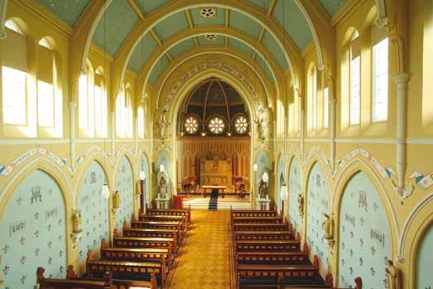

Figure 7: The interior of Loreto College Chapel, Mary’s Mount, Ballarat, 2007. Built between 1898 and 1902 to a design by architect William Tappin, this represents one of the most outstanding examples of a convent chapel in Australia. The interior is a highly intact and elaborate expression of Gothic Revival design. This is evident in the azure barrel vaulted nave and apsidal sanctuary ceilings of coffered panels with stencilled silvery stars, and for its timber parquetry floor, crafted timber pews, stained glass windows and stencilled artwork on the walls. Source: Loreto College, Ballarat.

Historical Values
Most places of worship provide physical evidence that expresses the state of the religious denomination and society more broadly at the time of construction. They are also physical legacies of important phases in the life of the place, indicating influences from significant events or activities and historical figures, through changes in the physical fabric. The significance of a place of worship will be greater where physical evidence of the important phases survives in situ, rather than where the evidence has been greatly altered or no longer exists. Importantly, a place of worship may have historical value whether or not this value is currently appreciated by the members of its congregation.
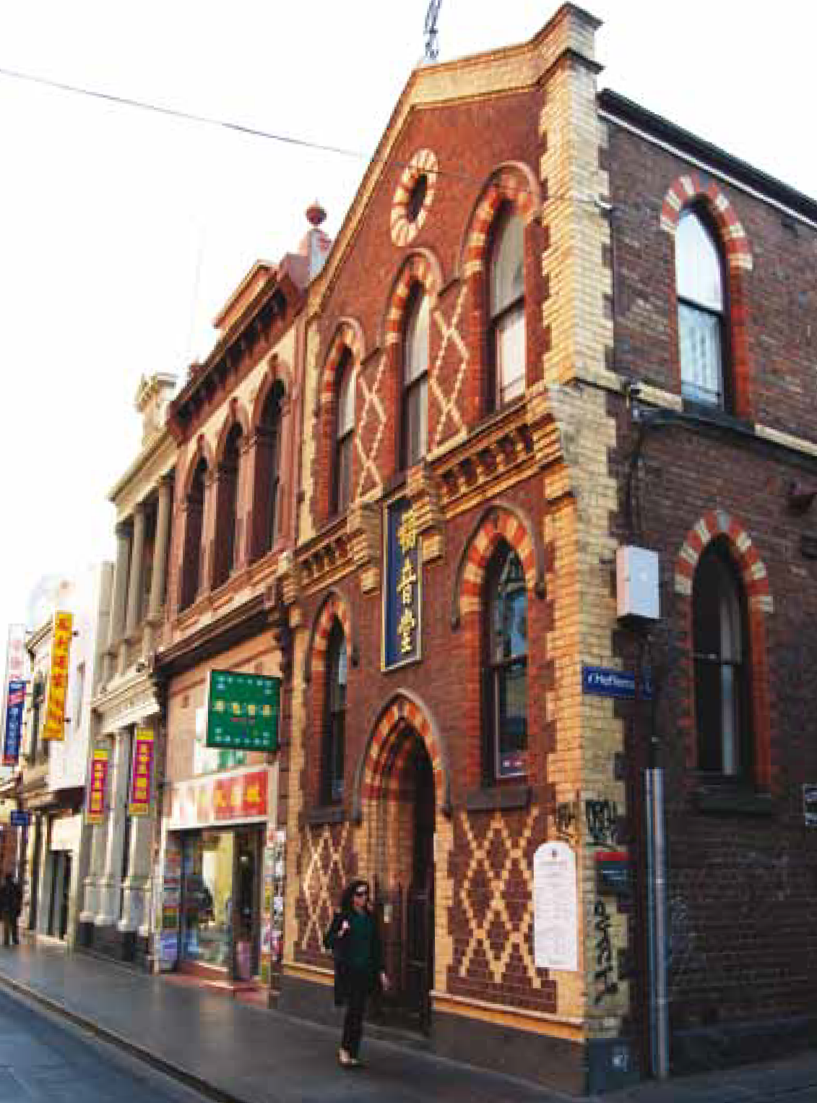
Figure 8: Chinese Mission Church, Little Bourke Street, Melbourne, 2008. This building shows attempts by Wesleyans and other denominations in Victoria to convert local Chinese to Christianity. It is historically significant for its links to early religious and social life of Chinatown, and as a place used continuously for worship, and as a focal point for the Christian Chinese community since 1872. Source: Heritage Victoria.

Scientific Values
The rarity and quality or representativeness of a place of worship can provide scientific or research value. This may be through outstanding, innovative design attributes for the time, or through expressing particular advances in technology such as an unusual construction method.
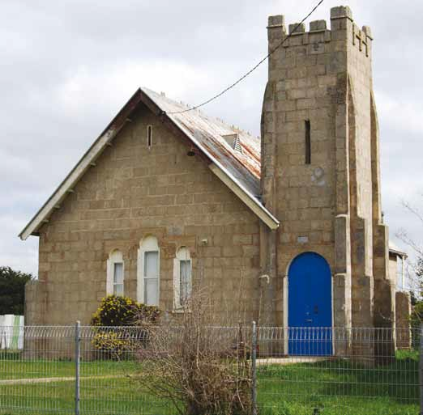
Figure 9: The Snake Valley Wesleyan Church constructed in 1908 is of architectural and scientific (technical) significance as the first known example of a building constructed in Victoria using concrete blocks to form a hollow cavity wall. The blocks are made with a mix which includes quartz pebble aggregate sourced from the nearby mullock heaps created by gold mining activities. Source: Heritage Victoria, 2008.

Social Values
Places of worship most commonly have highly important social qualities embracing spiritual and cultural sentiment. They are recognised and valued by congregations and the broader community as symbols of faith and of historical participation in faith education.
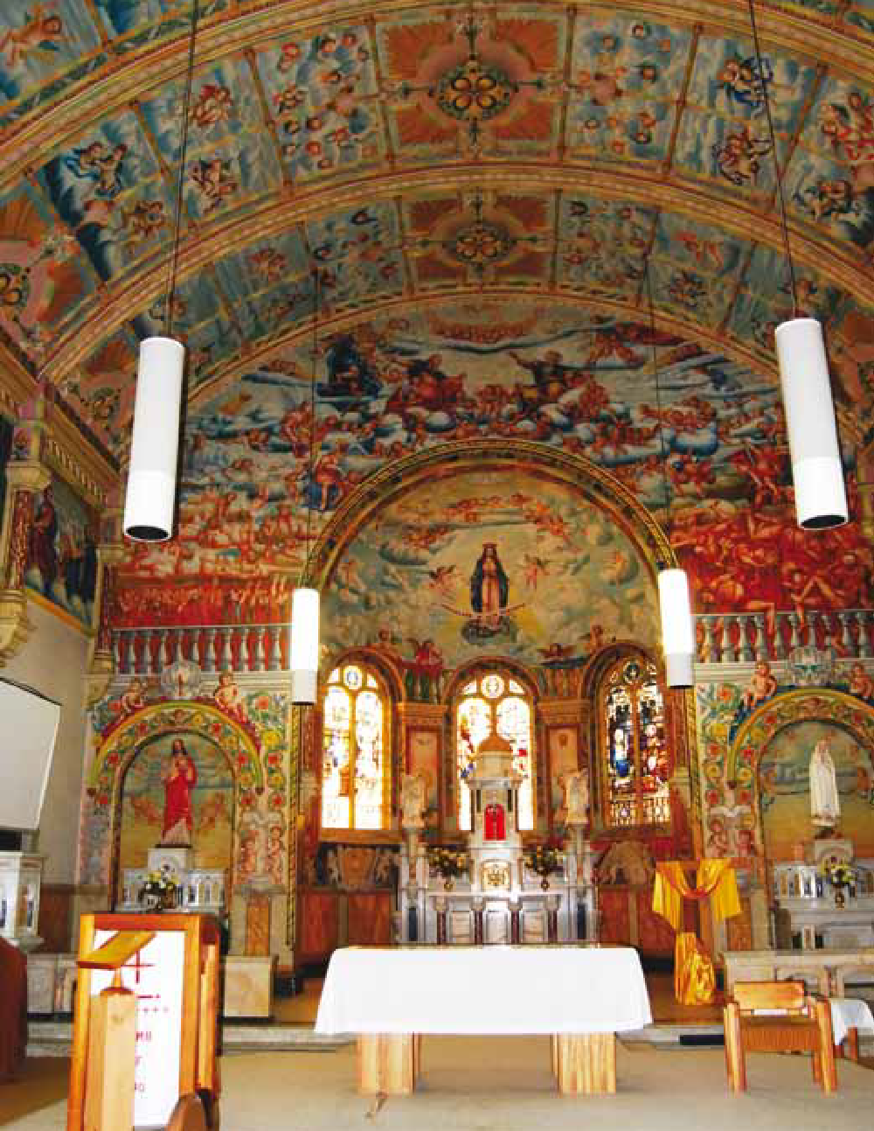
Figure 10: St Mary’s Catholic Church, Bairnsdale, 2008. The comprehensive interior decorative scheme is of murals depicting the apostles, numerous saints, imaginings of purgatory, heaven and hell, and many seraphim and cherubim. It was executed between 1931 and 1938 by Francesco Floreani, a migrant Italian from Udine who had studied painting at Udine College and then at the Academy of Arts in Turin. During the Depression Floreani became an itinerant farm worker in Bairnsdale. In 1931 he approached the church for work and, after completing some minor commissions, he undertook a comprehensive decorative scheme for the interior of the church. Source: Heritage Victoria.

Spiritual Values
Places of worship are physical symbols of spirituality. Spiritual value is largely intangible, although it is recognised by the community at large even where there may be no personal association or spiritual relationship with the place. Arguably, the spiritual value of a place may be substantially reduced or lost if the place of worship closes and the existing use ceases. The Victorian Heritage Register Criteria and Threshold Guidelines (Heritage Council of Victoria, 2012, reviewed and updated 2022) elaborates further on spiritual value in it being in existence to a particular community or cultural group who share a common interest, including belief system. There is also existence of a strong attachment to the place over an enduring period.
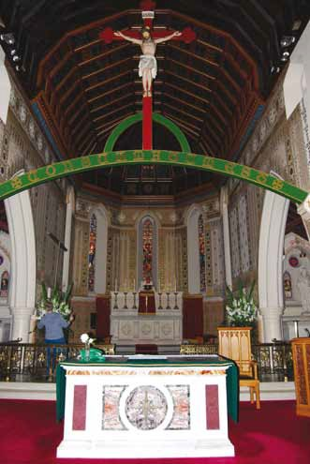
Figure 11: St Mary’s Catholic Church, St Kilda East, 2008. Built between 1859 and 1871 and designed by William Wardell, the church is notable for its wealth of internal fittings and richly decorated chancel. Source: Heritage Victoria
  - Significant Fabric

Building and Liturgical Fabric
Significant fabric is the physical parts of the exterior and interior of a place of worship, including fittings and fixtures, that contribute to its heritage value. In addition to the roofs, walls, floors and associated finishes and details comprising the architectural design of the building, an understanding of the other aspects of significance is also important. Understanding liturgical fittings and fixtures, spatial relationships and how people behaved within these buildings further informs the heritage values of a place. Basic liturgical features and the spatial configuration of the building often symbolise earlier, current and changing liturgical practices which contribute to the cultural significance of the place.
In Christian churches, interior fittings and fixtures include pews, altars, pulpits, lecterns, tables, chairs, baptismal fonts, reredos, rood screens, organs and organ pipes, hymn boards and other fittings and fixtures such as Stations of the Cross. In Jewish synagogues, significant interior fittings will often include the ark (ornamental closet containing Torah scrolls), bimah (table), menorah (seven-branched candlestick), New Tamid (lamp) and pews. In Muslim mosques, the carpet in the prayer room may indicate the spaces for prayer. In the minaret (a space where the call to prayer is made), the Star and Crescent may be present, representing the universe.
The layout of spaces in the place of worship may also be significant. For many of the larger Christian churches, the plan of the nave, crossing, transepts, chancel apse and sanctuary – articulated to form a cross – is important. In Anglican, Roman Catholic, Uniting Church in Australia, Baptist and Presbyterian churches, the historic pews may further contribute to the character, appearance and integrity of the interior, both in terms of their design and in their placement. The axial configuration of the pews often leads to uninterrupted views to important focal points such as the altar, communion table, chancel and apse. In Eastern Catholic and Orthodox churches, pews may be a more recent addition given that, traditionally, parishioners stood during the liturgy.
In Jewish synagogues, the spatial functions and compositions are different. A central space is often demarcated by the bimah, with the ark and lamp at one end, while the sides are for the congregation. There may also be a separate women’s section at one end.
Muslim mosques provide a further variation, whereby a large mosque has separate spaces for women and men, a library, and an itikaf for prayer, reflection and Qur’anic study during Ramadan.
Many places of worship feature memorials within the interiors. These memorials may honour or commemorate the fallen in wars or be tributes to past members of the congregation or worship leaders. Memorials are often important artworks (such as stained glass windows) that deserve retention and conservation in their own right, in addition to their social and cultural value. Depending on the type of memorial, how it might be attached to significant building fabric and the outcomes of consultations with worshippers, relocating memorials to other parts of the interior may be possible to allow for liturgical change.

The Setting
The setting of the place of worship may also contribute to its significance. Consideration therefore needs to be given to the heritage value of the perimeter fencing, garden and landscape features (including memorials in the form of trees, seats and gates), spaces around the building and any associated buildings such as church halls and manses or presbyteries.

Introduced Fabric
Some fittings and fixtures and other fabric may have been introduced over time yet may still have heritage value. Their introduction may reflect an important historical event in the life of the building and its people. Some interior features may have been introduced as finances permitted, others may have been provided in commemoration of a family member, while others may have been added as a temporary measure. The heritage authenticity of the fabric of the place of worship should therefore reflect the significant phases of construction and use associated with its historical chronology. This may include introduced fittings and fixtures. The underlying reason, purpose and function of the introduced fabric, will be important in determining whether it should remain or can be removed.
  - Other Social Value
The cultural heritage values of an historic place of worship are often interrelated with liturgical practices and ritual. In some circumstances, social heritage value will vary with the value attached to liturgy and ritual by worshippers. Social value may vary between different places and worshippers. It is important to consult with all members of a congregation prior to considering change. Change may be acceptable from a cultural heritage viewpoint, but may not necessarily be in accord with the values some worshippers place on existing liturgy and ritual. Understanding other social values may therefore be important before considering change.
  - Statements of Significance

Importance of the Statement of Significance
Statements of significance are critical in managing the conservation of an historic place of worship and in forming a basis for considering any change. Statements of significance should indicate ‘the what, why and how’ of the place’s significance.

Currency of the Statement of Significance
It is important that prior to considering change, the currency of the statement of significance be identified. Negotiating an updated statement of significance to include all significant fabric and associations, including changing worship practices over time, may assist informing worshippers, administrators, property managers and legislators about the opportunities and constraints for change. An accurate statement of significance – prepared prior to any consideration of change – will provide the basis on which to make informed decisions.
  - Levels of Significance
Levels of significance reflect Australia’s three-tiered system of government. The statement of significance will indicate how the place of worship is significant and a significance level. Being informed of the level of significance for each of the relevant heritage values will be important in determining the opportunities for and limitations of change. As a general rule the higher the level of significance, the stronger the presumption in favour of preservation. This is because highly significant places of worship have a large degree of integrity and rarity. Even where statutory internal alteration controls may not apply, consideration should still be given to the underlying historical significance of the place.

Places of National Significance
These places of worship are considered to be significant to the Australian nation and may be included on the National Heritage Register managed by the Commonwealth Department of Climate Change, Energy, the Environment and Water. These places have outstanding historic heritage value to the nation. They are considered to meet one or more of nine National Heritage List criteria. Whether a place has ‘outstanding’ heritage value can only be considered by comparing it to other, similar types of places. This allows consideration to be given to whether the place is ‘more’ or ‘less’ significant compared to other similar places, or if it is unique. The degree of significance can also relate to the geographic area, for instance, the extent of a place’s significance locally, regionally, nationally or internationally.

Places of State Significance
These are places of worship that are considered significant to the State of Victoria and are included in the Victorian Heritage Register. These places are the most outstanding examples either aesthetically, architecturally, historically, scientifically, socially or spiritually in Victoria. The place may meet the Heritage Council of Victoria’s assessment criteria threshold if it has high-level aesthetic and technical value/s, is highly intact, has been compared to similar places in the Victorian Heritage Register, and/or has high-level historical associations with events or persons in the history of the community and municipality, the importance of which are considered to go beyond local municipal boundaries.

Places of Local Significance
These places of worship are considered to be individually significant to a local area within a municipality and are included in a Heritage Overlay of a local government planning scheme. Places of worship in Heritage Overlays are considered to have had a significant impact in shaping the cultural, architectural, historical, social and/or spiritual identity of the local community and where applicable, have been compared to other places of state or local significance. These places meet the relevant assessment criteria prescribed in the local government heritage study brief.
  - Negotiating an updated Statement of Significance
It may be important to seek advice from the Local Government Authority and/ or Heritage Victoria about the currency of the existing statement of significance.
Problems often arise when change is being considered and statutory internal alteration controls apply, and yet very little information is identified about the interior in the statement of significance. Constructive negotiations with your local heritage advisor or the engagement of an independent heritage consultant may prove highly beneficial in the longer term. Ultimately, seeking endorsement of the updated statement of significance by Heritage Victoria and/or the Local Government Authority should form part of this process.
  - Heritage Legislation and the Statement of Significance
Statements of significance form the basis for including an historic place of worship in the Victorian Heritage Register. The majority of places of worship, however, are included in a Heritage Overlay in a local government planning scheme.

Victorian Heritage Register and the Heritage Act 2017
The Heritage Act 2017 establishes a legislative framework for heritage protection in Victoria, including the creation of the Victorian Heritage Register. Proposed changes to a registered place of worship may require a permit from the Executive Director, Heritage Victoria prior to the works being undertaken.
Section 90 of the Act provides an opportunity for a permit exemption for the purposes of religious services or rites. The Act states:
90 Exemption for the purposes of religious services or rites
(1) Subject to this section, a person may carry out works or activities in relation to the following places or objects for the purposes of religious services or rites without a permit—
(a) a registered place which is a place of worship or in the precincts of a place of worship;
(b) a registered object which is in a place of worship or in the precincts of a place of worship.
(2) Subsection (1) does not apply to a place that was built for purposes other than religious services or rites.
(3) The owner of the place or object must give notice of the proposed works or activities to the Executive Director at least 20 business days before the works or activities are to commence.
(4) A notice under subsection (3) must—
(a) be in the prescribed form; and
(b) include a declaration by an officer of the place of worship, authorised by the place of worship for that purpose, that the proposed works or activities are required for the purposes of religious services or rites.
(5) If the Executive Director is not satisfied that the proposed works or activities are for the purposes of religious services or rites, the Executive Director may notify the owner of the place or object that—
(a) the exemption under this section does not apply to the proposed works or activities; and
(b) a permit for the proposed works or activities is required.
(6) A notice under subsection (5) must be given within 15 business days after the Executive Director receives a notice under subsection (3).
Section 90A of the Heritage Act 2017 empowers the Executive Director to request additional information from the owner of a place of worship in relation to proposed works or activities to assist the Executive Director in determining whether the proposed works or activities are for the purposes of religious services or rites. If the owner fails to provide the information requested, section 90 of the Act will cease to provide lawful authority for an owner to carry out works or activities without a permit. Section 90A of the Act makes provision for owners to seek and be granted an extension of time within which to provide additional information to the Executive Director.
The website of the Department of Transport and Planning provides guidance on the different types of heritage permit exemptions and contact details for notifying the Executive Director, Heritage Victoria of any proposed works and activities directly relating to religious services and rites at https://www.heritage.vic.gov.au/permits-and-approvals/heritage-permit-exemptions.

Local Government Heritage Overlays and the Schedule to the Heritage Overlay
Places of worship of local significance are identified by a Heritage Overlay in the local government planning scheme schedule to the Heritage Overlay. The Schedule identifies:
- the applicable Heritage Overlay (map reference) number
- whether external paint controls apply
- whether internal alterations controls apply (these internal alteration controls may be specific to a particular space or building feature)
- whether tree controls apply (the controls should identify which particular trees contribute to the significance of the place)
- whether solar energy system controls apply
- whether there are outbuildings or fences of note (the Schedule specifically identifies outbuildings and fences that are not exempt from notification to other parties)
- whether the place is included in the Victorian Heritage Register
- whether prohibited uses may be permitted
- whether the place is identified in an incorporated plan
- whether the place is also an Aboriginal heritage place.
There are many places of worship where one or more of the above controls apply. Justification for these controls is normally through the provision of a statement of significance, often included as part of a local government heritage study.
For internal changes, a planning permit is required where internal alteration controls apply. Under Clause 43.01-3 in each local government Planning Scheme, no planning permit is required under the Heritage Overlay:
  - To internally alter a church for liturgical purposes if the responsible authority is satisfied that the alterations are required for liturgical purposes.
Communicating with the local municipality about the preliminary stages of any proposed change directly relating to religious services and rites is advised.

Consultation Process
Before deciding on any change, it may prove highly beneficial to consult with key organisations. In particular, consideration should be given to making contact with the following:
- Property manager – The property manager of the particular denomination is ultimately responsible for the management of most places of worship. Staff may be able to provide information and advice in relation to the types of changes being considered, with specific regard given to relevant internal policy, government legislation and funding opportunities.
- Local Government Authority – Your Local Government Authority is responsible for administering planning permits for changes to places of worship (where the places are identified in a Heritage Overlay). Seeking initial comments and ideas from a statutory planner and a heritage advisor will greatly assist in establishing the opportunities and constraints for change resulting from the heritage significance of the place. Ideally, organising a meeting with the property manager of the particular faith denomination and Local Government Authority (including the heritage advisor) may assist to fully inform you of all the issues involved.
- Heritage Victoria – If your historic place of worship is included in the Victorian Heritage Register, consultation with Heritage Victoria is encouraged tin determine whether there are opportunities for change or specifically in relation to liturgical change, gaining an understanding of whether permit exemptions may apply and the relevant notification process.
- Building Surveyor – A Relevant Building Surveyor is responsible for ensuring all Heritage Building works comply with the legal requirements and issuing Building Permits to allow building work to commence. A Consultant Building Survey ensures building work complies with legal requirements while providing Heritage design advice and guiding the client through any issues that may arise during the design phase.
  - Key Issues in Understanding Significance
Consideration should be given to whether:
- the place of worship has cultural heritage significance
- a statement of significance been prepared for the place of worship
- the statement of significance reveals sufficient information about the particular heritage values of the place of worship, including information about the exterior built form, interior spatial arrangements and fittings, exterior setting and associated buildings or structures
- the statement of significance needs to be updated to reflect all the significant heritage values of the place
- the place of worship is included in the Victorian Heritage Register or in the Heritage Overlay in a local government planning scheme
- contact has been made with the relevant property manager before any definitive plans for change are considered
- contact has been made with the relevant Local Government Authority or Heritage Victoria for initial advice before making any definitive plans for change.

- Managing Change of Ongoing Liturgical Use
  - Background
Faith and regular attendance at a place of worship are an important part of life for a number of people in Victoria. The Australian Bureau of Statistics 2021 Census reveals that 60.7% of Victorians have a religious affiliation. However, anecdotal evidence suggests that a much smaller proportion of the Victorian population regularly attend a place of worship. A review of the census figures for 1971 and 2021 also reveal that the populations of the principal religions in Victoria have declined in the past 10 years. Yet the Victorian Heritage Register and Victorian planning schemes indicate that the number of places of worship subject to statutory heritage protection has increased. Given the desire by religious authorities to ensure relevant, contemporary worship and mission as part of living places of worship, there are potential tensions between liturgical change and heritage values.
From a liturgical perspective, decisions on making changes for ongoing liturgical use need to be considered in the wider context of keeping the places of worship alive and relevant as a local centre of worship and mission. Active participation of worshippers and more flexible worship practices that emphasise nurture and community may cause a reconsideration of the original function of the historic worship space. The emphasis on many contemporary liturgies has altered from ‘telling’ to ‘discovering’ and from ‘explaining’ to ‘exploring’. This translates to important heritage features sometimes becoming obsolete with no existing purposeful function. Arguably, permitting some change to liturgical features may allow for the ongoing life of the building as a place of worship. In some circumstances, the inability to make change to liturgical fittings may result in the closure of the building. This could subsequently lead to a reduction in heritage significance. Further details on change of use are given in Applying the Heritage Overlay Planning Practice Note 1 August 2018.
From a heritage perspective, existing liturgical fittings may comprise part of the significance of the place. Internal rearrangements can have an adverse impact on heritage significance, harming important axes (such as original aisle and pew configurations), focal points (such as altars and pulpits), internal character (such as the blocking up or removal of important stained glass windows or chancels or apses) and the originally intended integration of building design and liturgy. The importance of liturgy in relation to significance and proposed change is summarised as follows:
“At a certain level the building itself becomes part of the liturgy. Unless we worship with our eyes closed tight, part of what is offered will be the glass, the wood and stone, the shapes and curves and spaces, all mixed in with the prayer and the Scripture, the music and the silence. People are conscious of this when they go into a great cathedral, or a building of particular beauty, character or strong simplicity but tend to take it for granted as they worship week by week in the building with which they are most familiar. But it remains true, whether they are aware of it or not. It means that all liturgical reordering should be approached cautiously and hesitantly (even if the final design is bold and imaginative). Otherwise, in the apparent interest of good liturgy, something is created that is out of keeping with the glass and wood and stone, and even more so with the shapes and curves and spaces. Where the liturgical arrangement is fighting against the architecture, there will be a tension in the liturgy that will get in the way of true worship. The building can be modified, but in sympathy with the basic design, not against it.”
It is therefore critical that a balance is struck between the need for liturgical change and acknowledgement and retention of heritage values. Finding this balance will be different for each building and situation. This section provides guidance on the issues that should be considered before making changes for ongoing liturgical use.
  - Needs Analysis
Before considering any specific change to an historic place of worship, a needs analysis should be carried out in consultation with the property manager of the faith or denomination. The needs analysis should identify:
- the needs of the existing worshipping congregation
- the reasons why existing conditions do not meet the needs of the existing or proposed liturgy
- the reasons why existing significant fabric cannot be retained in situ as part of existing or projected needs
- evidence that the changes will contribute to the long term sustainability and viability of the place
- sources of resources required for making the changes and how these resources will be found
- resources required for the ongoing servicing or maintenance as a result of the proposed change.

  - Internal Change
Most proposed alterations to an historic place of worship involve change to the interior. Consideration for allowing the change may be dependent on:
- the significance of the building and its interior, including the spatial qualities, main architectural axes and principal individual fittings and fixtures
- the evolution of previous change to the building fabric
- the type of change being considered (whether for liturgical or non-liturgical needs)
- evidence of the liturgical benefit for the change
- whether the change is reversible
- the extent of change being considered
- the location of the proposed change
- the design, character and appearance of the proposed change.

The types of change that may have an impact on the interior include:
- change to original painted walls, ceiling and associated decorative work (such as painted signs or lettering and stencilling)
- removal of significant light fittings
- changes to floor finishes (such as the covering of tiles or floor boards with carpet – this can have an aesthetic and acoustic impact)
- repositioning or removal of principal liturgical features
- reordering of pews and spatial functions
- adding new liturgical features and new equipment associated with the liturgy
- internal subdivision.

Liturgical Features
In most Christian churches, the principal features of the interior include the altar, pulpit, lectern, and font. In Jewish synagogues, these features include the ark and the bimah. Whatever the place of worship or the feature, the consequences of the change need to be carefully understood against the existing architectural coherence of the interior. Consideration should be given to whether:
- the feature serves a principal function as part of the liturgy and is identified in the statement of significance
- the significant feature has a history of alteration, reflecting liturgical change over time. For example, the evolution of change in liturgical fittings at St. Alipius Church, Ballarat (see earlier), contributes to its interior significance
- there are ways of retaining the feature by the sensitive reduction of its visual prominence (such as through different screening or lighting techniques)
- there are ways of careful adaptation of the feature that may again provide for a purposeful use as part of the contemporary liturgy. Any change may be dependent on the quality, rarity, integrity and significance of the feature. The existing scale, proportion and design of the feature would also need to be considered. For example, the slight lowering and narrowing of a pulpit may reinstate its original use or provide additional serviceable space at its front
- there are opportunities for the relocation of the feature within the interior. This may be dependent on the existing function and symbolism of the feature as part of the interior as a whole, and the place where the feature is to be relocated
- the addition of new liturgical features allows for the retention of existing fabric without causing damage or visual or liturgical confusion. For example, this could include the retention of an existing pulpit, with the installation of a removable data projector screen in front of it
- the feature may have a more sustainable use in a similar place of worship. This should also be considered as a last resort if the feature has significance to the existing interior and after interpretive measures have been implemented.

Example
The interior of this former Methodist Church (Figures 12, 13 and 14) was built 1870 and largely intact in 1993, prior to the removal of the decorative timber and lead communion rail. The rail was relocated to the vestry to allow for additional space at the front of the church. Greater flexibility was provided as a result of the liturgical practices that had changed since the church was built. It also meant that the principal architectural focus of the church interior – the pulpit – could be retained without change. The removal of the communion rail allowed for a higher degree of participation in the celebration of the sacrament given the larger open space. While the removal of the communion rail may have had some impact on the heritage significance of the church interior, this impact was outweighed by the need for a more flexible space for liturgical reasons. Nevertheless, the removal of the rail was the cause of debate within the congregation.

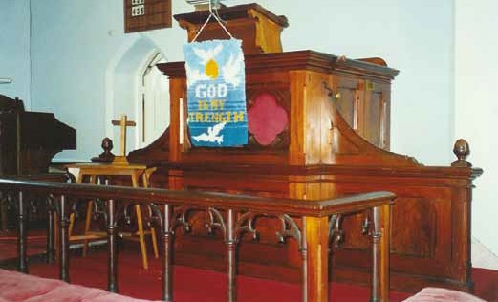
Figure 12: Intact communion rail, 1993. Source: David Rowe.
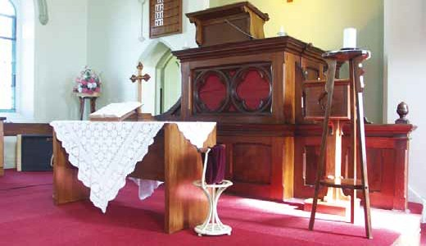
Figure 13: Removed communion rail & platform extension, 2007. Source: David Rowe.

This same church interior also features an early painted display on the west wall which reads ‘God Is Our Refuge and Strength’. These types of early decoration have significance for aesthetic and social (liturgical) reasons. They can be easily retained where internal change is being considered and are costly and difficult to reinstate after overpainting.
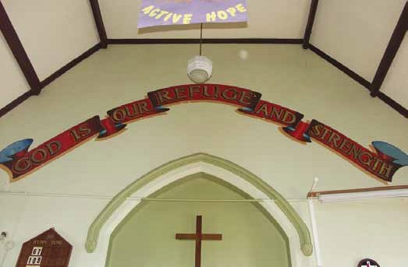
Figure 14: Original painted sign which makes a significant contribution to the aesthetic and social values of the 19th century church interior, 2007. Source: David Rowe

Introducing other features
The need for a more inclusive and flexible worship space has in some places of worship led to a need for additional minor internal alterations for functions either directly or indirectly associated with the liturgy. These alterations may include:
- installation of cupboards
- installation of tea and coffee-making facilities
- installation of a toilet.

These types of alterations generally have the least impact on significance if situated in unobtrusive locations, such as rear corners (the liturgical west end) or through the use of a vestry or side porch. Consideration needs to be given to the location of any new services to avoid damage to significant ceiling, wall and floor fabric. The design of any new cupboards, kitchenettes and similar installations should be a streamlined, contemporary interpretation of original construction and detail. For the provision of tea and coffee making facilities, steam from kettles can damage historic plaster ceilings and walls. The design brief needs to recognise any potential damaging impacts of these types of installations.
Other installations that may be required for contemporary liturgy include the introduction of computer facilities, data projectors and associated display screens, and temporary window coverings. Generally, the installation of computer equipment should be carried out in a way that avoids visual obstruction to the principal focal points of the interior, but any units or cupboards associated with the introduction of new technology should be introduced in a reversible manner (see later section on building services and utilities for further details). The ability to view data projector screens may require the installation of window screens or blinds. Ideally, these should be installed in a reversible, temporary manner and activated when required, to avoid permanent covering of significant stained glass or decorative windows and the obstruction of natural light which often contributes to the ambience of the interior. Permanent installation of more solid window coverings may also cause damaging and unnecessary moisture build-up in the window opening.

Reordering of the Interior

Minimal Recording
The fixed seating in many places of worship contributes to the significance of their interiors, by virtue of the relationship with the architectural axis of the building, related design and detailing, and construction. Depending on the integrity of the interior, it may be possible for the partial removal of some pews in less-used areas of the building, so long as this does not involve the removal of original principal floor fabric (such as exposed timber floor boards). This often provides spaces for flexible uses, such as meetings, children’s areas and before-or-after-worship social activities such as morning teas. Partial removal of pews may also be justified to allow for disabled access (see Section 7 for further details).
In some historic interiors, the original seating may not be fixed. This may include pews or more likely seats in specific areas of the building, such as choir stalls. There may be greater flexibility for temporary removal (and safe storage) of original seats and pews, and alternative uses applied to these areas as part of the ongoing life of the building.

Radical Rearrangement
Radical rearrangement of the interiors is often controversial for social and heritage reasons both within and outside the building’s particular religious community. Removal of pews may be proposed because of major liturgical change in the life of the place of worship, or simply to provide comfort and space.
In these cases the first thing to consider is the significance of the pews. Pews that were installed at the same time as the building’s construction will be of significance for that reason alone, although pews acquired at a later may also be significant. They may represent an important development in the history of the place, or may have been donated by important historic figures. Most pews will be of some significance if only because they are likely to demonstrate the original orientation and relationship to the interior.

Pews may also be significant in their own right, perhaps because of the quality of the craftsmanship or design or particular historic significance. The Heritage Act 2017 allows for objects integral to a registered place to be included in the Victorian Heritage and this may include things like church pews. Objects integral cannot be removed or re-located from a registered place without approval under the Act. Where it is desired to remove significant pews for better comfort, it might be useful to consider whether the objectives can be achieved by modifying the layout or adapting the pews themselves. If a lack of space between rows is a problem, one or two rows might be removed and the remaining pews spread out. Existing pews might be padded for greater comfort.
If it is found that the existing pews are not particularly significant and it is decided to replace them with chairs, consideration should be given to retaining some rows of pews at the rear and/or sides so that the original layout can be understood. These remaining pews could also serve as ‘overflow’ seating for special events.
With the installation of any new seats, consideration needs to be given to:
- whether a permit is required under the Heritage Act 2017
- the original architectural axes of the building and whether alternative seating patterns will have an adverse impact on the significance, character or appearance of the interior
- the weight of the new seating and whether the existing floor structure is sufficient to carry any additional load
- the design, construction and detailing of the new seats, to avoid visual and liturgical tensions with existing retained fabric
- the types of fixings for the new seating and whether the fixings will damage significant floors
- a heritage benefit for the conservation of the remaining significant fabric as a balance for the loss of some significant fabric. This may be through the restoration of a particular principal feature of the interior or an agreed schedule of maintenance works.

Internal Subdivision
In a number of cases, internal change and even modest scale internal adaptations can achieve comparable results to more costly and disruptive external additions. Adaptation of an historic place of worship may involve internal subdivision to create more flexibility in the use of the place. Any internal subdivision needs to be handled carefully to retain significant spatial and axial configurations, and character and appearance. New visual barriers should not normally interrupt significant spatial volumes and views to significant focal points and areas within the building.
Depending on the scale, complexity and significance of the interior, opportunities may be available for:
- the provision of removable screens to create entrance foyers near the main external entrance or meeting space or other associated spaces in transepts
- the provision of full height partitions below galleries or in aisle corners to create narthexes, meeting spaces or air locks
- the provision of transparent screening in side aisles to create meeting spaces, kitchenettes, and other spaces for non-worship use
- the adaptation of tower bases, vestries or side porches for kitchenettes or toilets (subject to meeting other legislative provisions)
- the provision of traditional gallery spaces at the back end of the interior for flexible worship and non-worship use.

The design of any screens and other internal subdivision devices needs careful attention. Particular consideration should be given to:
- minimal interference with existing fabric. Ways of providing flexibility of space should be considered that minimise any potential removal of significant building fabric, openings in significant walls, floors or ceilings, or alterations to significant window and door openings
- the interface of the new work with existing significant fabric. Any new work should be reversible and cause minimal damage to existing fabric
- the construction and detailing of the new work, which should generally be streamlined and innovatively draw on the detailing of existing fabric
- the retention of a sense of spatial volume where this is part of the significance of the interior, through the use of minimal or transparent new fabric.

  - External Alterations and Additions
In some circumstances where the numbers of worshippers have increased, or a larger entry or lobby is required or an additional worship space is desired, some external alterations and/or additions may be considered.
However, any addition should involve minimal intervention to existing fabric, and allow the existing building to be retained as the dominant three-dimensional feature in critical viewlines.
If a new structure directly attached to and expanding the existing historic building is the only option, consideration should be given to:
- Location: An addition should preferably be located to the side or rear of the building and not be dominant in critical views of the building. Additions to the main frontage should be avoided, unless the facade of the building was never completed in original form.
- Design, Scale & Height: If the addition is visible within critical viewlines of the significant building, it should be of subservient proportions and not dominate or detract from the historic structure. If the proposed addition is large in area relative to the existing building, consideration should be given to designing it as a new building linked to the old (refer section 5.4 New Buildings).
- Style and Details: Unless there is a history of such additions, exact copying should be avoided. Instead, one of the following main approaches should be employed:
  - A simplified version or modern interpretation of the original architectural style and detailing. This should not simply appear to be an inferior copy, or detailed such that it becomes a dominant element.
  - A contemporary design that does not draw directly on existing features, but may draw on principal design elements (such as verticality or the materials or roof shape) of the building, and retains a similar level of detail. This option is one that would require the most skill to achieve an appropriately respectful outcome.
  - A design that is entirely recessive or a transparent minimal form eg. mainly glass and dark materials.
- New pathways and driveways: these should reflect existing significant materials, textures and colours.

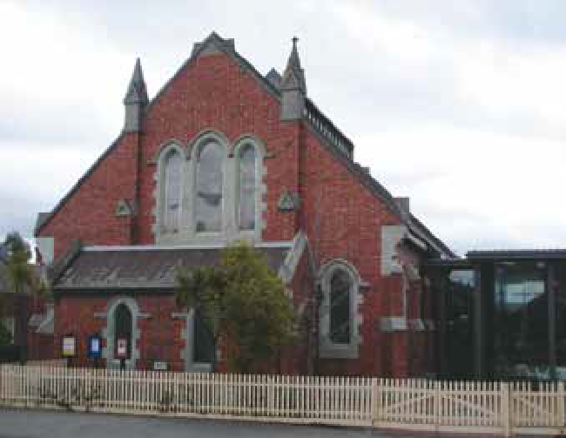
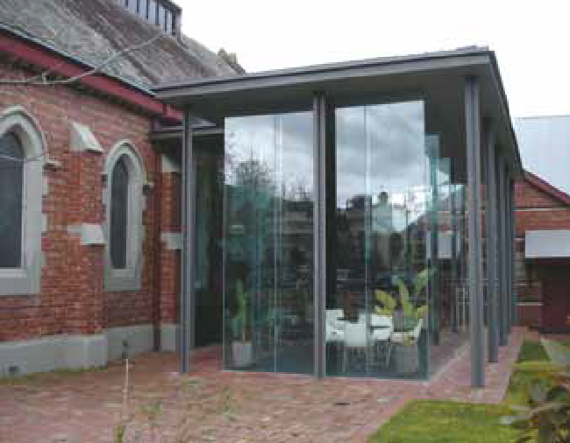
Figure 15 and 16: St Michael’s, North Carlton. Main entry is now from new glass foyer to side. Source: Rohan Storey.

Removal of Stained Glass Windows
Stained Glass has usually been designed to contribute to the aesthetic value of the built fabric and the internal ambience of the interior. The removal of stained glass windows should be avoided.
Removal may be appropriate in some situations to ensure that the windows survive. This may result from substantial deterioration or where the heritage building is sold and adapted for another use.
Careful consideration needs to be given to memorial windows. Informed decisions on retention or removal may need to include consultation with the congregation and possibly with the people or organisations (and their descendants and associates) associated with the memorial.
In any case, window removal should be based on sound advice from a suitably qualified stained glass expert as many early windows are fragile and irreplaceable.
Sometimes removal is proposed to avoid damage through vandalism. Protective screening might be a preferable alternative. Acrylic sheet has been used for this purpose but this is not recommended as its reflectivity detracts from the external appearance of the windows. The best solution is to install a fine metal mesh screen, ideally a phosphor bronze or dull finish stainless steel.
  - Key issues in Managing Change for Ongoing Liturgical Use
Consideration should be given to whether:
- a needs analysis has been prepared
- the change will have any impact on the significance of the place, including any significant liturgical features identified in the statement of significance
- the extent of change proposed will impact on significant liturgical features and whether the features serve a principle function as part of the existing and proposed liturgy
- there are ways of retaining principal significant liturgical features by reducing their visual prominence, careful adaptation or relocation (within the existing building)
- any significant liturgical features may be relocated to a similar place of worship (as a last resort)
- the location, design and construction of any new internal work is respectful to existing significant fabric
- any minor reordering of existing seating will have an impact on the significance of the interior, particularly with regard to architectural axes and the integrity of the existing seating, and the replacement use of the specific area of the interior
- sufficient justification can be provided that clearly indicates that any radical internal rearrangement is the sole means of ensuring the survival of the original ongoing liturgical function of the interior
- any subdivision of the significant interior (for the provision of other liturgical or non-liturgical areas within the building) will have any impact on the significant spatial volumes, architectural axes, view lines to significant focal points, and the character and atmosphere of the interior
- any new external alterations and additions are in keeping with the character and appearance of the existing building, in terms of height, bulk, massing, form, and construction, or are provided as a physically separate building connected by a link
- any new external alterations and additions are recessive in location and scale to the significant building
- the new external alterations and additions draw on existing detailing in a contemporary manner
- the implications of the new external alterations and additions on the existing significant interior have been considered.

- Managing the Setting
  - Background
Many places of worship are situated at the heart of cities, towns and rural centres in Victoria. While the building itself is often the local landmark, its setting can also be an important contributor to its significance and appearance. A large proportion of 19th century churches, for example, were situated on elevated, landscaped ground. Associated buildings, exotic and native trees, perimeter fences, memorial gardens, and other landscape features may therefore form part of the significance of the place of worship and the wider neighbourhood. Before deciding on any change within the grounds of a place of worship, consideration should be given to those aspects of the setting that may contribute to its significance.
Other considerations should also be carefully worked through. Discussions with the congregation and with the property manager of the particular denomination should be carried out to determine whether the proposed change to the setting accords with any relevant policies or regulations, and to determine whether there are any other impediments (such as covenant restrictions) on the land. Further thought should also be given to the heritage or planning controls that may apply to the site, including:
- whether the land is included in the Victorian Heritage Register
- land zoning and whether the uses proposed are in accord with the relevant zone/s
- whether prohibited uses may be permitted as a result of the Heritage Overlay
- whether the proposed use will create physical change to the setting which may impact on its significance.
  - Changes to the Setting
Changes to the setting of an historic place of worship may be considered for a number of reasons. An expansion of worship space and associated activities, the need for income-generating activities to support the life and ongoing use of the place and general modernisation of the appearance of the place are just a few of the changes that may impact the setting. Another change may result from the need for disabled access (see Section 7 for further details).

Landscaping
Landscapes associated with places of worship can make a substantial contribution to the significance of the specific site and the wider area. When considering the planting of new trees and other plants or paving treatments for paths, consideration should be given to whether:
- the new trees, plants or paving will have any adverse impact on existing landscape features, broader setting and building fabric. New trees planted too close to building fabric have the potential to cause structural problems to roofs, blocking of gutters or invasive root systems to foundations. Consideration should be given to the mature scale and character of the new trees and plants, and whether they have the potential to block important views to focal points within the grounds
- the removal of landscape features will have any adverse impact on the significance of the place. The grounds of places of worship are often the location of memorials and other commemorative or liturgical features that have a range of important meanings to many people, including those within the wider community
- details have been established on how the new landscape will be sustained in the future and its ongoing management
- new paving treatments are in keeping with the character and appearance of the setting, and are graded away from buildings
- there is a need to remove any concrete apron from around the building
- new garden beds will impact on the building. Where new pavements are adjacent to buildings, they should not submerge existing sub-floor ventilation openings.

Provision of New Car Parking
Given the aging population of many congregations, the provision of car parking is an important consideration. Further details in relation to disabled access are provided in Section 7. Several issues need to be considered in relation to the provision of new car parking within an existing significant setting. These issues include:
- the location of the proposed car park. While the most ideal solution may initially be to consider a location as close as possible to the front door of the worship centre, the significant landscape features and views need to form part of the decision-making process. Recessive and yet readily accessible locations are preferable in retaining cultural heritage values. Areas at the rear of places of worship, including existing or redundant tennis courts, or areas at the sides of significant buildings (but towards the rear) are often the ideal location
- the surface treatment and kerbing of the car park. The finish of the car park surface can have a substantial impact on the setting of the place. Consideration should be given to existing traditional surfaces, and to breaking up these surfaces with garden beds or other perimeter landscape features
- surface drainage. Any new car park area has the potential to cause considerable rainwater run-off which may impact significant buildings if located adjacent to them. Suitable surface drainage is therefore an important consideration.

Fencing

Existing Fencing
Perimeter fencing to places of worship often relates to the design and era in which the original (or early) building/s was constructed. It often makes an important contribution to the presentation of the property when viewed from the public realm. In relation to existing fencing, consideration should be given to:
- retention of original or early fences identified in the statement of significance
- restoration and repairs. The local government heritage advisor may be in a position to provide some basic advice on appropriate repair methods applicable to the historic fence. Alternatively, engaging a heritage consultant may also be appropriate. The local government heritage advisor or a private heritage consultant should also be able to provide a list of tradespeople to assist with the repairs
- removal. Only where the fence is not original or significant.

New Fencing
A new perimeter fence to a place of worship will play an important role in the overall presentation of the property. Careful thought needs to be given to:
- the purpose of the fence and whether there is a history of fencing in the location/s being considered
- the potential impacts the fence may have on views to the property and spaces within it by virtue of the proposed design, construction and height of the fence
- access to the property, through the provision of pedestrian and vehicular gates.
Before deciding on the type and design of a new fence, carry out some research to determine:
- whether there is a history of perimeter fences
- the designs of any earlier fences. Most places of worship have a collection of historic photographs. Even where these photographs may focus on people and activities, other features such as fences can often be identified in the background. From a heritage viewpoint, a new fence based on an historic design (including height) is an ideal outcome
- fence designs common for the style, construction, scale and context of the place of worship. Visit other places of worship of similar style and construction, to identify any early fence types that may be applicable and appropriate. While not specific to historic fences to places of worship, the Technical Bulletin 8.1 entitled A Guide to Identification, Conservation and Restoration of Historic Fences and Gates c.1840-1925 compiled by Richard Peterson for the National Trust of Australia (Victoria), 1988, may be a useful general guide.
Example:
St. Albans Uniting Church, St. Albans Park (Figures 17 and 18)
The 19th century photograph shows the original timber picket fence that formed the boundary to the Church property in the 19th century, which was very different to the fence introduced in the early 20th century, as shown in the recent photograph.
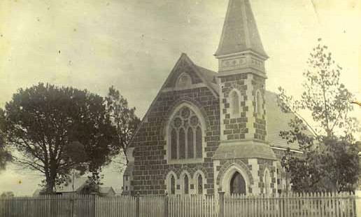
Figure 17: St. Albans Uniting Church, St. Albans Park, n.d. [c.1890]. Source: St. Albans Uniting Church.
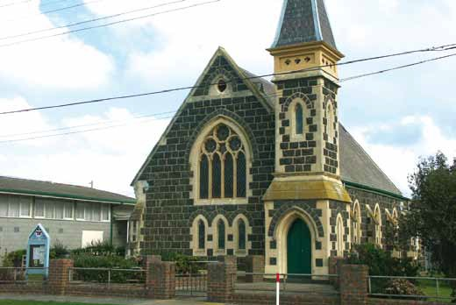
Figure 18: St. Albans Uniting Church, 2007. Source: David Rowe.

Signage
A traditional feature of most places of worship is the signage board. Most traditional signs are freestanding and provide details about worship services and times, and possibly other important information associated with the place. At certain times of the year, additional signs may be required to advertise special services, such as at Christmas and Easter. Before considering change to an existing sign or the construction of a new sign, thought should be given to:
- the heritage status of the existing sign and whether it is identified in the statement of significance
- opportunities for restoration and repair if the existing sign has heritage value
- the location, scale, design, construction and finish of any proposed sign. It is important that signs are noticeable and their messages are clear, but they should not dominate the significant settings and buildings. The shape of the signage board or structure and the lettering style may need careful consideration. The locations of most signs should be freestanding and not attached to significant buildings. Where attaching to a building is acceptable, consideration needs to be given to the placement and scale of the sign and the method of attachment. Attaching signs to significant buildings should be done in the least intrusive manner possible.

Church Yard Cemeteries
There are a select number of places of worship in Victoria where cemeteries are situated within the church grounds. Aside from the obvious cultural importance of the cemetery itself, the link between worship and death may be critical to the ongoing aesthetic, historic and social significance of the place. Obscuring views (through the provision of fencing or plantings) or subdividing churchyard cemeteries from the bulk of the site has the potential to adversely affect the significance of the place. It is therefore important that:
- the visual and cultural relationships between the churchyard cemetery and the rest of the site be considered before making any change to the setting of the place
- any new developments or changes to the setting are not situated in locations that have the potential to disturb archaeological sites.

New Buildings
Many historic places of worship feature more than one building.
Associated buildings including church halls, manses, vicarages or presbyteries, pavilions and other structures may or may not contribute to the significance, character and appearance of the place. Those of heritage value should be identified in the statement of significance.
New buildings proposed as part of the ongoing liturgical use of the site may include new fellowship centres, community-related centres and meeting rooms, and halls.
If the purpose is integral to the operation of another building, a link may be provided between the two in the form of a simple small structure, connecting preferably to an existing doorway or perhaps a minor window altered to form an opening. Such a link should be kept as small in area as possible and preferably mainly in glass.

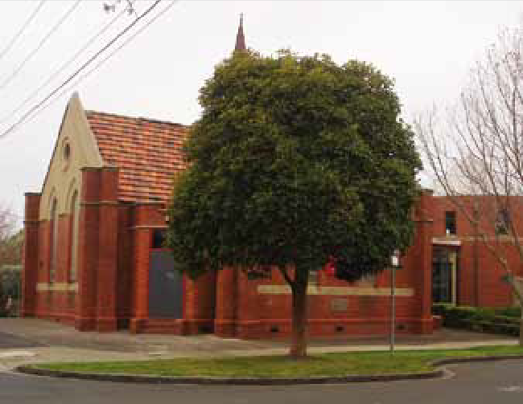
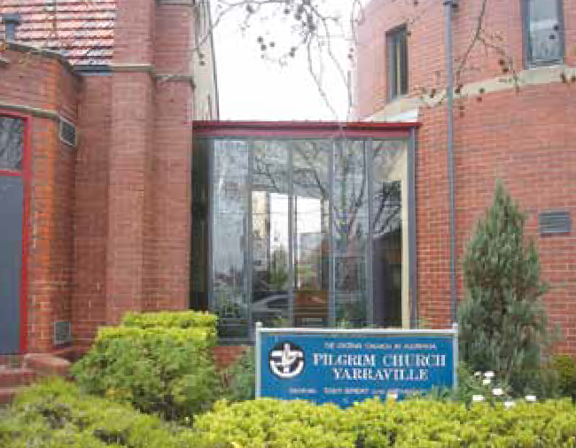
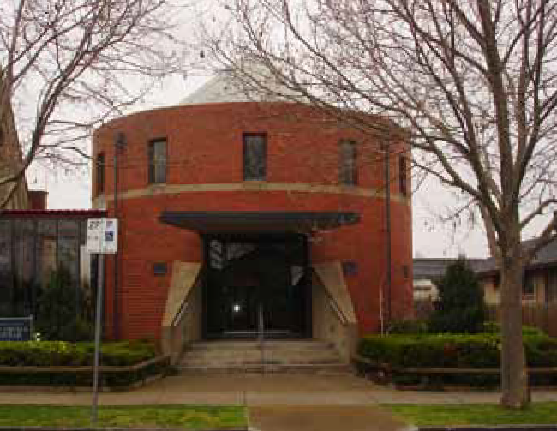
Figures 19, 20 and 21: Pilgrim Uniting Church, Yarraville. The original Edwardian church has been greatly expanded by the construction of a new brick cylinder entry structure to one side, linked by glass walls to the original church

In relation to new buildings, whether connected to an existing building or entirely separate, the following guidelines apply:
- Location: New buildings should generally be located to the side or rear of the principal building/s or of the site as a whole, and be located to avoid main viewlines of or between significant buildings.
- Design, Scale and Height: If the new building is visible within critical viewlines of significant buildings, new construction should not visually dominate or detract from the principle buildings or the site.
- Style and Details: Exact copying should be avoided. Instead, one of the following three main approaches should be employed:
  - A simplified version or modern interpretation of the original architectural style and detailing. This should not simply appear to be an inferior copy, or detailed such that it becomes a dominant element.
  - A contemporary design that does not draw directly on existing features, but may draw on principal design elements (such as verticality or the materials or roof shape) of the building, and retains a similar level of detail. This option is one that would require the most skill to achieve an appropriately respectful outcome.
  - A design that is entirely recessive or a transparent minimal form eg. mainly glass and dark materials.
- New pathways and driveways: these should reflect existing significant materials, textures and colours.

Land Subdivision
As previously outlined, the setting of an historic place of worship can make a substantial contribution to its cultural heritage significance. Historically, many places of worship were situated on prime land parcels, being substantial in scale and having regular allotment patterns. Given the often central and financially valuable locations of places of worship, parts of the site may be considered surplus to the current needs of the congregation. The provision of welfare services or low-income housing are other reasons subdivisions might be proposed. However, subdivision is not a readily reversible change and should be approached with caution. The placement of the significant building stock, the views to and from these buildings and other important landscape features, and the potential impacts of future development (as a result of the subdivision) should be the overriding considerations in any subdivision proposal. In particular, consideration should be given to the following:
- the historical importance of the extent of the setting and site layout and whether they need to be retained as part of the significance of the place
- the location of the proposed subdivision, and whether the associative and historical links of the place will be maintained. Any subdivision should retain the significant setting, including the grouping of significant buildings, landscape features, views and spaces. The isolation of significant buildings and features from the original setting may be detrimental to the heritage values of the place
- the layout and pattern of the proposed subdivision, and whether they are in keeping with the existing layout and pattern of the site
- the broader streetscape impacts of the proposed subdivision, particularly where the place of worship is a significant individual landmark in a heritage area
- the setbacks, layouts, scale, form, design, height, bulk and materials and finishes of the proposed development on the subdivided land, and whether they will adversely impact on the significance of the setting and significant buildings of the centre. Any new development should be recessive and respectfully contemporary in design and not dominate over the worship site
- a heritage benefit as a result of the subdivision, such as the preparation of a conservation management plan, provision of a financial sum for restoration and repair works, or the implementation of interpretive measures to provide an appreciation of the original extent of the site.

  - Key Issues in Managing the Setting for Ongoing Liturgical Use
Consideration needs to be given to the following where changes to the setting are being proposed:
- the policies and regulations of the property manager of the particular faith
- the land zonings of the local government planning scheme
- the heritage status indicated in the local government planning scheme and/or the Victorian Heritage Register
- the legal status of the land
- the implications of new landscape features on the significance of the existing setting
- the implications of the removal of existing landscape features and whether this will impact the overall setting
- the management options for the ongoing viability of the new landscape
- the significance of existing perimeter fencing and options for restoration, repair or reconstruction
- the potential impacts of new fencing on views and setting
- the design, construction and height of new perimeter fencing, based on earlier fences (through analysis of historical photographs) or fence designs of worship places of similar scale, style, construction and setting
- the significance of existing signage and options for restoration and repair
- the location, scale, design, construction and finish of proposed signs and the implications on significance
- the retention of visual and cultural relationships between churchyard cemeteries and places of worship
- the location, design, scale, height, design details, construction and associated paving of proposed buildings and whether it will affect the significance, character or appearance of the setting
- the location, finish and drainage of new car parking
- the historical importance of the existing extent and layout of the land and the implications of any subdivisions on the significance, character and appearance of the setting
- the broader streetscape impacts of proposed subdivisions where the place of worship is within a heritage area
- the implications for the significant setting of the location, design, setbacks, scale, form, height, bulk and materials of proposed development on the subdivided land
- the heritage benefit to be provided in return for the benefit gained of any subdivision.
- Relocation and Demolition
  - Background
Most places of worship have strong associations with the site upon which they are situated and are often important traditional symbols within the broader community. Their significance lies in their architecture, history, construction and social and educational role in their community. The relocation or demolition of places of worship should therefore be avoided, as the loss of these important places may not only be a loss of a significant building on its site, but also the loss of a substantial community asset. Relocation and/or demolition may be acceptable in specific limited circumstances. This section outlines some of the situations where relocation or demolition may be considered.
  - Relocation
Relocation of principal places of worship and associated buildings should normally be avoided. Alternative options need to be considered to ensure their longer term viability.
From a heritage viewpoint, few opportunities are available to relocate principal masonry buildings such as brick or stone structures. Relocation of these types of buildings not only creates a significant associational loss to the site and area from which it has been relocated, but has a highly detrimental impact on physical fabric and integrity. It is rare for a masonry building to be successfully relocated (given that each building block needs to be relocated stone by stone or brick by brick). Occasions where relocation may be appropriate include where the design or construction may be highly uncommon and the building is not in use or has been abandoned; where the relocation is cost-effective and/or responds to community aspirations; and where a viable use has been identified.
Example:
The former St. Johns Roman Catholic Church (Figure 22), Sutherlands Creek, was constructed in 1858. It was built of Maude quartzitic sandstone and represented a very rare method of 19th century building construction, being the only known church in Victoria of this construction. Abandoned from c.1950, the building was relocated stone by stone to the Deakin University campus, Waurn Ponds, in 1986. It is now used as an ecumenical campus chapel (Figure 23).
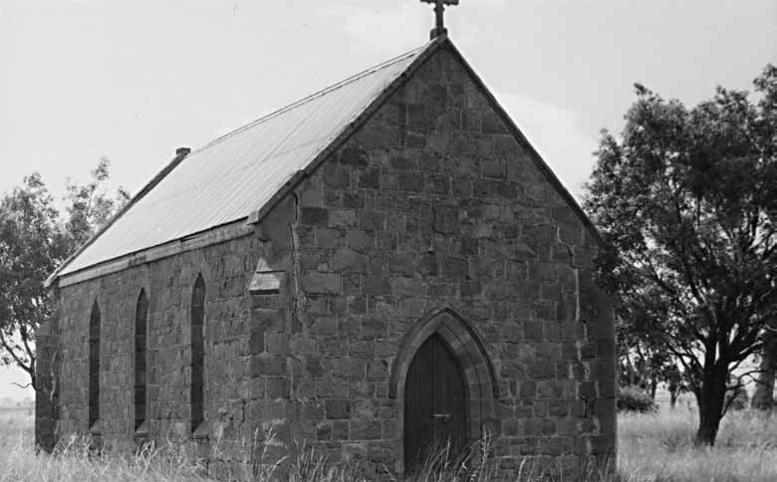
Figure 22: St. Johns Roman Catholic Church, Sutherlands Creek, 1966. Source: Latrobe Picture Collection, State Library of Victoria.
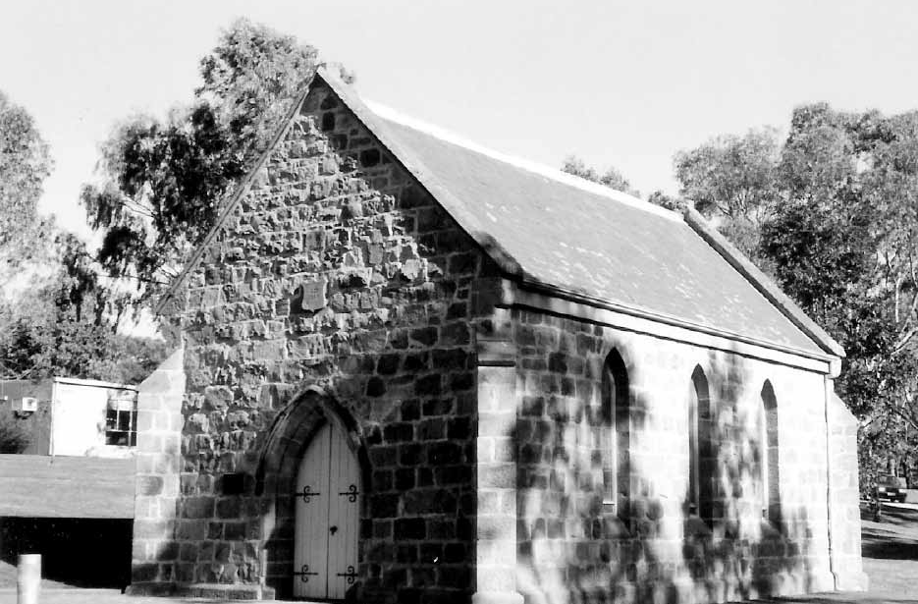
Figure 23: Deakin University Chapel (formerly St. John’s Roman Catholic Church), Waurn Ponds, 1998. Source: David Rowe.
There may be more opportunities for the relocation of timber or prefabricated buildings if they have a history of previous relocations. Relocation of timber or prefabricated buildings may be considered if:
- there is a history of relocation and the associational value of the building is not such that would cause an adverse impact on the significance of the place as a whole. This may relate to principal or secondary buildings and other structures that may not be original or early, and whose provenance is well documented
- justifiable evidence has been provided clearly indicating that the relocation is the sole means of ensuring the survival of the building
- justifiable evidence has been provided indicating that the relocation will allow for the longer term viability and sustainability of the site as a whole, as part of its primary worship function
- the relocation involves a significant landscape feature within the site and there is a history of different locations of the feature (such as a flagpole or memorial seating)
- the relocation involves a secondary building that is being relocated on the same site.

Example:
All Saints Anglican Church, Lorne, was built in timber in 1880. In 1884, it was relocated to a new site in Lorne using sledges pulled by horses and bullocks to its current site (Figures 24 and 25). The church now has long historical associations with the local Anglican community in Lorne on its existing site.
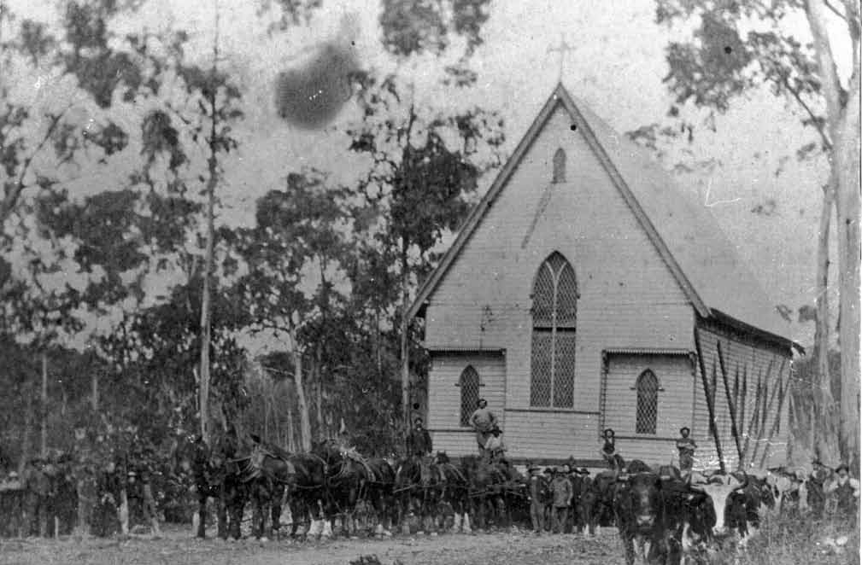
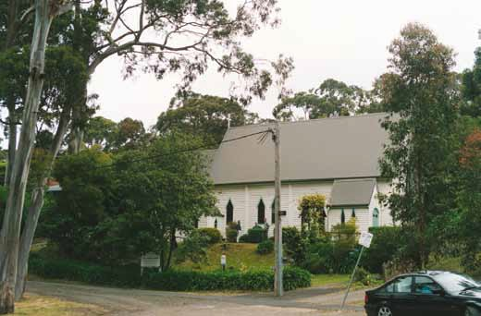

Figure 24: All Saints Anglican Church, Lorne, c.1884, being relocated to its existing site by horses and bullocks. Source: Lorne and District Historical Society.
Figure 25: All Saints Anglican Church, Lorne, 2002. Source: David Rowe.

  - Demolition
Demolition of significant places of worship is not normally an acceptable option from heritage and social viewpoints. All avenues for the retention of the building should be thoroughly investigated. Demolition of significant secondary buildings such as church halls also should normally be avoided. Generally, there is no valid basis for contemplating the demolition of a significant secondary building to allow improvements to the main building, as often the significance of the place includes the setting and the complex of buildings within it, in addition to any important historical and social associations each specific building may have.
From a heritage viewpoint, the few acceptable opportunities where demolition may be considered include the following where:
- the demolition involves the removal of later modifications and additions to an historic place of worship that do not contribute to its significance, as outlined in the statement of significance
- the demolition is the result of a catastrophic event (such as a fire) whereby the remaining building fabric is structurally unsound and a Building Order has been issued by a registered building surveyor and supported by an independent structural engineer.
  - Key Issues in Relocation and Demolition
For any proposed relocation or demolition, consideration needs to be given to:
- avoiding the relocation of significant places of worship
- whether there is a history of relocation for the building (particularly buildings that may be easily relocated, such as those constructed of timber or prefabricated material). The relocation should only be considered if there are no significant long term associational links with the existing site and setting
- whether the relocation provides the only means for the survival of the building
- avoiding the relocation of significant landscape features unless there is a history of relocation
- whether the relocation provides the sole means for the survival of the landscape feature
- whether the relocation involves a secondary building being moved on the same site
- avoiding substantial or total demolition, as all avenues for the retention of the building should be explored
- avoiding the demolition of significant secondary buildings
- demolition of later non-significant modifications or additions only
- the structural instability of the building as a result of a catastrophic event (such as a fire or earthquake), with the remaining fabric being deemed to be unsafe as a Building Order has been served by the relevant building surveyor for its removal that is supported by an independent structural engineer.

- Building Services and Utilities
  - Background
Most places of worship were not designed to provide sophisticated levels of comfort and services. Services to these types of buildings were normally isolated to specific locations. Today however, there are general expectations that these places will provide good lighting, at least minimal heating in winter and well-ventilated interiors in summer. Technological advancements have also influenced worship practices, with electronic equipment becoming a more important part of the worship experience. Access to plumbing for toilets and sinks is now becoming a requirement in buildings not designed for such services. This section deals with some of the issues that require careful thought prior to the removal or introduction of services and utilities.
  - General Principles
The general principles that need to be considered given the significance of external and internal building fabric to many places of worship are to ensure:
- the work is carried out in a manner that will not diminish the significance of the place of worship
- consideration has been given to the existing building fabric and its original intended performance
- the work involves minimal intervention to significant fabric
- the work is reversible
- the work is carried out by a suitably qualified tradesperson under the supervision of a heritage practitioner.
  - Existing Services
Careful thought needs to be given to the significance and condition of existing services. Historic switches, fixtures, plumbing services for heating systems, and other historic equipment such as organs and associated pipes may contribute to the significance, character or appearance of the historic place of worship, or they may be significant in their own right. An assessment of the heritage value of existing services should be made prior to their removal or adaptation.
Whether the historic services are significant or not, their condition needs to be monitored. Flaws in existing services such as electrical wiring or plumbing pose substantial hazards to places of worship, particularly where these services are concealed behind walls and ceilings, under floors and in organ chambers. Existing services must be regularly assessed to ensure satisfactory performance, safety and sustainability.
Where historic services are identified as having significance, options for retention (even if redundant) need to be given uppermost priority. However, unsafe or redundant wiring and equipment should be disconnected for occupational health and safety reasons, even if for temporary periods until funds are available for repairs. For historic switches and electrical fixtures and features, adaptation may be possible through rewiring and updating of some of the components. Safety switches, for example, should be incorporated into switch boards. Supply should be checked against the capacity of the existing services.
  - Location of New Electrical and Plumbing Services
Careful thought needs to be given to the location of new electrical and plumbing services in places of worship to minimise physical intervention and avoid potential secondary impacts on existing fabric. Preliminary discussions with electrical, plumbing and other contractors should ensure that the significant fabric of the place of worship is well understood. In particular, consideration should be given to the following:

Cutting and Chasing in Services
Every effort should be made to avoid cutting or chasing in electrical services or pipework. New services should be adapted to suit the building. Cutting into early timber wall or ceiling frames and beams, floor joists and bearers or significant timber screens, partitions, pulpits, pews and other significant fittings and fixtures not only impacts on the integrity of the significant fabric, but also has potential to weaken it structurally. Examine options for the least amount of servicing or pipework possible and run services or pipes around structural members and significant fabric (particularly where this fabric is concealed, such as around a ceiling beam or floor bearer).
Chasing services into plaster wall surfaces, columns, cornices and architectural features of highly significant interiors also has a detrimental impact on their integrity. This type of intervention not only damages the significant fabric, but it is also not reversible.

Concealed Services
Concealing new services has the least visual intrusion and impact on the significant fabric of a place of worship if careful consideration is given to the locations of the service runs. Concealing services in service rooms (such as vestries), towers, wall cavities (where they exist), sub-floor spaces and roof spaces are some of the most likely and appropriate locations. Importantly, any new concealed services should be recorded and tested prior to being enclosed and completely concealed. Services should not be located in concealed areas where their performance is likely to have an impact on adjacent significant fabric.

Exposed Services
For solid walls and other parts of a place of worship where external or internal wiring and other services cannot be concealed, services should be routed in those parts of the building beyond the normal field of vision and should follow the lines of the significant fabric, to reduce their potential visual dominance. Running wiring on the rear faces of exposed ceiling beams, along the tops of beams and cornices and colouring or painting to blend with the background are some of the possible solutions. However, exposed services in the most important spaces of the building, and particularly nearby focal points such as chancel arches and altars, are unlikely to be successful as they will detract from the character and detailing of the significant fabric.
All new service boxes and panels, outlets and switches should be located in areas that minimize the impact on the appearance and integrity of the significant fabric.
New services connected to masonry surfaces should ideally be fixed in the mortar rather than the masonry (where the mortar is sufficiently strong).
  - Lighting
Increased comfort and the need to provide sufficient lighting for the visually impaired are public expectations in places of worship today. Yet, some light fittings may in themselves have aesthetic heritage value and provide an ambience that relates to the original intended design and appearance. Opportunities may also exist to introduce additional types of light to highlight or reduce the dominance of particular architectural or liturgical features, define spaces, enhance colours, textures and forms in addition to their functional necessity.

Existing Significant Lights
Existing significant light fittings – whether pendants, chandeliers, sconces or other types – should be retained and incorporated into any new lighting systems. All existing and significant lights should be inventoried in situ prior to removal for restoration. Existing lights need to be carefully examined to ensure that they meet current regulations and safety standards. They may need to be cleaned, polished, lacquered, repaired and rewired and, where necessary, specific parts replaced or altered to meet current regulatory requirements.

New Lighting Systems

Interior
Changing or adding to the lighting in places of worship can have a dramatic effect on the character and appearance of the interior and the liturgy. Most existing significant lights are decorative or festive lights (such as pendants) within the interior. Where other types of lighting are situated in unobtrusive locations and where the installation avoids major damage to significant fabric they may be considered. The new lighting should enhance the character and appearance of the place and the quality of the experience, and not produce unnecessary glare.
One discrete solution is to use carefully located up lighters and light the interior from the reflected light off the ceiling. This solution however requires very powerful lights which are both expensive to buy and to run and well beyond the reach of most congregations. One of the simplest and cheapest solutions is to use simple pendants and if these have light weight acrylic shades, perhaps cylinders spheres or half spheres they can be suspended on the power cable alone avoiding additional wire suspensions.
Thought always needs to be given to how lamps at the end of their life can be changed. This can be awkward when light is required over a large bank of pews. A long pendent length can be helpful however as pendants can be hooked at some distance and swung out to ladders erected in the aisle enabling the lamp to be replaced.
Task or reading lights (for beaming light directly downwards onto lecterns, choir stalls and organs) and indirect or architectural light (used to highlight architectural elements such as ornamental plasterwork, wall stencilling or liturgical features such as altars) are some of the types of lighting that could be considered. These additional lighting systems often involve spot or flood lights to create the dramatic effects, as the lighting is directed to particular concentrated areas. Downlights (light emanating from an opening in the ceiling having a balled elliptical reflector) are generally inappropriate for significant interiors, as they involve substantial intervention into significant ceiling fabric and if located in high ceilings they have the potential to produce glare.

Exterior
External floodlighting may assist to highlight important architectural features of the place of worship at night. They may also be required for security and safety reasons. Unobtrusive locations should be sought for spot and floodlighting and any fixings to exterior fabric minimised. Generally, given the architectural integrity of these buildings, any floodlighting should enhance its appearance. Consideration of alternative lighting types, (such as neon lights) that would create a focus on the lighting itself, is discouraged.
  - Heating
Most places of worship are used so intermittently that full heating of the interior to a modern comfort level is unsustainable and the expense not justified. Heating traditional places of worship is also problematic in that they are often large spaces with very high ceilings.
The retention and reuse of existing early heating systems may be possible through necessary upgrades to meeting current regulatory requirements.
Consideration also needs to be given to minimising physical intervention in significant building fabric. The type and location of heating may therefore be guided by whether there are opportunities to install plant, flues, ducts, service pipes and conduits in unobtrusive locations and in a manner that minimises damage to physical fabric.
The installation of new heating systems requires a particular understanding of the thermal performance of the building construction. Places of worship constructed in the 19th century, for example, were often built of masonry materials such as brick and stone using lime-based mortars and renders. These materials enable the overall building fabric to ‘breathe’, allowing any moisture in the fabric to readily evaporate. The introduction of powerful contemporary heating systems – particularly where traditional ventilation ducts and openings are also blocked – may upset the traditional performance of the building fabric. Rapid changes in air temperature and humidity can create additional moisture build up, causing damage to significant and often fragile building fabric and surfaces.

The provision of a new heating system will require an assessment of:
- the climate in which the place of worship is located
- size of the building
- construction and materials.
Various combinations of heating systems have proved acceptable over time, but this varies greatly from building to building. Heating systems that may be appropriate (depending on the building and the hours of use) are:
- hydronic heating
- ducted warm air
- radiant floor panels
- under-pew radiators.
Each place of worship has individual needs, resources and internal environmental conditions. Particular consideration may need to be given to:
- required heating start up times
- options for high capital costs (but lower running costs) or low capital costs (but higher running costs)
- intervention into building fabric.
It is strongly recommended that advice is sought from an independent mechanical engineer (independent of specific company and product representation) for specific guidance in conjunction with advice from a heritage advisor or heritage consultant.
  - Cooling
The installation of cooling systems in places of worship that are used intermittently is not often justified. The designs of most places of worship usually allow warm air to escape through windows, vents, clerestories and towers. Increasing air circulation is therefore the ideal method of cooling the interior. Checking the condition of ventilating sashes in stained glass and other windows, repairing frames and hardware and unblocking ceiling vents and flues are some economical measures that may assist thermal comfort. Opening up doors in vestries, towers and porches to create up and cross drafts may also assist. In some situations, ceiling fans may be appropriate, but where there are significant ornate ceilings, they are discouraged. A simple seasonal solution may be the provision of electrical pedestal fans. Given that traditional masonry buildings often retain cool night time air, earlier morning worship times to maximise the performance benefits of the building may also prove worthwhile.
  - Fire Safety
Given that the bulk of places of worship are unoccupied for much of the time, they are also at greater risk from fire. Flawed electrical systems and burning candles are two of the potential causes. The installation of sprinkler protection system, fire detection and emergency lightning are important considering creating safeguards against the loss of significant building fabric and features. Careful consideration needs to be given to reducing any potential visual intrusion and installing systems in a manner that involves the least impact on significant fabric. The level and type of fire safety measures need to be assessed by a fire safety expert.
  - Organs
A significant feature in many Christian places of worship is the organ. In some instances, an organ may have intrinsic heritage value itself, as well as value in its association with a place of worship. It may make an important aesthetic contribution to an interior (mainly by virtue of the scale and prominence of the organ pipes), in addition to its contribution to the worship service. Organs identified in the statement of significance should therefore be retained.
Specialist advice should be sought in relation to the regular maintenance and repair of organs and the merits of introducing electronic upgrades (depending on the integrity and rarity of the organ mechanisms).
  - Bells and Associated Works
Bells and associated works (ropes and pulley or mechanical devices and frames) often contribute to the significance of places of worship and should be identified in the statement of significance. Their significance may relate to their specific function, operating mechanisms, provenance (such as the particular patent and date of manufacture), integrity and rarity. Given the often elevated locations at the summit of towers, they are difficult to reach for regular maintenance and monitoring. Operating bell systems should be monitored and maintained on a regular basis by qualified specialists. Where traditional manual operation of the bells is no longer sustainable, the installation of electronic equipment to augment the existing operation should be weighed up against the integrity and rarity of the existing significant system, and the importance of continuing its audible function.
Where the systems may be redundant, all the parts and framing should be retained in situ for possible repair in the future.
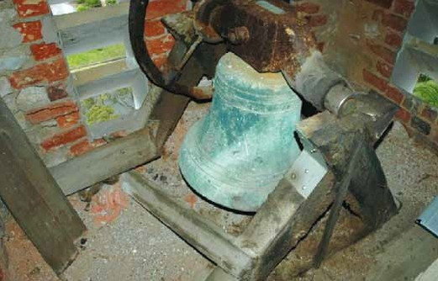
Figure 26: Bell and associated system in the tower of St. George the Martyr Anglican Church, Queenscliff, 2005. Source: Wendy Jacobs and David Rowe.
  - Solar Energy Systems
Solar panels are an effective measure to reduce energy consumption. The installation of solar panels will require careful consideration of their size, number and placement to that they do not adversely impact the significance, character and appearance of the heritage building. Heritage Victora has published Solar Panel Guidelines for places included in the Victorian Heritage Register, but the same principles can be applied for all historic places of worship.
In particular, consideration should be given to solar panel installations:
- On less significant and/or less visually prominent roof faces such as rear chancels, vestries and porches.
- Minimal size and number for main side roofs. The panels should be located towards the lower reaches of the roof and be framed by roof cladding. Ideally, the solar units should not exceed 15% for a visible roof plane. Solar panels on main front roofs should be avoided.
- On less significant buildings on the site, such as a hall or shed.
- Freestanding banks of panels (in recessive locations) for highly significant heritage buildings.
  - Telecommunications Equipment
Towers and steeples may provide opportunities for the installation of telecommunications equipment, bringing valuable income to places of worship. Prior to installing this type of equipment, consideration should be given to:
- broader community opinion
- the impact the equipment may have on significant physical fabric as a result of cable runs, antennae, junction boxes and potential alterations to architectural detailing, such as tower louvres, to facilitate transmission.
  - Key Issues in Building Services and Utilities
Before changing or installing building services or utilities, the following should be considered:
- the significance and condition of existing services, and whether they can be retained and adapted to meet contemporary needs and regulations
- the location of new electrical wiring and plumbing, which minimises physical intervention and visual intrusion, and secondary impacts on existing fabric
- the avoidance of cutting or chasing in new services into existing significant building fabric
- opportunities for introducing concealed services in vestries, towers, sub-floor spaces and roof spaces
- opportunities for introducing exposed services (where concealment is not possible), routed in these parts of the building beyond the normal field of vision and following the lines of significant fabric. There are potentially few opportunities for introducing exposed services in principal spaces and focal points (such as chancel arches and altars)
- opportunities for retaining existing significant light fittings and upgrading specific parts to meet current regulations and safety requirements
- opportunities for introduced new task or reading lights, or indirect or architectural light to enhance the liturgy and/or character and appearance of the interior
- opportunities for retaining and upgrading significant heating systems
- opportunities for installing new heating systems that consider the traditional thermal performance of the significant building fabric, increase thermal comfort to specific isolated areas only, location and type of heating and minimise intervention in significant fabric
- the avoidance of installing cooling systems given the intermittent use of many places of worship and the opportunities for increasing traditional air circulation through the repair of windows and window openings and the creation of up and cross drafts through opening doors in vestries, towers and porches
- opportunities for introducing sprinkler systems and smoke detection systems to reduce the risk of fire
- the significance of organs and associated features such as the organ pipes, and the need for regular maintenance and repair
- the significance of bells and bell systems for continued operation and the retention of systems that may currently be redundant
- the impacts of new telecommunications equipment on significant building fabric and the impacts on the broader community.

- Accessibility and Inclusion
  - Background
People with disabilities constitute 17.7% of the Australian population. Anecdotal evidence suggests that many regular worshippers are elderly and approximately 50% of people over the age of 60 have age-related disabilities. Yet, a number of traditional (particularly 19th century) places of worship in Victoria impede inclusive involvement by virtue of physical and liturgical impediments. Access to places of worship, including the external pathways, entrances, internal routes and multiple levels, as well as liturgical fittings and fixtures may be difficult or impossible for portions of the community. Occupational Health and Safety legislation is required to be addressed by property managers and congregations to ensure places of worship are inclusive for all without compromising significant heritage values and spirituality.
  - Legislation

Disability Discrimination Act 1992 (Commonwealth)
The Disability Discrimination Act (DDA) requires people with disabilities to be given equal opportunity to participate in and contribute to the full range of social, political and cultural activities. Places of worship must comply with this legislation irrespective of whether any change or building works are being proposed. The DDA promotes and protects the quality of physical, informational and attitudinal access as opposed to limited or marginalised access. From a legal perspective, the DDA overrides other Commonwealth, state or territory heritage legislation. The single exception is where the provision of access under the DDA creates proven unjustifiable hardship. However, in the majority of situations, solutions should be considered that maximise access with minimal impact on significant fabric. The DDA and heritage legislation are non-prescriptive and so there is flexibility in applying the relevant legislative provisions to achieve optimum accessibility and heritage outcomes.
In addition to the DDA, the requirements of the Building Code of Australia and the relevant Australian Standards must also be considered when proposing a change to provide access for disabled people. Engaging a member of the Association of Consultants in Access Australia – in consultation with the local council heritage advisor or a private heritage consultant – may assist in working through the access and heritage issues in a highly informed way.

Disability Act 2006 (Victoria)
The Disability Act provides a framework for governments and communities to work together to enable people with a disability to actively participate in the life of the community. While the Act is more focussed on legislating provisions for disability service providers, other government agencies and community services – including places of worship where applicable – may also benefit from understanding and implementing the objectives and principles of this Act.

Building Legislations
Australian Standard 1428.1 2009 provides minimum design requirements for new building work and is referenced in the National Construction Code and Premises Standards. Compliance with AS 1428.1 will enable access for people with disabilities to and within a building.

Occupational Health and Safety Legislation
Under legislation and common law, all employers have an obligation to provide a safe and healthy workplace and to endeavour to remove or minimise potential risks. Places of worship therefore need to be assessed in relation to potential risks to the health and safety of paid employees. However, employers, leaders and property managers of places of worship also have a duty of care to volunteers, contractors and the general public. Both the Commonwealth and Victorian Governments administer Occupational Health and Safety legislation. This legislation is based on the following principles:
- identify potential risks
- work to eliminate the risks from the place of worship
- control the risk so that it no longer exists, or reduce the risk
- no employee, volunteer, contractor or the general public should be in an environment that places them at risk
- protect the health and safety of employees, volunteers, contractors and the general public at places of worship.
Preparing a written risk analysis for places of worship is therefore important in identifying, eliminating or reducing potential risks. Where these risks involve significant building or liturgical fabric, solutions should be considered that eliminate or reduce the risk, without diminishing the significance of the fabric. The risk analysis should be reviewed annually and an essential safety measures report prepared.
  - Process of Analysis
In Improving Access to Heritage Buildings, Eric Martin suggests a five step approach to identifying and implementing accessibility modifications which may impact on the integrity and significance of heritage place. This approach is valid for places of worship. The approach is as follows:
- review the significance of the place and identify the elements of greatest significance
- undertake an access audit to determine existing and required levels of accessibility
- evaluate access options within a conservation context. This process includes consultation with authorities and approval of the proposed action
- prepare the access policy or action plan
- implement the necessary action.
  - Access Audit
An access audit should identify all the barriers and issues that need to be resolved to provide appropriate accessibility to the place of worship. The main types of barrier are:
- organisational
- physical
- sensory
- intellectual
- social and cultural
- financial.
In relation to places of worship and cultural heritage significance, particular consideration needs to be given to physical barriers. Access audits must identify accessibility barriers for people with a variety of disabilities. These barriers include:
- pathways from car parking to building entrance
- building entrances
- multi-level spaces (such as choir lofts)
- narrow aisles
- fixed pews and other seating
- floor finishes
- toilets.
Current liturgical practices may also create organisational, physical and sensory barriers for some disabled people. Access audits must also account for these types of barriers including:
- elevated chancel platforms, pulpits and lecterns
- small print Bibles, hymnals and associated materials
- lighting
- auditory systems
- fragrance-free areas.
  - Car Parking and Pathways
Car parking for disabled people needs to be provided in reasonably close proximity to the principal entrance to the place of worship. The parking spaces should be well sign-posted, clearly identified and specifically dedicated to the disabled. Consider sealed surfaces for car parks and pathways (such as flagstones or pavers) and avoid loose surfaces. Where sealed surfaces may have an impact on significant settings to places of worship, consideration could be given to well compacted or cement stabilised gravel or crushed rock surface. Kerbs to parks and paths should be dropped between setting down points and designated parking bays, and the approach to the building entrance. Car park and pathway gradients and the widths of the pathways also need to be considered against the relevant Australian Standards.
Consideration also needs to be given to existing vegetation. Pathways and car parks should be clear of trees and particularly overhanging branches and associated debris.
  - Principal Access to the Place of Worship

Principal Entry
Defining the principal access to the place of worship is critical in ensuring inclusive access. Where original, highly significant principal entries do not provide access for all and cannot be altered without substantial compromise to existing fabric, consideration should be given to a new or alternative entry to ensure that disabled people are not discriminated against. Disabled-only entry through a side porch or vestry marginalises disabled people and, apart from extenuating circumstances, should be avoided. Many places of worship enjoy more than one entry. The original main entrance should obviously be retained in situ to ensure retention of integrity and heritage significance, and can also serve for special ceremonial events and activities, such as weddings and funerals.
Where existing alternative entries are proposed for the principal accessible entry, consideration also needs to be given to any potential impacts it may have on internal circulation routes and fittings and fixtures (including fixed pews).
Where new entries are proposed, particular consideration must be given to the integrity and significance of the existing building fabric, location of proposed entry and its associated fittings and features. Interventions in existing walls, windows and doors to provide new accessible entries should only be considered where the impacts can be minimised.
Whatever solution is found, all principal entries must be independently accessible. Consideration needs to be given to the entry level, door opening size and door operation.

Ramps
An existing traditional main entry may become more accessible by the provision of a ramp. There are different types of ramps and ramping situations that could be considered. These include:
- extending existing steps at the entrance out to create a platform - where one or two short steps lead to the entrance of the place of worship, it may be possible to extend the steps forward to create a landing. The surrounding ground could be regraded to the appropriate gradient to provide access to one or both sides of the landing
- regrading ground levels and paths leading up to the entry - where there is also sufficient setback on the site, ramping ground levels and pavements to a gradient that provides level access to the door threshold may be possible. Consideration needs to be given to the altered character and appearance of the entrance as a result of the steps being submerged, and to any potential impacts on sub-floor ventilation caused by the raised paving
- permanent ramp structures - ramps are often the most obvious solution to the provision of entry access. The available space, type and configuration of the ramp are critical factors in determining whether the ramp structure will have any impact on the significance of the building. Places of worship with very limited front setbacks have few opportunities to introduce a ramp. In these situations, it may be possible to negotiate the regrading of public paving to serve as a ramp. Symmetrically composed facades and entrances to places of worship may also limit opportunities for constructing a ramp, as the asymmetrical ramp configuration may impact on the significant architectural balance of the place. When proposing a ramp structure, consideration also needs to be given to:
  - the provision of landings at either ends of the ramp and half way down depending on its length
  - whether the ramp structure will cause moisture build-up along wall bases as a consequence of rainwater ponding and submerged sub-floor vents
  - the design of ramp balustrades and railings. Ramp balustrades should be streamlined so that they do not become an unnecessary focal point.
  - Contemporary interpretations of design details of the significant building fabric often provide successful solutions where the balustrades are not confused with original fabric. Balustrades and rails should contrast visually with the background to enable use by the visually disabled
  - ramp surfaces. All ramp surfaces must be stable, firm and slip resistant. They should also be finished in a unobtrusive manner
- temporary ramps - given the intermittent use of many places of worship, temporary or semi-permanent ramps may be a feasible option. Daily or weekly installation of the ramps requires additional management, but there is the benefit that they can be easily removed. Management of the ramps must be specified to ensure that they are in place prior to worship times. All temporary ramps also need to comply with relevant Australian Standards.

Lifts
Where the introduction of ramps may not be possible or the change in levels is large, the installation of a lift could provide an expensive but appropriate conservation and access solution. The main types of lifts are as follows:
- standard lift - the most common lift is a standard lift that requires a lift shaft. This may be difficult in many places of worship, although a possible location is the tower or steeple which may provide sufficient vertical space. The use of these lifts may best serve internal access needs to elevated spaces such as well-used choir lofts. The high initial, maintenance and operating costs may prohibit the installation of these types of lifts for places of worship used infrequently and where there are small congregations.
- platform lift - inclined and vertical platform lifts allow a person to traverse stairs in a wheelchair. Inclined platform lifts require wide stairs and can pose a safety hazard by restricting emergency egress. Vertical platform lifts allow for greater flexibility in relation to placement and design. However, safety and other legislation often requires these types of lifts to be operator-assisted.
- retractable platform lift - these types of lifts can provide the most ideal solution given that they can be disguised as part of the ground pavement outside the entrance until they require operation. However, they are expensive to install and no examples are known in Australia.

Stairs
Existing stairs outside or within places of worship often contribute to their significance. Apart from wheelchair users, stairs are also an important means of vertical travel for those with serious mobility impairments. In a number of circumstances, some adaptations may be required to ensure that the stairs meet current legislative requirements. Stair nosings should be clearly defined, stair handrails should indicate the ends of the steps and handrails are required, ideally on both sides. Existing balustrade rails may be too low to meet current requirements. Rather than altering existing balustrades, installing new, streamlined balustrades at the appropriate height is often a better conservation solution.

Door Openings
Accessibility issues may relate to existing door openings. Ensure there is at least 850mm width clearance, ease of operation of the door and the door swing, and lack of door threshold steps.
In relation to width clearance, a number of significant door openings may be too narrow. The option of fitting offset hinges may provide additional sufficient clearance. For interior doors in less intact or less significant interiors, it may be possible to remove the door and store in a safe on-site location for future use.
In relation to ease of operation, the weight of heavy 19th century ecclesiastical doors may prevent disabled people accessing the place of worship. Additional mechanical or electrical assistance may require installation to overcome this accessibility issue. Door handles should be not less then 900mm and not more 1100mm above the finished floor.
Door swings may prevent people in wheelchairs from opening the door and entering the place of worship. Generally, during hours of worship the doors are often open and attended, thereby minimising the barrier.
  - Worship Spaces
For most of the major faiths, group worship and interaction is a significant aspect of the liturgy. However, worship spaces often present many obstacles to inclusive accessibility. These obstacles may be an important part of the liturgical function of the place, and represent significant heritage fabric.

Access Routes and Circulation
Access routes such as aisles and corridors that service the primary liturgical function of the place of worship may need to be considered in relation to accessibility. Sharp directional changes and very narrow aisles present just two possible impediments. Depending on the significance and integrity of the interior, some of these issues may be resolved through the possible strategic removal of specific pews or the provision of an alternative principal entry to avoid the need to access narrow aisles.

Pews and Seating
As discussed in Section 2.3, pews and seating can make a substantial contribution to the significance of the interior of a place of worship. They assist to define important architectural axes and circulation, and add much to the aesthetic value of the interior design. Yet most historic interiors with fixed seating make no provision for wheelchair users. Spaces for wheelchairs should be an integral part of any fixed seating plan. How this is achieved will be dependent on the integrity, significance and layout of the existing seating. Generally, wheelchair locations should be provided in dispersed viewing positions throughout the interior to allow people in wheelchairs to be seated with their families and friends. Where standing and singing is part of the liturgy, sight lines for wheelchair users will also need to be considered. Each viewing position should also provide for two wheelchair spaces where possible. The provision of wheelchair spaces should not hinder egress from adjacent front, rear or side aisles.
Some examples for introducing spaces for wheelchair users are as follows:
- the removal of a few seats or pews in the front, centre and rear of the interior. The redundant seats should be safely stored for possible future use
- shortening the length of some seats, with the decorative ends salvaged and reattached to the altered seat (although some wheelchair users may prefer the decorative ends not be replaced to facilitate transfer from the wheelchair to the seat).

Floors, Platforms and Fixtures
Some places of worship feature sloping timber floors towards the liturgical west end, or sloping choir floors. This creates challenges for wheelchair users, particularly when required to be in a stationary position. These sloping floors may contribute to the significance of the interior and their complete removal may not be an option without adversely impacting on heritage values.
Some examples for change are as follows:
- removal of specific seating (where the seats are set on level floors)
- construction of a level platform in the allocated wheelchair space.
Raised dais, other platforms and fixtures provide other barriers to inclusive access. Where these raised platforms have been introduced, all opportunities should be taken to provide conditions that make them accessible, including the provision of sufficient circulation space and ramps. Where they are significant, reversible or unique solutions may be required, such as the provision of temporary ramps and in some situations, slight alterations to the liturgical fitting or fixture. If alternative arrangements can be made by introducing a new fitting without change to the significant fabric, this should be the preferred option.
  - Auditory Barriers
Given that a sizeable number of regular worshippers are middle-aged and elderly, it is important that there are no auditory barriers. These barriers may be overcome by upgrading existing sound systems and engaging an acoustic consultant to advise on auditory improvements.
There are other measures that can also be considered. These include:
- ensuring that the lighting does not create shadows on the face of the worship leader to prevent lip reading
- ensuring that fonts, tables, pulpits, lecterns, bimahs and other liturgical features are not placed in front of windows where silhouettes of worship leaders may be created that prevent opportunities for lip reading
- projection of overhead or data projector displays onto freestanding screens or blank walls to project hymns, scriptures, litanies, prayers and other liturgical information
- provision of assistive listening systems, such as FM systems that send radio waves, audio induction loop systems that use magnetic waves, or infrared systems that use invisible light waves – all of which transmit sound to a receiver, listening area or headset.
  - Visual Barriers
Visual disabilities for worshippers can be broad and varied and require consideration as part of the worship service and physical function of the place. Visual barriers may be overcome by consideration of some of the following measures:
- lighting - poorly or dimly lit places of worship may form part of the significance of the interior. Ensure that appropriate directional and uniform lighting in strategic locations is provided, and lighting that avoids glare and reflectivity from walls, windows, floors and fittings. Further details on lighting types are given in Section 6.5
- large print materials - the provision of select numbers of large-print newsletters, hymnals, prayers, and liturgies
- Braille materials - where there are worshippers with profound visual disabilities that read Braille, the provision of newsletters, hymnals, prayers and liturgies in Braille
- visual displays and screens - the provision of overhead or data projector screens to allow large screening of hymns, prayers and liturgies
- improving signage - the provision of a clear, principal sign of welcome to people with disabilities near the principal entry, together with clearly marked signs along individual accessible routes and facilities. All signs should be identified by the international symbol for accessibility, and particularly to the accessible worship interiors and toilets
- tactile indicators - the provision of tactile indicators on handrails at the top and bottom of flights of stairs and ramps, and tactile floor grids at the thresholds to entries, steps and ramps (tactile flooring should not replace highly intact and significant floor finishes).
  - Toilets
One of the most serious accessibility challenges in places of worship is the toilet spaces. Often added to a building at an early time, the toilet spaces may be small, difficult to find and not have fittings and fixtures that meet current standards and requirements. The provision of an accessible toilet is therefore essential. This toilet may be of a unisex type and installed to comply with relevant Australian Standards. The location of the accessible toilet is an important consideration. In places of worship, the ends of side aisles in large churches, porches, vestries, or tower bases may allow for the incorporation of a toilet. An addition to the church may also be another possibility. See previous sections for further details on interior alterations and building additions for ongoing liturgical use.
  - Key Issues in Accessibility and Inclusion
In mitigating potential accessibility issues, consideration should be given to:
- accessibility and Occupational Health and Safety Legislation (including the Disability Discrimination Act, National Code of Australia, and the Australian Standards) and whether the historic place of worship complies
- the preparation of a risk analysis to identify, eliminate or reduce potential occupational, health and safety risks to places of worship
- the identification of accessibility modifications that consider the integrity and significance of places of worship
- the preparation of an access audit to identify all the barriers and issues so that a barrier-free place of worship can be created
- provision of disabled access for car parking and paths within places of worship
- accessible principal entries (including an entry for all worshippers, size of entry, entry level, doors and door furniture)
- ramps to principal entries
- installation of lifts and the type of lifts
- adaptation of existing worship spaces to provide a barrier-free environment, which may require solutions to issues of access routes and circulation, fixed pews and seating, floors and platforms and liturgical fittings and fixtures
- understanding auditory and visual barriers and making provisions for overcoming these barriers
- accessible toilets.

- Environmental Sustainability
  - Background
The conservation of places of worship makes an important contribution to environmental, social and economic sustainability. From a heritage perspective, sustaining the function and fabric of a place of worship is often critical to maintaining significance. Retention of places of worship also has environmental sustainability benefits, as maintenance and conservation substantially reduces demolition and new construction waste, and conserves the embodied energy in the existing buildings. Embodied energy is the energy consumed by all of the processes associated with the production of a building. Existing building stock has been regarded as a huge source of wasted energy in relation to energy consumption, although places of worship generally perform well given their intermittent use. In establishing energy efficiency measures for places of worship – either as a particular goal for environmental reasons or as part of some alteration or adaptation of the building – consideration needs to be given to existing legislation, traditional/original building performance and building systems and building management. Equally importantly, the intermittent use of many places of worship should be a critical factor in determining whether energy efficiency measures are required at all. Further details on energy efficiency measures for heritage buildings are available from the Heritage Buildings and Sustainability Guidance.
  - Traditional Building Performance
Places of worship are constructed in a variety of ways. Places of worship built of stone or brick have very different performance regimes than more modern buildings with their contemporary moisture barriers, damp proof courses, membranes, cavity walls and insulation. Traditional masonry places of worship have porous fabric which absorbs and allows for the evaporation of moisture. These buildings therefore perform best when they are able to breathe.
Sealing building envelopes to traditional masonry places of worship for example, may be counterproductive and damaging to the historic significant fabric. Similarly, the installation of insulation in ceilings may also prevent the necessary evaporation of moisture and, where ceiling fabric needs to be removed to install the insulation, it can have an adverse impact on the integrity of the interior. Where places of worship are used infrequently, attempts to create an energy efficient space in contemporary terms may also be cost and energy efficiency prohibitive.
Optimising the traditional building performance of the historic place of worship may be one method of reaching an energy efficient solution. As discussed in Section 6.7, increasing air circulation in warmer months may be possible through removing introduced glazing over openable windows, restoring and repairing ventilating sashes in windows, unblocking ceiling vents and flues, and opening doors in vestries, towers and porches to create up and cross drafts. Ensuring that the fabric continues to breathe by controlling moisture – as well as avoiding potential long term damage (such as ensuring adequate sub-floor ventilation, sealed drainage systems and ground levels sloping away from the building and below floor level) – may also be considered an appropriate balance between heritage and energy conservation.
  - Management of Energy Consumption
Other energy efficiencies in places of worship may involve reducing and managing energy consumption. Non-intrusive ways of improving energy efficiency include:
- repairing broken windows, and damaged doors and seals, to avoid excessive air infiltration
- repairing leaking taps, toilets, and pipes
- regular (annual) preventative maintenance
- lowering temperatures and minimising use of existing heating systems
- installing more energy efficient heating systems (without compromising significant heritage fabric) if the place of worship is used on a regular (daily) basis
- installing more energy efficient lighting
- installing dual/ or low-flush toilet cisterns
- lowering temperatures to existing hot water heating systems
- installing energy efficient hot water heating systems
- providing conditions that support cross and up ventilation processes to increase air circulation throughout
- development of efficient building management regimes, such as pre-heating interiors (to a low level) during cooler months and flushing warm air before use in warmer months
- installing rainwater tanks in unobtrusive locations and with non-reflective finishes for toilet operation.

The management of energy consumption that is non-intrusive to significant building fabric can also include other measures. Retaining, monitoring and comparing energy accounts, purchasing green energy, keeping secure records, and providing public information on energy consumption to regular users and worshippers to ensure a holistic effort in increasing energy efficiencies are just some of these measures.
  - Existing Building and the Building Code of Australia (BCA)
Section J of the Building Code of Australia (BCA) contains energy efficiency requirements for Class 2 to 9 buildings, which includes places of worship. Alterations and extensions must comply with the Building Regulations (2018) and the relevant provisions of the National Construction Code (NCC). The Building Regulations may modify the NCC, and regulation 233 has specific provisions for alterations and additions.
Building Regulation 233 denotes if alteration to an existing building is completed over or permitted within 3 years altering more than 50% volume of the building, the entire building must be brought into to conformity with current code. If any part of the alterations to an existing building is less than 25% of the floor area the Relevant Building Surveyor may consider partial compliance.
This includes building fabric, glazing, shading, sealing, air conditioning and ventilation systems, artificial light and power and access for maintenance of new building services.
Importantly, when applying regulation 233, the Relevant Building Surveyor must also consider other requirements including:
- Regulation 229 - Change of use.
- Regulation 231 - Subdivision of existing building.
- Regulation 234 - Alterations affecting exits and paths to exists.
The performance approach allows for elements to be traded off against each other as part of an Alternative Solution. Rigorous justification and documentation is required to support the alternative solution, which will be considered by the Relevant Building Surveyor. Alternative solutions might allow for compliance or acceptable partial compliance with the Regulations while ensuring the retention of the integrity and significance of heritage fabric. Rigorous assessments on energy and significance-related issues may include:
- embodied energy savings as a result of the retention and continued use of the place of worship (as opposed to the construction of a completely new building)
- optimising traditional building performance
- reducing energy consumption
- managing energy consumption.
The application of the energy efficiency provisions can also be modified by the Building Appeals Board, which has the authority under the Building Act 1993 to adjudicate on the application of the Building Regulations 2018. The Board operates in a manner similar to the Victorian Civil and Administrative Tribunal and can amend the regulatory requirements on an individual basis.
If the Proposed Design does not meet the deem to satisfy provisions the design can also be considered by the Building Appeals Board.
  - Key Issues in Environmental Sustainability
In assessing the environmental sustainability of places of worship, consideration should be given to:
- the energy efficiency performance measures in Section J of the Building Code of Australia.
- the Relevant Building Surveyor has the authority to determine the extent of compliance with the BCA where additions to places of worship (that are over 50% of the volume of the existing building) are proposed, including whether the existing significant building fabric needs to meet all of the relevant energy efficiency provisions
- alternative solutions to Section J performance measures may be justified if rigorous assessment is relating to other energy efficiencies of the existing significant building fabric such as its embodied energy, optimal traditional performance, methods of reducing energy consumption and the management of energy consumption
- the designer has the option of using the Building Appeals Board to consider the merits of the proposed building work as the Appeals Board has the authority to modify the application of the BCA energy efficiency provisions on a case by case basis.

References
Assessing the cultural heritage significance of places and objects for possible state heritage listing: The Victorian Heritage Register Criteria and Thresholds Guidelines, Heritage Council of Victoria, December 2012, reviewed and updated December 2022.

Australia ICOMOS. 2013. Burra Charter. Australia ICOMOS website, viewed May 2023, https://australia.icomos.org/wp-content/uploads/The-Burra-Charter-2013-Adopted-31.10.2013.pdf

Australian Building Codes Board. 2008. Building Code of Australia, CanPrint Communications, Canberra.

Australian Bureau of Statistics. 2022, 'Religious affiliation in Australia: Exploration of the changes in reported religious in the 2021 Census', https://www.abs.gov.au/articles/religious-affiliation-australia

Australian Institute of Refrigeration, Air Conditioning and Heating. 2003 ‘Member Survey: Energy Efficient Design in the Commercial Building Sector’, report prepared by the Australian Institute of Refrigeration, Air Conditioning and Heating, May 2003.

Bailey, J. 2002. ‘Form and Function: Explaining the Need’ in Church Extensions & Adaptations, 2nd edn, Church House Publishing, London.

Baker, D. & Chitty, G. 2000. Church Heritage Record: A Study of Needs and Options, Archbishops’ Council of the Church of England, London, viewed 15 May 2008, ‹www.britarch.ac.uk/adca/chrrep.pdf›

Balderstone, S. 2004. ‘Built Heritage: A Major Contributor to Environmental, Social and Economic Sustainability’, Sustainability Discussion Paper, April 2004, Viewed 15 May 2008, ‹www.heritage.vic.gov.au/pages/pdfs/Sustainability_Heritage_paper.pdf›.

Clinton, C., Lynch, S., Orchard, J., Weston, D. & Wright, A. 1999. Religion in Focus: Islam in Today’s World, John Murray, London.

Heritage Victoria & The Heritage Council of Victoria. 2007. The Heritage Overlay: Guidelines for Assessing Planning Permit Applications. Heritage Victoria & The Heritage Council of Victoria, Melbourne.

Human Rights and Equal Opportunity Commission, ‘Disability Discrimination Act Action Plans: A Guide for Non-Government Organisations’, Human Rights and Equal Opportunity Commission website, viewed 15 May 2008, ‹www.hreoc.gov.au/disability_ rights/action_plans/NGO_Guide/ngo_guide.html›.

Hawkes, W. 2002. ‘Practical Problems and Possibilities: the Design Aspects’ in Church Extensions & Adaptations, 2nd edn, Church House Publishing, London.

Lewis, M. (ed.) 1991. Victorian Churches: Their Origins, Their Story and Their Architecture, National Trust of Australia (Victoria), Melbourne.

Macintosh, A., Massam, K. & Prior, R. 2006. ‘Theology of Property’, unpublished paper, A Project of the Synod of Victoria and Tasmania Board, Uniting Church in Australia.

Martin, E.1999. Improving Access to Heritage Buildings: A Practical Guide to Meeting the Needs of People with Disabilities, Australian Heritage Commission, viewed 15 May 2005 ‹www.environment.gov.au/heritage/ahc/publications/commission/books/ pubs/improving-access-heritage-buildings.pdf›.

Perham, M. 2002. ‘Space to Celebrate: the Liturgical Aspects’ in Church Extensions & Adaptations, 2nd ed, Church House Publishing, London.

Peterson, R. 1988. ‘A Guide to Identification, Conservation and Restoration of Historic Fences and Gates c.1840-1925’, Technical Bulletin 8.1, National Trust of Australia (Victoria), Melbourne.

Rowe, D. 2008. ‘Sustainability, Heritage Buildings and the BCA’, Technical Leaflet, Heritage Victoria, Melbourne.

Rowe, D. 2008. ‘Sustainability and Heritage Buildings’, Technical Leaflet, Heritage Victoria, Melbourne.

Rowe, D. & Huddle, L., 2000. Greater Geelong Outer Areas Heritage Study Stage 2, Authentic Heritage Services, prepared for the City of Greater Geelong.

Royal Australian Institute of Architects. 2002. Practice Note AN13.05.004, ‘Improving Access to Heritage Buildings and/or Places’, April 2002.

Willingham, A. 1986. Geelong Region Historic Buildings and Objects Study, vol.1, Geelong Regional Commission, Geelong.

Victorian Building Authority, Building Practice Note EE-02: Applying the BCA energy efficiency measures to existing Class 2 to 9 buildings, Victorian Building Authority, 2022.

Places of worship include churches, synagogues, mosques or other place of assembly for religious purposes. The place of worship may constitute one building or a complex of buildings, often within a significant setting.
These Guidelines focus on places of worship established following European Colonisation. They are not intended to diminish the cultural heritage values associated with other places identified by Victoria's First Nations People.
D. Baker & G. Chitty, Church Heritage Record: A Study of Needs and Options, Archbishops’ Council of the Church of England, London, March 2000, section 2.6.1. Similar statements have been made in Australia, such as in an unpublished paper by A. Macintosh, K. Massam & R. Prior, ‘Theology of Property’ a project of the Synod of Victoria and Tasmania Board, Uniting Church of Australia report, 2006.
Christian churches - those places of worship relating to the Catholic, Orthodox, Anglican or other protestant faiths and distinguished from buildings of other faiths (for example, some dictionaries have described synagogues as belonging to the Jewish church and the definition ‘Christian churches’ is to provide distinction between Christian and non-Christian places of worship).
W. Hawkes, ‘Practical Problems and Possibilities: the Design Aspects’ in Church Extensions & Adaptations, 2nd edn, Church House Publishing, London, 2002, p.43.
Liturgy - a ritual of public worship in accordance with a prescribed form, often using particular internal spaces, objects and fixtures within a place of worship.
Chancel - the extended area of the liturgical east end of the church, usually narrower than the nave, and traditionally containing the altar.
Apse - an area of semicircular or polygonal form, projecting from the ecclesiastical east end of a church, or occasionally elsewhere.
Nave - the long arm of a church housing the congregation.
Assessing the cultural heritage significance of places and objects for possible state heritage listing: The Victorian Heritage Register Criteria Thresholds Guidelines, Heritage Council of Victoria 2012, reviewed and updated 2022.
C. Clinton, S. Lynch, J. Orchard, D. Weston & A. Wright, Religion in Focus: Islam in Today’s World, John Murray, London, 1999.
See Australian Bureau of Statistics, 2021, Religious affiliation in Australia, https://www.abs.gov.au/articles/religious-affiliation-australia
ibid.
Rev. J. Bailey, Bishop of Derby, ‘Form and Function: Explaining the Need’ in Church Extensions & Adaptations, op.cit., p.3. Similar statements are made in Australia, such as those by Macintosh, et.al., op.cit.
Rev. M. Perham, Anglican Dean of Derby, ‘Space to Celebrate: The Liturgical Aspects’ in Church Extensions & Adaptations, op.cit., p.5.
A. Willingham, Geelong Region Historic Buildings and Objects Study, vol.1, Geelong Regional Commission, Geelong, 1986, sheet 4.
ibid.
Rowe & Huddle, Authentic Heritage Services, Greater Geelong Outer Areas Heritage Study Stage 2, prepared for the City of Greater Geelong, April 2000.
Disability, aging and carers, Australia Summary findings https://www.abs.gov.au/statistics/health/disability/disability-ageing-and-carers-australia-summary-findings/latest-release#:~:text=In%202018%20there%20were%204.4,years%20and%20over%20had%20disability.
E. Martin, ‘Heritage Buildings and Disability Access’, presentation by Eric Martin & Associates to the NSW Attorney General’s Department. Presentation notes provided by Heritage Victoria.
Royal Australian Institute of Architects, Practice Note AN13.05.004, ‘Improving Access to Heritage Buildings and/or Places’, April 2002.
E. Martin, Improving Access to Heritage Buildings: A Practical Guide to Meeting the Needs of People with Disabilities, Australian Heritage Commission, 1999.
S. Balderstone, ‘Built Heritage: A Major Contributor to Environmental, Social and Economic Sustainability’, Sustainability Discussion Paper, April 2004, p.2
‘Member Survey: Energy Efficient Design in the Commercial Building Sector’, report prepared by the Australian Institute of Refrigeration, Air Conditioning and Heating, May 2003, p.6.
This is particularly pertinent where there are no building works proposed and the building has only occasional use.
Victorian Building Authority, Building Practice Note EE-02: Applying BCA energy efficiency measures to existing Class 2 to 9 buildings, Victorian Building Authority, 2022]
Ibid.
Ibid.
Ibid.
See Technical Leaflet: Heritage Buildings and Energy Efficiency Regulations, Heritage Council of Victoria, 2009 and Technical Leaflet: Heritage Buildings and Sustainability, Heritage Council of Victoria, 2009.

