Heritage Victoria
Technical Note

  - Specification for the submission of Archival
Photographic Records

Introduction
The extent of the record will depend on the nature of the subject and the proposed works. The extent of the record should be specified by the client commissioning and the permitting authority requiring the record to be made. The number of photographs taken and images printed will depend on the size, complexity and level of detail of the subject place. The scope of the project must be determined before commissioning a consultant to undertake the work and may require the approval of the relevant authority before the project can be undertaken.

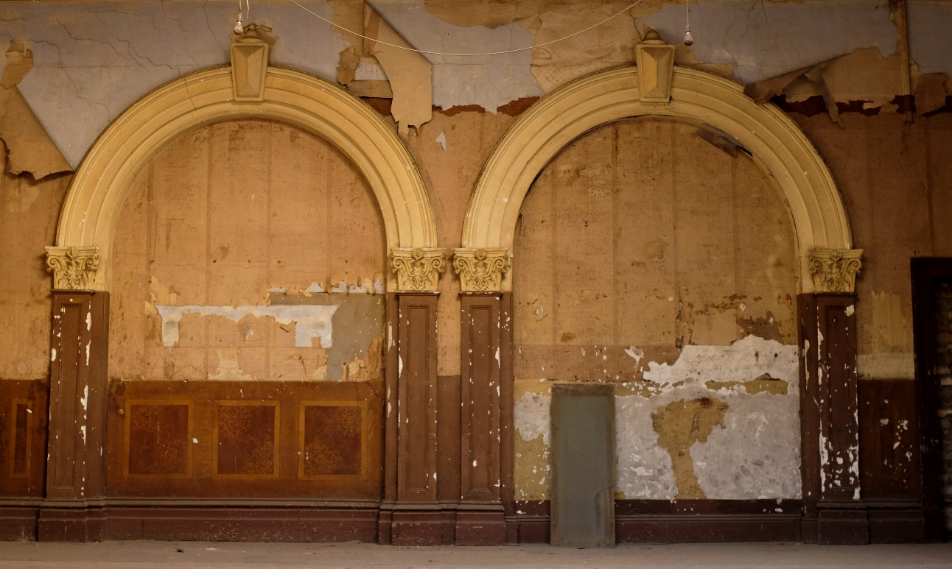

Submission Requirements

Photographs
However, regardless of the size and complexity of the project, the final record must include 2 complete sets of the following:
- 1 x sets of selected black & white (monochrome) printed photographs
  - Photographs are to be printed on archival quality paper and printed with archival quality pigment inks.
  - Images are to be printed on one side only.
  - Printed colour photographs are not encouraged and will only be accepted if printed using pigment inks, Printed colour photographs should only be included to communicate colour scheme information, in which case each printed image should also include a Macbeth Colour Checker or the printed set should include a duplicate photograph that includes a Macbeth Colour Checker.
  - The minimum size of each image will no less than 6x4 inches (152x102mm)
  - Each image shall be printed separately. Ie. Not multiple images printed on a single sheet.
  - Each individual image will be stored in a clear archival quality sleeve or pockets within an archival quality binder.
  - Each printed photograph should be identifiable by its file name and number. This file name and number is to be printed on each respective photograph. This name can be either be printed on the front of the photograph or the back. However, any photograph that has its file name and number printed on the back must not be placed back to back with another photograph in the archival sleeve or pocket.
- 1x full set of black and white printed contact sheets describing the full set of digital image files. Contact sheets are to be printed in the same medium as the photographs.
- 1 x full sets of digital image files in each of the following formats:
    - High resolution colour TIFFS
    - High resolution black& white tiffs
    - High resolution colour JPGs
    - Low resolution colour JPGS
  - Each digital set must include all identical images.
  - All digital image files are to be geo-reference wherever possible.
  - Image files are to be stored and provided on external hard drives only. Digital records on other media such as DVD, CD (or similar), memory cards (eg: SD XF) or USB thumb style drives will not be accepted.

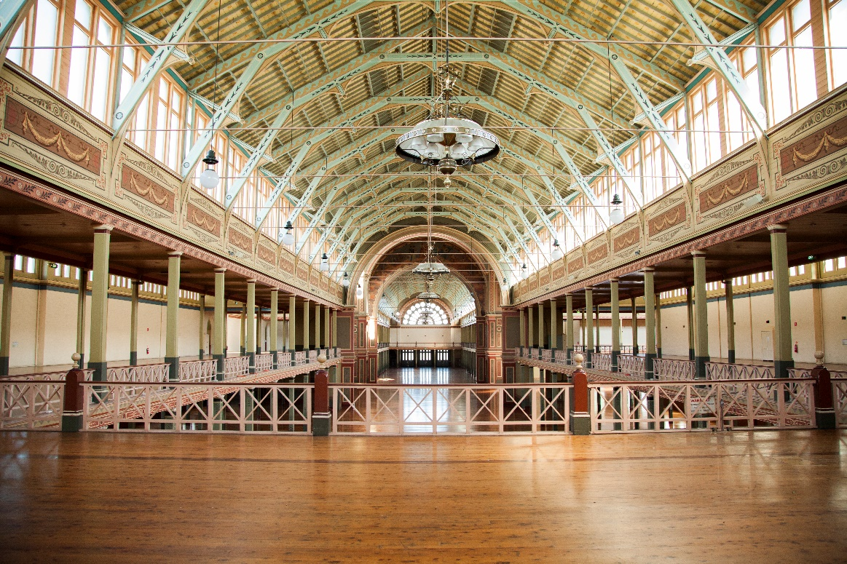

Documentation
- 1 x set of scale drawings accurately showing the subject and the location each image or position and direction of each shooting position to scales suitable to convey the necessary information. Wider angle shots will require the position and the direction of the shot to be shown while detailed shots can be displayed at the image location.
  - Viewers of the record must be able to accurately identify each photograph with its location on the plan.
  - All recordings must include a plan, however where detailed images are taken on vertical surfaces, elevations must also be included.

- Documentation containing the following information:
  - Name of Place
  - Address or location of place
  - Photographer’s name and contact details
  - A short written description of the place.
  - A statement of significance of the place
  - A written description of the reasons for undertaking the recording
  - A copy of the scope of any proposed works.
  - A description of the recording methodology
  - Information regarding the printed photographs including the printing process used, type of ink and type of paper stock used.
  - Record of which geodetic datum has been used to geo reference any photographs. (most likely to be WGS84)

- A log showing information regarding the shoot and information for each photograph. The log must include the following information for each image:
  - Date of the shot
  - Aperture, shutter speed and ISO used
  - Camera/s used
  - Lenses used
  - Focal length used (& 35mm lens equivalent if using a cropped or medium format sensor)
  - Sensor size
  - File name (Name of Place_Location_Descriptor (if used)_Date Taken_Image No. eg: Flinders Street Railway Station_Melbourne_Clocks_1 March 2017_001)
  - Image/File numbering is to be a continuous sequence throughout the entire set.
  - Image numbers must relate to the measured site drawings
  - Description and details
  - Location information, where applicable. The record must be in Latitude/Longitude (D°MM.MMM) (WGS84). The record should note if the coordinates are for the location of the subject or the photographer.

Please contact Heritage Victoria if you require further information, clarification or wish to discuss a particular project on 03 9938 6894 or heritage.permits@delwp.vic.gov.au

