TECHNICAL LEAFLET

Access for all to heritage Places

Introduction Dignified access for people with disabilities should be provided to, and within heritage places. However, many heritage buildings offer specific challenges that need to
be overcome when providing access for all. Any proposal for change to a heritage place should be informed by, and tested against, a thorough understanding of the impact on significance. In many cases heritage, planning and building permits will be required when undertaking changes to a heritage place to provide access for all.

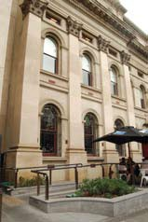All buildings, including heritage places, are subject to the requirements of the Federal Disability Discrimination Act 1992 (DDA) and complementary state based legislation such as the Equal Opportunity Act 1995 in Victoria. The DDA applies whether buildings are in public or private ownership. This Act requires that people with disabilities be given an equal opportunity to access premises without
discrimination unless a case of unjustifiable hardship exists. When heritage buildings undergo change, the requirements of the Building Code of Australia (BCA) apply
to the new work and, in some instances, the existing building, and this includes a number of specific provisions for people with disabilities. Any change to a heritage building needs to consider the impact on the heritage values.

State library of Victoria, Melbourne (DPCD)
An external ramp provides access to the building’s café.
Providing access for all to heritage buildings has broader equity issues including improved access that benefits a range of users including parents with children in strollers, couriers and furniture movers as well as people with disabilities. Universal design, or access for all, is an overriding objective that should always be aimed for when upgrading a heritage place.

This Technical Leaflet provides information on disabled or universal access to heritage places. This may include buildings and their setting such as gardens. Its aim is to show that it is possible to modify a range of heritage buildings so that they are accessible to people with a disability while maintaining the heritage values of the place. There are a number of excellent detailed guides to overcoming the practical
problems associated with providing access for people with disabilities, some of which are included in the resources section of this Technical Leaflet.

Background Disability Discrimination Act
The definition of disability, as outlined in the DDA, can be summarised as anything that results in a total or partial loss of a person’s bodily or mental functions. This includes physical, visual, hearing, intellectual and psychiatric impairments. Current Australian statistics indicate that some 20% of Australians have a disability. This rises to 50% for people over 60. The DDA is Commonwealth legislation requiring that people with a disability be given equal opportunity to participate in, and contribute
to, a full range of economic, social, political and cultural activities. The goal of the DDA is not fulfilled by limited access. Instead it promotes and protects equality of full access: physical, informational and attitudinal.

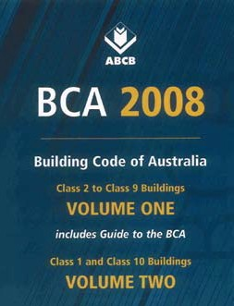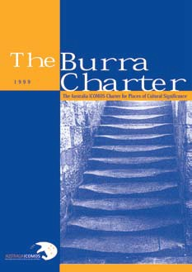Right: Building Code of Australia includes specific provisions for people with disabilities.

Far Right: The Burra Charter is the guiding document for conservation practice.

Under Section 23 of the DDA it is unlawful to discriminate against a person on the basis of a disability.

The DDA is a complaints based Act. It requires people who consider themselves discriminated against to lodge a complaint with the Human Rights and Equal Opportunities Commission (HREOC). The right to access is not absolute in law and the DDA includes provision in Section 11 whereby a person can argue that to
implement the provisions of the DDA would cause them unjustifiable hardship. The Federal Courts would decide on whether a defendant would suffer unjustifiable hardship if required to provide access.

Complaints about the lack of provision of access for people with disabilities should
in the first instance be made to the person who manages or owns the heritage place. Where no resolution can be achieved a complaint may be lodged with the Federal Human Rights and Equal Opportunity Commission under the DDA. Complaints can also be made through the Victorian Equal Opportunity Commission, where there has been a breach of the Equal Opportunity Act.

Building Code of Australia
Whenever new work is undertaken it must meet the requirements of the BCA and this includes several specific provisions for people with disabilities. In particular, the following clauses and the associated Objectives, Functional Statements and Performance Requirements relate to disabled access:
- D3 General Requirements and Access
- E3.6 Lifts
- F2.4 Toilet Provisions

There is no requirement to upgrade a building to current BCA with regard to access for people with disabilities if no new work is proposed. In Victoria the BCA is applied through the Building Act 1993.

BCA and DDA
Following extensive consultation, the Australian Government made the Disability (Access to Premises – Standards) 2010, which came into effect from 1 May 2011. These Disability Standards were adopted in the BCA, and were applied in Victoria through the Building Act 1993 and the Building Regulations 2006, from 1 May 2011. These requirements provide greater clarity of what is required by architects, designers, owners, occupiers and managers of buildings to meet the obligations of the DDA. The access requirements have changed in the BCA and exceptions and concessions for lessees, lifts and toilets are applied in Victoria through the Building Regulations. An access protocol to assist with achieving access, such as in an existing building, has been adopted through the Building Act. A person can argue to the Victorian Building Appeals Board that to comply with an access provision of the BCA, would cause them unjustifiable hardship.

Heritage
Heritage legislation at Commonwealth, State and Territory or local level seeks to conserve and protect the heritage significance or heritage values of a place.
Significance is expressed in a Statement of Significance which describes the value of the place to the community and includes a range of criteria embodying aesthetic, historic, scientific and social values. Heritage legislation aims to protect significant
heritage for past, present and future generations. All works to places on the Victorian Heritage Register, including those made to improve access, will require a permit under the Heritage Act 1995. Many alterations, especially the provision of external ramps etc. will require planning permission where a heritage place is included in the heritage overlay of the local planning scheme.
The guiding document for conservation practice is the Australia ICOMOS Charter for Places of Cultural Significance (The Burra Charter). The Burra Charter defines conservation as including all the processes of looking after a place: maintenance, preservation, restoration, reconstruction and adaptation. One of the guiding principles of the Burra Charter is a cautious approach of changing as much as necessary but as little as possible (Article 3). This approach should guide any works to provide access for people with disabilities.

Guiding Principles In providing disabled access to heritage places, the aim is to meet the obligations of the various acts and regulations while providing the same opportunities for all including people with disabilities to use, appreciate and enjoy heritage places. This includes ensuring access for all through providing:
- car parking as close as is reasonable
- access to the buildings on a common or similar route
- access into the building at the same entry used by all where possible. This is usually referred to as the principle public entrance, and may or may not be the original or historic entry
- access through each level of a building
- access to, and between all levels of the building
- use of toilets and other facilities
- information in all formats - written, visual and audio
- services such as telephones, vending machines, counters and retail outlets
- access throughout the site including open space, landscapes, gardens and garden structures.

Universal access is about ensuring independence and dignity for all users entering and using places.
The objective is to achieve maximum access with minimal impact on the heritage values while complying with relevant heritage, planning and building legislation and adopting the sound conservation philosophy contained in the Burra Charter.

Process The recommended process for developing and implementing a scheme for improving access to a heritage place is to:
- Review the significance of the heritage building or place, identify the elements of significance and have a suitably qualified heritage consultant prepare or update a conservation management plan (CMP). CMPs should consider how access can be achieved and provide policies that allow design solutions that meet the legislative requirements while retaining heritage significance.
- Undertake an access audit, using an access consultant if necessary, to determine the place’s existing and required level of accessibility. Not only to the principle public entry and other parts of the building, but also to services offered and to information provided.
- Develop accessibility options using an architect with experience of working with heritage places and testing these against the CMP or statement of significance. The option that maximises access but has the minimum impact on heritage significance should generally be selected.
- Establish a policy on access and heritage and prepare an action plan. The final strategy to overcoming access issues in heritage places may involve BCA
performance based responses, called Alternative Solutions rather than using the prescriptive BCA Deemed to Satisfy solutions or management responses such as providing awareness training.
- Obtain appropriate heritage, planning and building permits prior to implementing the action plan.

There is no one solution to a problem. Different heritage buildings will have varying levels of significance, different settings, and there may be a range of possible solutions to optimising access for all. Each case needs to be assessed on its own merits and the best set of solutions found.

Solutions
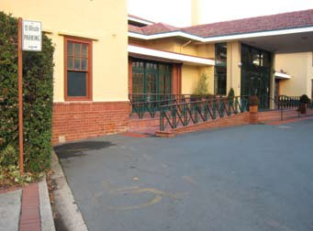Car parking and access Hotel Kurrajong, Canberra
(EMA)
Accessible car parking spaces are provided next to ramp access without blocking access to the ramp for other users.

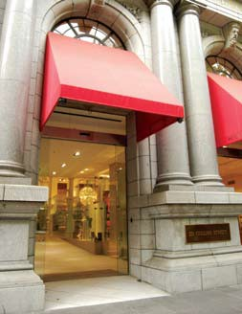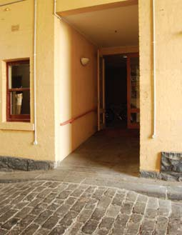

271 Collins St, Melbourne (DPCD)
The entry has been modified as part of a retail redevelopment to remove the threshold step through the introduction of an internal ramp.
Former Metropolitan Meat Market, North Melbourne (DPCD)
The bluestone paving has been relaid to overcome the threshold at the kerb stone and provide ramped access for wheelchair users.

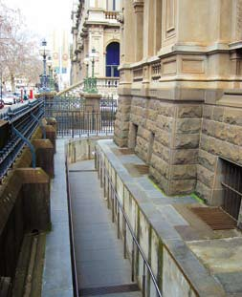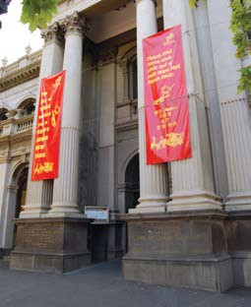

Bendigo Court House, Bendigo (DPCD)
The main entrance is accessed by a ceremonial flight of steps that would be difficult to provide ramp access to.
Access to an alternative entrance to the basement level is provided by a new ramp located in the void between the building
and the pavement.
Former Collingwood Town hall, Collingwood (DPCD)
A new ramp constructed in bluestone has been created within the portico
to overcome a threshold at the main entrance.

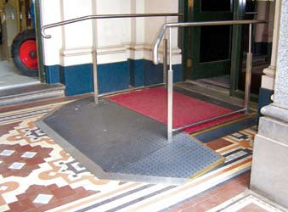Bendigo Information Centre (former Post Office), Bendigo (EMA)
A reversible ramp and landing added to
overcome step to entry without damaging historic tiles.

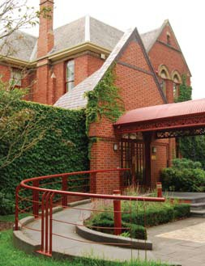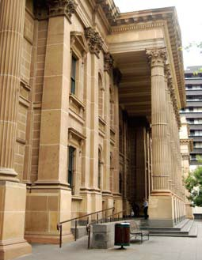

University House, University of Melbourne (DPCD)
A sensitively designed external ramp and landing has been provided to the main entrance.
State Library of Victoria, Melbourne (DPCD)
An external ramp adjacent to one side of the portico has been incorporated on the front façade to accommodate a modest change in level without significantly diminishing the symmetry of the building.

Former St Kilda Town hall, St Kilda (DPCD)
By keeping the gradient of the shared pedestrian/ vehicle access to less than 1 in 20 it does not have to be treated as
a ramp in terms of the Building Regulations.
Former Prahran Town hall, Prahran (DPCD)
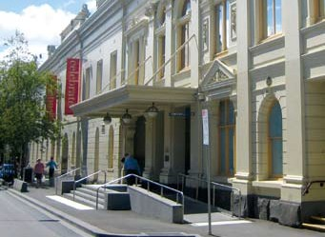A natural change in level across the length of the building helps reduce the length of ramp required.

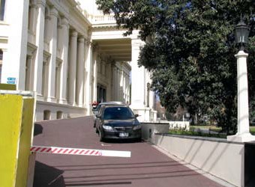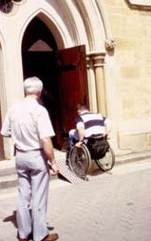St Mark’s Church, Hobart, Tasmania (EMA)
A light-weight portable ramp is used to overcome a two- step threshold, where only occasional wheelchair access is
required. This solution requires active management with staff and volunteers trained on the handling and use of the ramp.

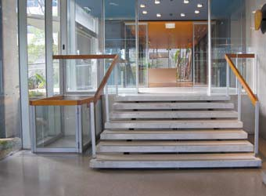Orica (former ICI) house, Melbourne (DPCD)
A sensitively designed platform lift has been integrated into the foyer of this modernist office block at the side of the main entry stairs.

Vertical access off street
- large level change

Vertical access within building – small changes of level

Princes’ Bridge Walk, Federation Square, Melbourne (DPCD)
A contemporary steel and glass external lift has been provided to deal with a large change of level adjacent to a historic bridge and provide access to a hospitality and tourism precinct.

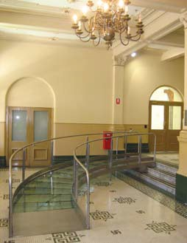

Prahran Town Hall, Prahran (DPCD)
A high-quality reversible glazed ramp has been provided in the foyer to overcome a change in level.

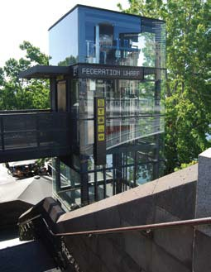

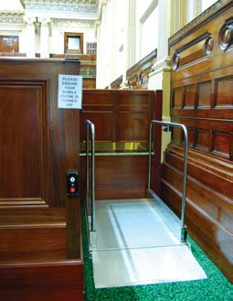

Parliament house, Melbourne (DPCD)
An inconspicuous platform lift provides access to the public gallery.

Vertical access within building – large changes of level

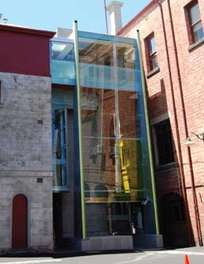

Former Fitzroy Town hall, Fitzroy (DPCD)
A new external lift adjacent to the accessible entrance from the car park provides access to all floors.

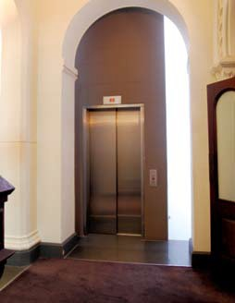

Former Magistrates Court (RMiT University) (DPCD)
A new internal lift has been incorporated into the historic interior.

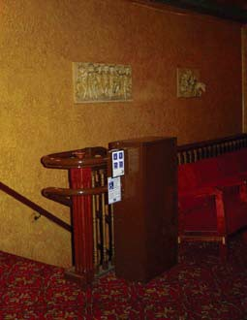

Forum Theatre, Melbourne (DPCD)
A stair climbing platform is provided for wheelchair users to access the upper levels of the theatre where a lift would not be practical to install. It has been painted to minimise its impact on the historic interior.

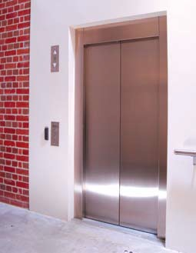

Former Metropolitan Meat Market, North Melbourne (DPCD)
A new internal lift has been incorporated into this former industrial building.

Upgrading existing stairs

Signage

Accessible WC facilities

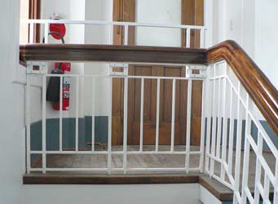Old Parliament house, Canberra, ACT [EMA] An additional bar clamped on existing
balustrade to increase height and meet
safety from falling requirements.

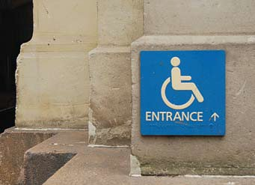GPO Building, Melbourne (DPCD)
Signage is used to inform wheelchair users and parents with pushchairs of the accessible entrance.

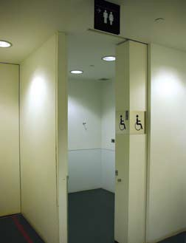Immigration Museum, Melbourne (DPCD)
New accessible WC facilities can be integrated into existing spaces within an historic building.

Existing ramps

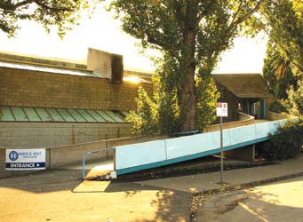Harold Holt Swim centre, Glen iris (DPCD)
The existing, but non- compliant, ramp is retained in use as part of the architectural
significance of the building.

Existing lifts

Cultural heritage landscapes
Athenaeum Library, Melbourne (DPCD) The existing historically significant lift still provides access within the
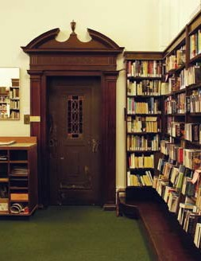Athenaeum, Collins Street, Melbourne. Management systems are in place to provide staff assistance to wheelchair users who otherwise would find the manual doors and non-compliant controls difficult to use.

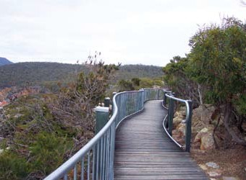Freycinet National Park, Tasmania (Pam Enting)
An accessible pathway, which does not detract from the landscape, provides access for all to the Tourville Lighthouse.

Resources General References
  - Australian Buildings Code Board, 2004, Disability Standards for Access to Premises (Buildings), Canberra
  - Australian Buildings Code Board, 2004, Draft Access Code for Buildings, Canberra
  - Disability Discrimination Act 1992 (Commonwealth)
  - Equal Opportunity Act 1995 (Victoria)
  - Building Act 1993 (Victoria)
  - Building Regulations 2008 (Victoria)

References
  - Building Commission Victoria, 2003, Making a Complaint About Access to Public Buildings, Melbourne http://www.buildingcommission.com.au/resources/documents/Accesspublic.pdf
  - Building Commission Victoria, n.d., National Initiatives on the Access to Premises Standard [information sheet], Melbourne http://www.buildingcommission.com.au/resources/documents/niotatps.pdf
  - English Heritage, 2004, Easy Access to Historic Buildings, London http://www.english-heritage.org.uk/upload/pdf/EH_EasyAccess_2004.pdf
  - English Heritage, 2005, Easy Access to Historic Landscapes, London http://www.english-heritage.org.uk/upload/pdf/EAHL.pdf
  - Foster, L., 1997, Access to the Historic Environment: meeting the needs of disabled people, Donhead, Shaftsbury, Dorset.
  - Martin, E., 1999, Improving Access to Heritage buildings: A practical guide to meeting the needs of people with disabilities, Australian Heritage Commission, Canberra. http://www.environment.gov.au/heritage/ahc/publications/ commission/books/pubs/improving-access-heritage-buildings.pdf
  - Royal Australian Institute of Architects, 2002, Practice Note AN 13.05.004: Improving access to heritage buildings and/or places.
  - Australia ICOMOS Charter for Places of Cultural Significance (The Burra Charter). http://www.icomos.org/australia

Websites
  - Heritage Victoria, www.heritage.vic.gov.au
  - Association of Consultants in Access, Australia Inc. www.access.asn.au
  - Eric Martin & Associates, www.emaa.com.au

For further information and assistance visit www.heritage.vic.gov.au and www.heritagecouncil.vic.gov.au

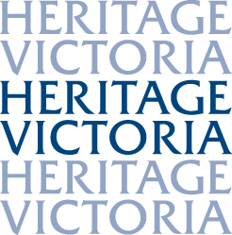
Prepared by Eric Martin with Jim Gard’ner for the Technical Advisory Committee of the Heritage Council of Victoria 2008.

Endorsed and published by the Heritage Council of Victoria November 2008.
Revised December 2008.
This publication is copyright. No part may be reproduced by any process except in accordance with the Copyright Act 1968.
Authorised by the Victorian Government, 8 Nicholson Street, East Melbourne.

© Heritage Council of Victoria, 2008.
Disclaimer This publication may be of assistance to you but the State of Victoria and its employees do not guarantee that the publication is without flaw of any kind or is wholly appropriate for your particular purposes and therefore disclaims all liability for any error, loss or other consequence which may arise from you relying on any information in this publication.

