Instructions to complete form

Application form
Application for permit for entry into a protected zone or to disturb a shipwreck or shipwreck artefact (r 5)
Preliminary information
It is the applicant’s responsibility to ensure that the full and correct information is provided. Applications made on behalf of business names or unincorporated associations also require an individual applicant’s name, eg Ms Jane Smith, Capital Enterprises Pty Ltd.
Who should complete this form?
A person wanting to make an application to enter a protected zone, or to disturb a shipwreck or shipwreck artefact.
Enquiries and more information
Web: heritage.vic.gov.au
Phone: (03) 7022 6390
Email: heritage.victoria@delwp.vic.gov.au
Please lodge your application via email to heritage.victoria@delwp.vic.gov.au
Please note: all sections must be completed. Incomplete applications will be returned to the applicant which may result in delays.

Office use only
 | Shipwreck/ artefact |  | Application no. |  | Date received
 | Payment method |  | Fee received?
 |  |  | YES NO

- Applicant details

Title:
First name:
Surname:
Address:
Email address:
Telephone:
Is this application on behalf of a company or organisation? | Yes  No
What is the name of the company or organisation?
What is your position title?

- Details of registered shipwreck, historic shipwreck, registered shipwreck artefact or historic shipwreck artefact
Name of shipwreck or artefact:
Location (if known):
Victorian Heritage Register number (if known):
Description of shipwreck or artefact:

- Details of vessel/s involved with the activity
Vessel name/s:
Registration number/s:
Vessel contact details (phone, radio call sign and frequency):
Name/s of boat operator:

- Permit type
Tick boxes as applicable:
Permit type
To enter a protected zone and undertake recreational diving or snorkelling
To enter a protected zone and undertake recreational diving or snorkelling and require the use of moorings
For commercial operator to enter a protected zone and undertake recreational diving or snorkelling on one occasion
For commercial operator to enter a protected zone and undertake recreational diving or snorkelling on five occasions
To enter a protected zone for other purposes
To enter a protected zone for other purposes and require the use of moorings
To recover shipwreck artefacts or historic shipwreck artefacts
To disturb a registered shipwreck, historic shipwreck, registered shipwreck artefact or historic shipwreck artefact
Other (please state)

- Details of the activities to be undertaken
Summary of activity:
Proposed date/s of activity:
Name/s of diver/s:

- Permit fee
Fee to be paid:
Note: If these activities are being undertaken by a community group or for conservation, educational research or public safety, it may be possible to apply for a waiver of the permit fee. Please contact Heritage Victoria at heritage.victoria@delwp.vic.gov.au

- Payment options
Please record payment details below (application will not be processed without accurate payment details)
 | BPAY Biller Code: 72637  Customer Ref: 164123456786  Telephone & Internet banking BPay, Contact your bank or financial institution to make this payment from your cheque, savings, debit, credit card or transaction account.  More info: www.bpay.com.au | By Cash, Cheque or Debit Card only

BPAY (please tick) | Australia Post (please tick)
Amount paid: | Amount paid:
Your bank name: | Unique sequence number (see example below):  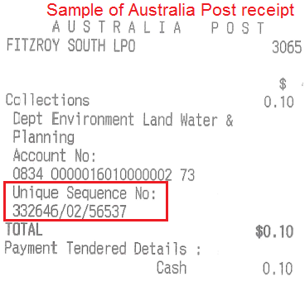
Receipt number: | Payment method:
Receipt date: | Receipt date:

- Applicant declaration
I state that the information I have given on this form is correct to the best of my knowledge
Name:
Signature:
Date:

